**CS 2302 Data Structures**

**Fall 2019**

**Lab Report #3**

Due: October 8th, 2019

Professor: Olac Fuentes

TA: Anindita Nath

**Introduction**

For this lab, we were asked to implement two classes: a *List* class and a *SortedList* class. Both classes will contain functions that perform the same operations on a singly-linked list. The main difference between these two classes is that the *List* class will perform operations on a singly-linked list that always has its elements unsorted while the *SortedList* class will perform those same operations on a singly-linked list that always has its elements sorted in ascending order. For this lab, it is key to remember the properties of singly-linked lists and iteration since they are required for all exercises. The main objective of this lab is to write a program that implements a *List* class and a *SortedList* class with functions that perform the same operations on a singly-linked list and compares their performance.

**Proposed Solution Design and Implementation**

**Operation #1 (Print()):**

In the *SortedList* class, I implemented an iterative function that traverses through the entire singly-linked list and prints the data of each node in the list. Additionally, for each node, except the tail node, it prints an arrow that points to the next element.

In the *List* class, I did not implement a separate function for this operation. Instead, the *List* class inherits that same function from the *SortedList* class.

The big-O running time of this operation is **O(n)** in both classes because it traverses through the singly-linked list once to print the contents of the list.

**Operation #2 (Insert(i)):**

In the *SortedList* class, I implemented an iterative function that traverses through the singly-linked list until it finds the proper place to insert integer i to the list. That way, the list remains sorted. If the list is empty, the function inserts i as a single node. Otherwise, it determines whether i is less than the value of the list’s head, greater than the value of the list’s tail, or in between those two values and inserts i to its proper place. If integer i falls into either of the first two options, it will be prepended or appended to the list, respectively. Otherwise, the function will traverse through the list to insert i to its proper place.

In the *List* class, I implemented a separate function for this operation. This function simply appends integer i to the singly-linked list. If the list is empty, the function inserts i as a single node.

The big-O running of this operation is **O(n)** in the *SortedList* class because it may need to traverse through the singly-linked list once to insert an integer that is in between the values of the head and tail of the list. Meanwhile, the big-O running time of this operation is **O(1)** in the *List* class because it inserts the integer at the end of the singly-linked list without the need to traverse through it.

**Operation #3 (Delete(i)):**

In the *SortedList* class, I implemented an iterative function that traverses through the entire singly-linked list and removes all instances of integer i from the list. If the values of the head and tail of the list match that of integer i, their pointers will be updated accordingly in order to remove them. If integer i is not in the list, the list remains the same.

In the *List* class, I did not implement a separate function for this operation. Instead, the *List* class inherits that same function from the *SortedList* class.

The big-O running time of this operation is **O(n)** in both classes because it traverses through the singly-linked list once to remove all instances of the integer from the list.

**Operation #4 (Merge(M)):**

In the *SortedList* class, I implemented an iterative function that traverses through a second singly-linked list M of type *SortedList* and inserts all its elements into the original singly-linked list by calling the Insert(i) function implemented in this class.

In the *List* class, I implemented a separate function for this operation. This function simply appends a second singly-linked list M of type *List* to the original singly-linked list. If the original list is empty, then the second list is considered as a single list.

The big-O running of this operation is **O(n2)** in the *SortedList* class because it traverses through the original singly-linked list more than once to insert all elements of the second singly linked list. Meanwhile, the big-O running time of this operation is **O(1)** in the *List* class because it merges both singly-linked lists without the need to traverse through it.

**Operation #5 (IndexOf(i)):**

In the *SortedList* class, I implemented an iterative function that traverses through the singly-linked list and returns the value of the index of integer i. To do this, I initialized the value of the index at 0 and incremented it by 1 every time the value of the node does not match that of i. Once i is found, the function returns the value of its index. If integer i is not in the list, the function returns -1.

In the *List* class, I did not implement a separate function for this operation. Instead, the *List* class inherits that same function from the *SortedList* class.

The big-O running time of this operation is **O(n)** in both classes because it traverses through the singly-linked list once until it finds the integer and returns its index.

**Operation #6 (Clear()):**

In the *SortedList* class, I implanted a function that sets the head of the singly-linked list to None to remove all elements from the list.

In the *List* class, I did not implement a separate function for this operation. Instead, the *List* class inherits that same function from the *SortedList* class.

The big-O running time of this operation is **O(1)** in both classes because it removes all elements from the singly-linked list by simply changing the head of the list to None.

**Operation #7 (Min()):**

In the *SortedList* class, I implemented a function that returns the value of the head of the singly-linked list since it is the smallest element in the sorted list. If the list is empty, the function returns math.inf.

In the *List* class, I implemented a separate function for this operation. This function initializes the minimum value of the singly-linked list to the value of its head, and it iteratively traverses through the entire list in order to compare the value of each node to the current minimum value. If there is a node whose value is less than that of the current minimum value, the latter is updated. Once the function traverses through the entire list, it returns the minimum value. If the list is empty, the function returns math.inf.

The big-O running time of this operation is **O(1)** in the *SortedList* class because it returns a single value by simply referring to the head of the singly-linked list. Meanwhile, the big-O running time of this operation is **O(n)** in the *List* class because it must traverse through the singly-linked list once in order to find and return the smallest element in the list.

**Operation #8 (Max()):**

In the *SortedList* class, I implemented a function that returns the value of the tail of the singly-linked list since it is the largest element in the sorted list. If the list is empty, the function returns -math.inf.

In the *List* class, I implemented a separate function for this operation. This function initializes the maximum value of the singly-linked list to the value of its head, and it iteratively traverses through the entire list in order to compare the value of each node to the current maximum value. If there is a node whose value is greater than that of the current maximum value, the latter is updated. Once the function traverses through the entire list, it returns the maximum value. If the list is empty, the function returns -math.inf.

The big-O running time of this operation is **O(1)** in the *SortedList* class because it returns a single value by simply referring to the tail of the singly-linked list. Meanwhile, the big-O running time of this operation is **O(n)** in the *List* class because it must traverse through the singly-linked list once in order to find and return the largest element in the list.

**Operation #9 (HasDuplicates()):**

In the *SortedList* class, I implemented an iterative function that traverses through the singly-linked list and compares the values of each pair of adjacent nodes. If the function finds two values that match, it returns True, which indicates that the list has duplicates. Otherwise, it continues traversing through the list and stops when it reaches the tail of the list. If there were no two adjacent values that matched throughout the entire traversal, the function returns False, which indicates that the list does not have duplicates. Furthermore, the function returns False if the list is empty, or it contains a single element.

In the *List* class, I implemented a separate function for this operation. This function traverses through the entire singly-linked list and compares the value of each node with that of the other nodes in the list. If the function finds at any point two values that match, it returns True. Otherwise, it continues traversing through the list and stops when it reaches the tail of the list. If no two values matched throughout the entire traversal, the function returns False. Furthermore, the function returns False if the list is empty, or it contains a single element.

The big-O running time of this operation is **O(n)** in the *SortedList* class because it traverses through the singly-linked list once to determine if there are any two adjacent, duplicate values in the list. Meanwhile, the big-O running time of this operation is **O(n2)** in the *List* class because it traverses through the singly-linked list more than once in order to determine if there are any two duplicate values in the list.

**Operation #10 (Select(k)):**

In the *SortedList* class, I implemented an iterative function that traverse through the singly-linked list and returns the k-th smallest element in the list. To do this, the function decrements the value of k by 1 every time the function moves from one node to the next. Once k reaches 0, the function returns the value of the current node, which indicates that this value is the k-th smallest value in the list. If the function reaches the tail of the list, and the value of k is greater than or equal to 1, this means that the list has less than k – 1 elements. Therefore, the function will return math.inf. Furthermore, if the value of k is initially less than 0, it will return math.inf as well.

In the *List* class, I implemented a separate function for this operation. This function uses bubble sort to sort the singly-linked list. To find the k-th smallest element in the list, it employs the same algorithm as the Select(k) function implemented in the *SortedList* class after it has sorted the list through bubble sort.

The big-O running time of this operation is **O(n)** in the *SortedList* class because it traverses through the singly-linked list once to find the k-th smallest element in the list by decrementing the value of k until it reaches that element. Meanwhile, the big-O running time of this operation is **O(n2)** in the *List* class because it uses bubble sort to sort the singly-linked list, which requires multiple traversals through the list until each element is in its proper position in the list.

Table summarizing the big-O running times for each operation in both classes

|  |  |  |
| --- | --- | --- |
| Function | SortedList | List |
| Print() | O(n) | O(n) |
| Insert(i) | O(n) | O(1) |
| Delete(i) | O(n) | O(n) |
| Merge(M) | O(n2) | O(1) |
| IndexOf(i) | O(n) | O(n) |
| Clear() | O(1) | O(1) |
| Min() | O(1) | O(n) |
| Max() | O(1) | O(n) |
| HasDuplicates() | O(n) | O(n2) |
| Select(k) | O(n) | O(n2) |

For each operation, I used the same randomly generated native list for both classes. The order in which each operation was performed is as follows: insert the elements of the native list into both singly-linked lists, print the singly-linked lists, delete an integer from both singly-linked lists, merge two randomly generated singly-linked lists, one for each class, with their corresponding original list, print the index of an integer found in both singly-linked lists, print the smallest and largest elements of both singly-linked lists, print the Boolean value that tells if both singly-linked lists have duplicates or not, print the k-th smallest element in both singly-linked list, and clear both singly-linked lists. Throughout this process, I included the total running time for each operation in both classes.

**Experimental Results**

**Operation #1:**

For this operation, I will test randomly generated lists of integers of sizes 50, 100, 500, 1000, and 5000. Additionally, I will test this operation to print lists without duplicates for sizes 50, 500, and 5000 and lists with duplicates for sizes 100 and 1000.

Case 1: Size of list = 50

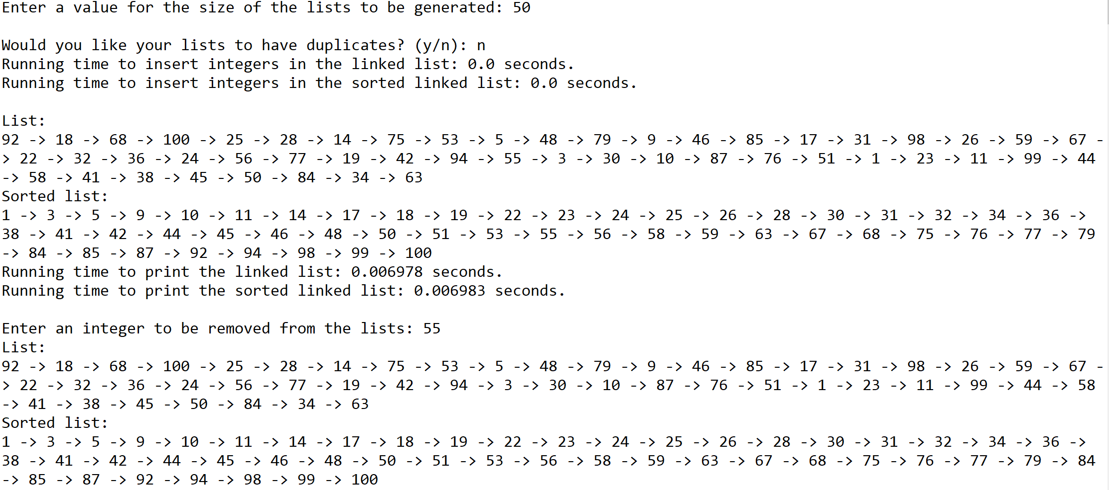

Case 2: Size of list = 100

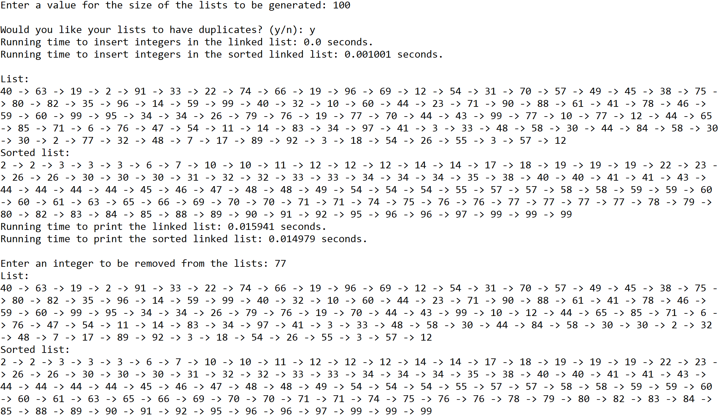

Case 3: Size of list = 500

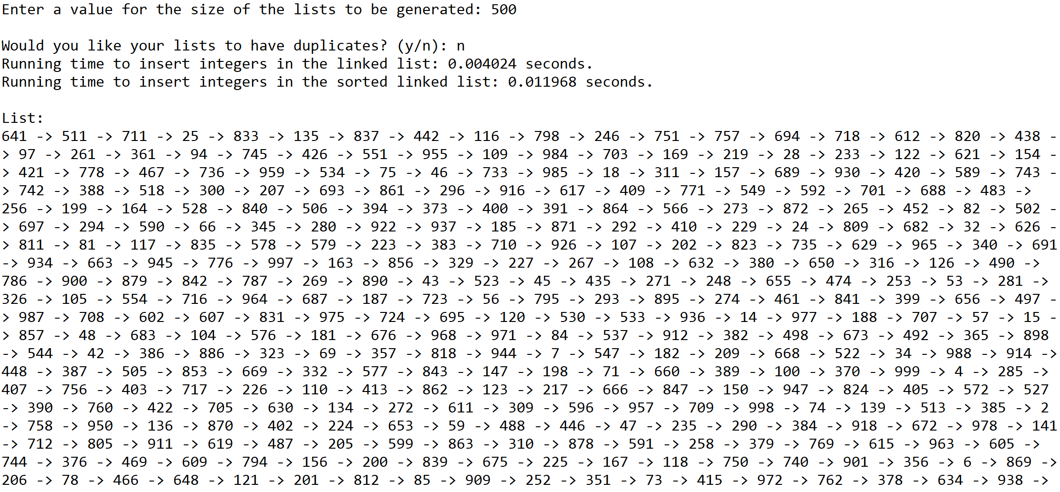

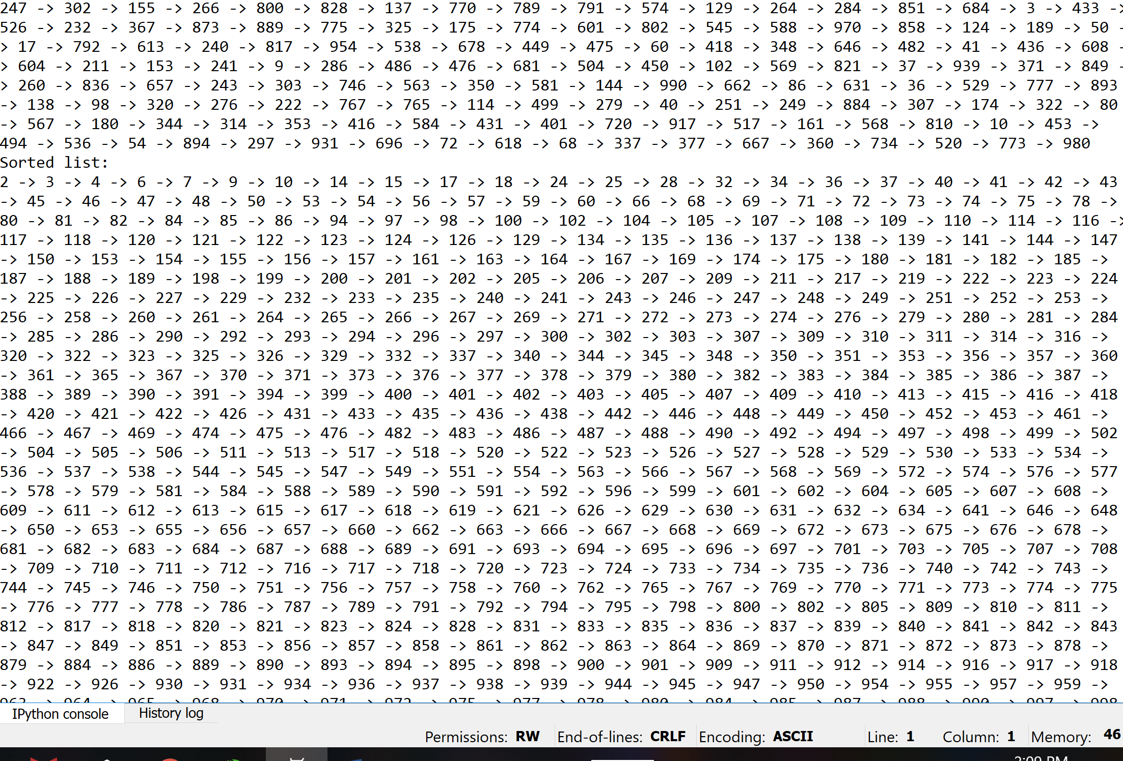

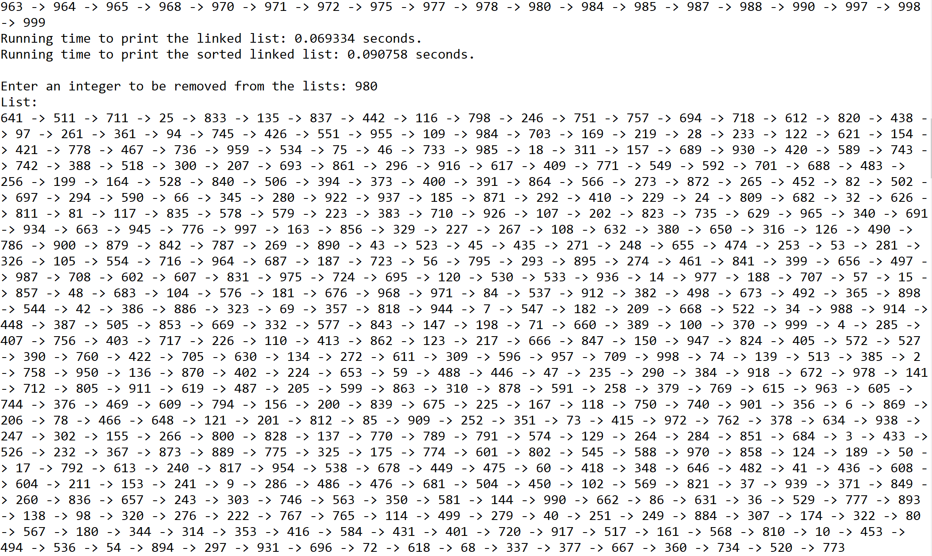

Case 4: Size of list = 1000

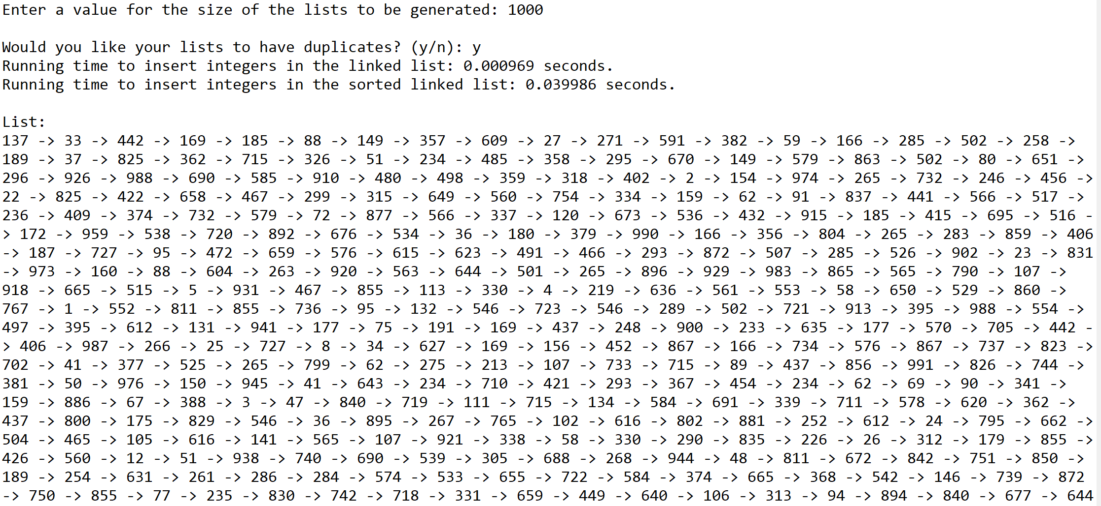

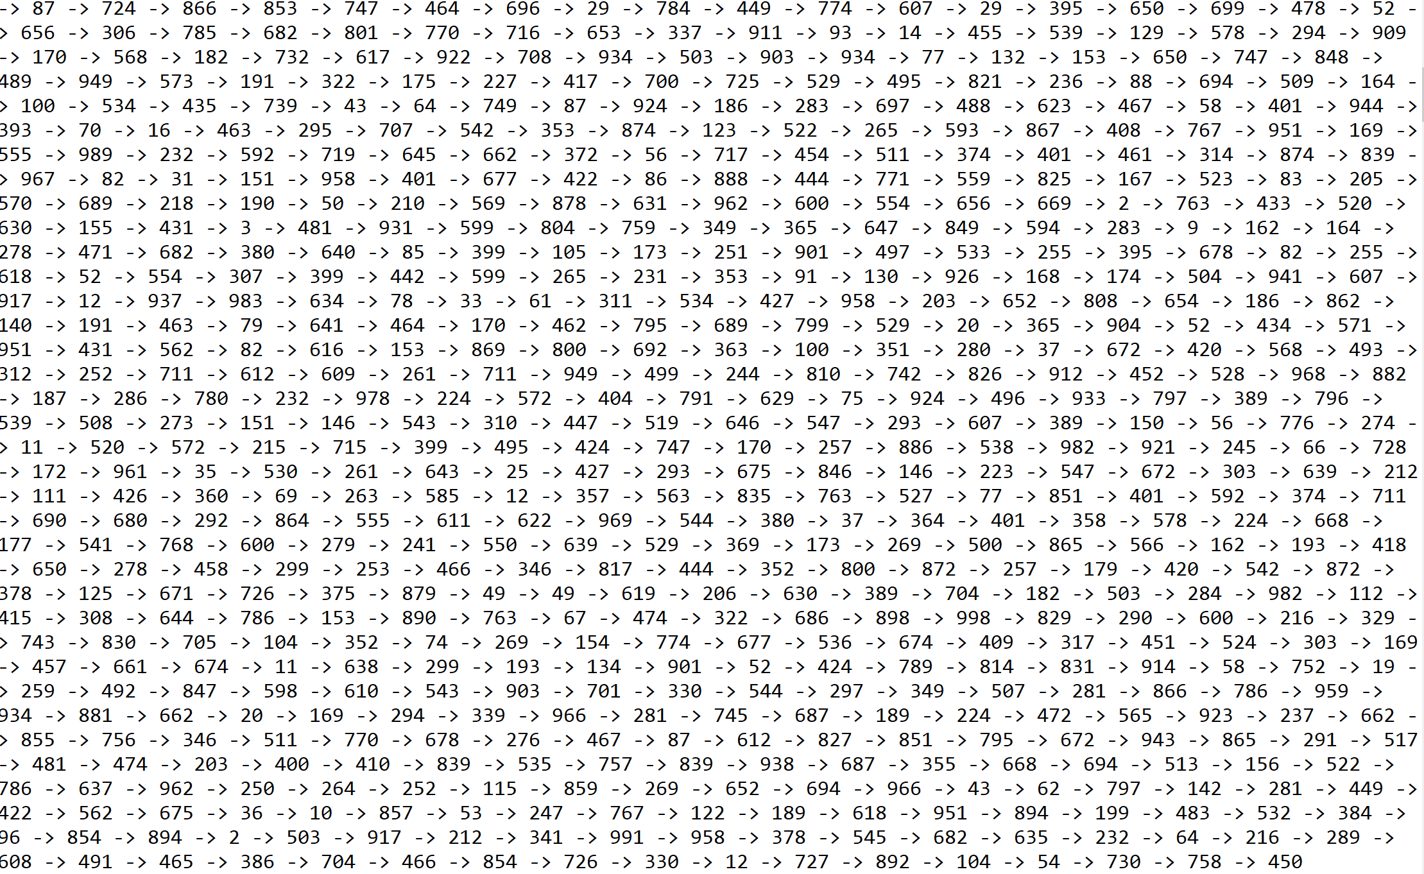

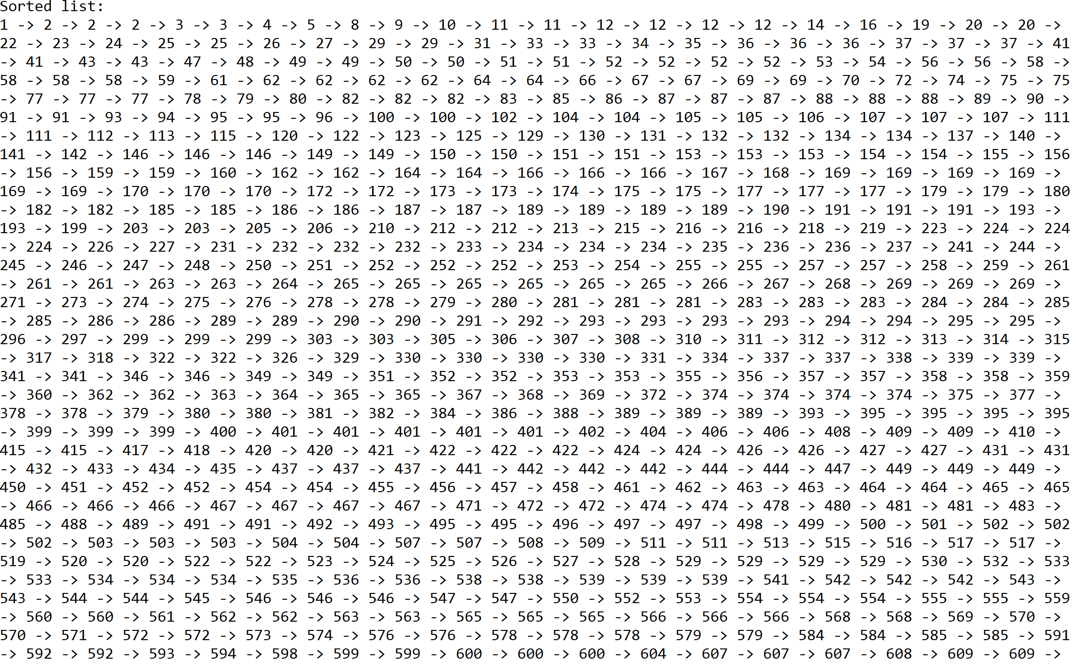

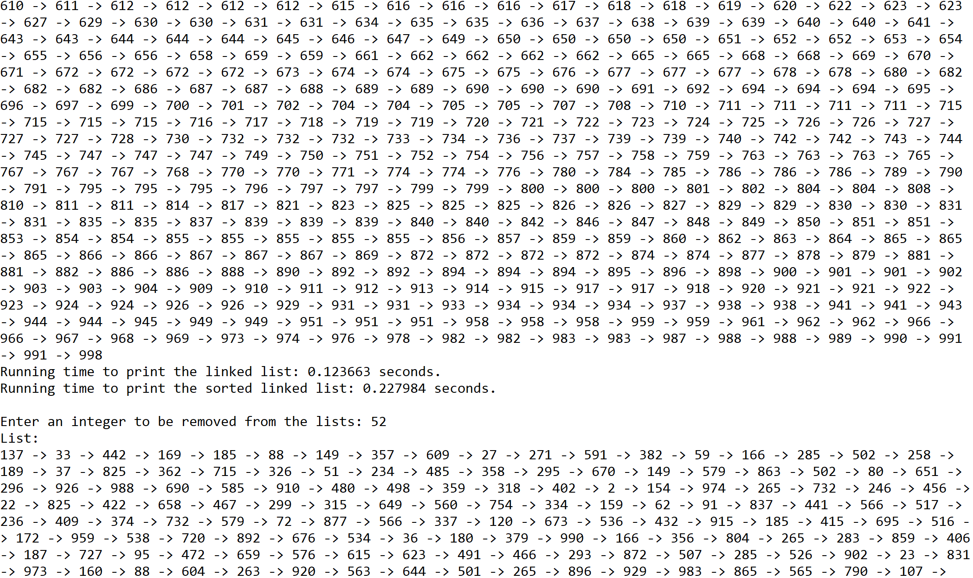

Case 5: Size of list = 5000

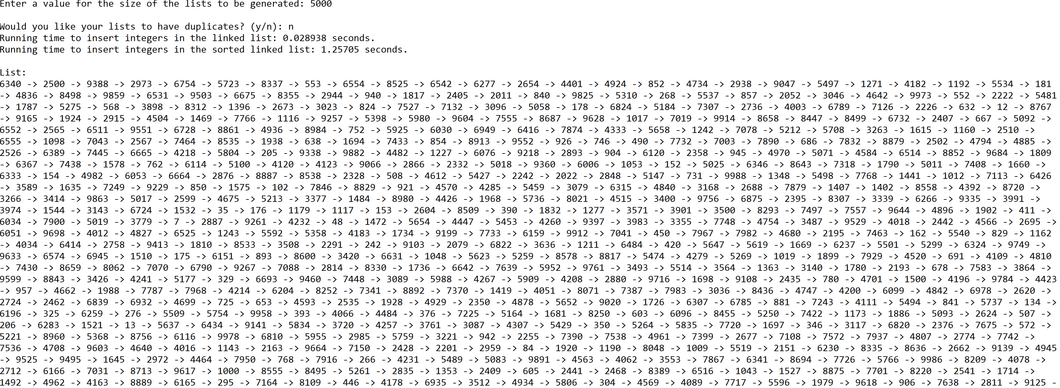

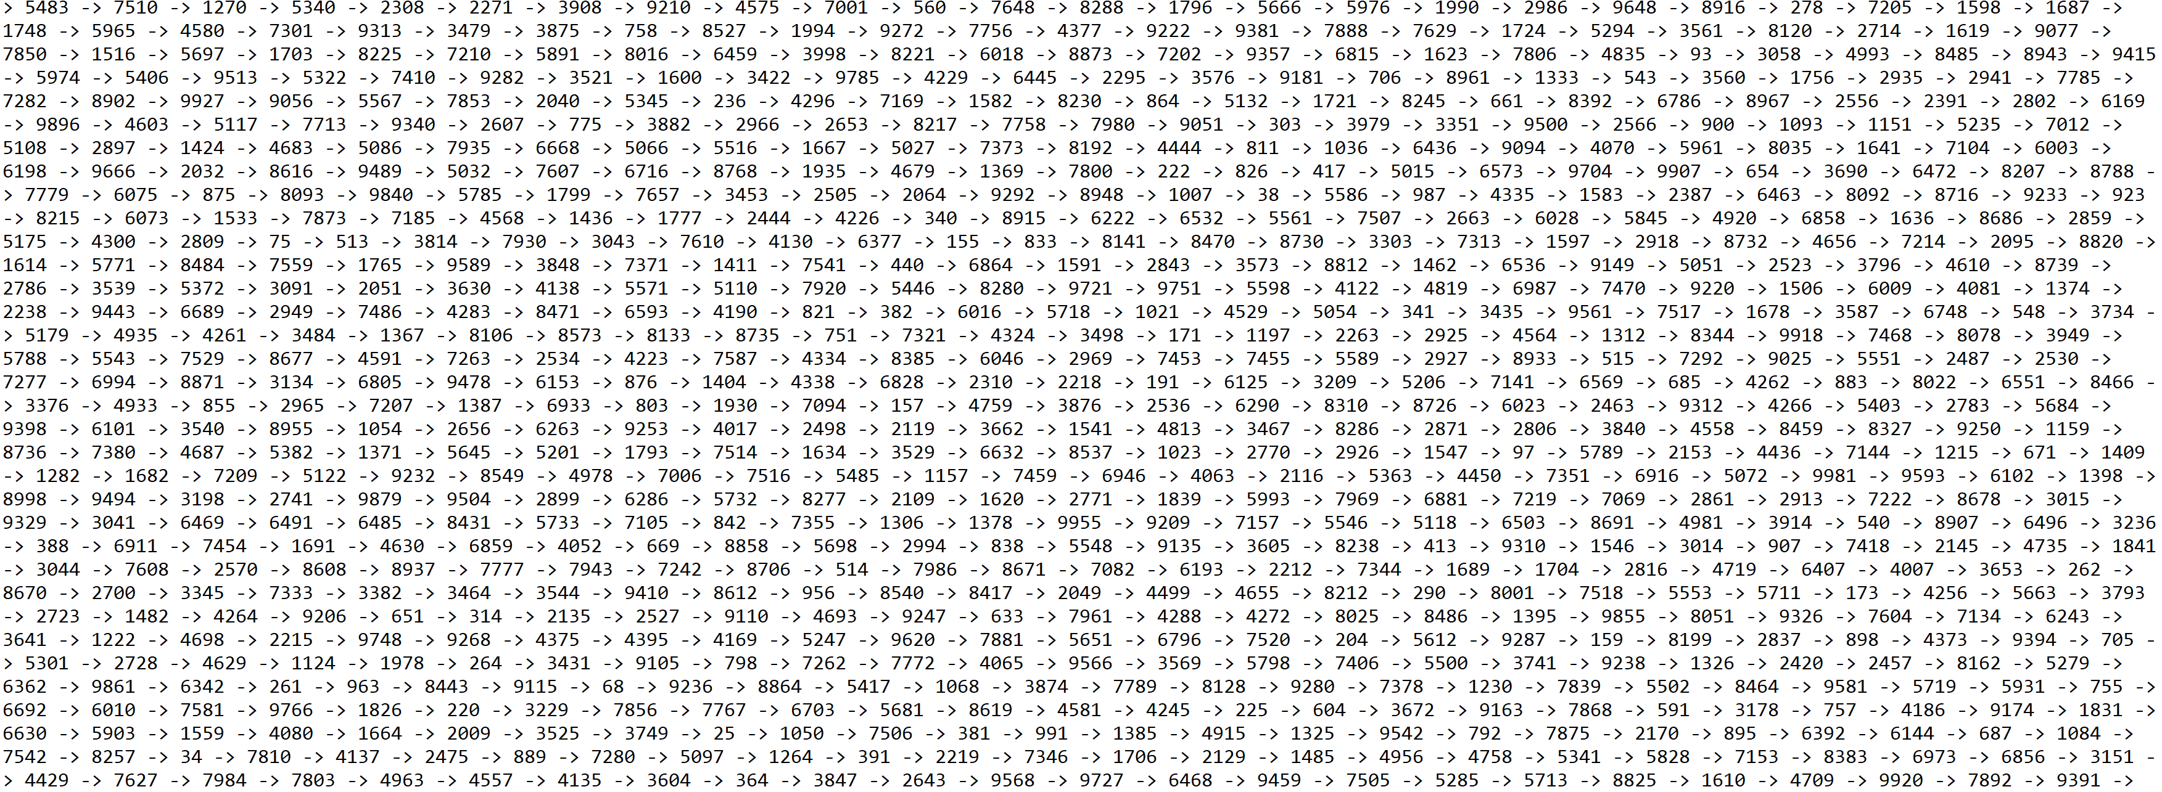

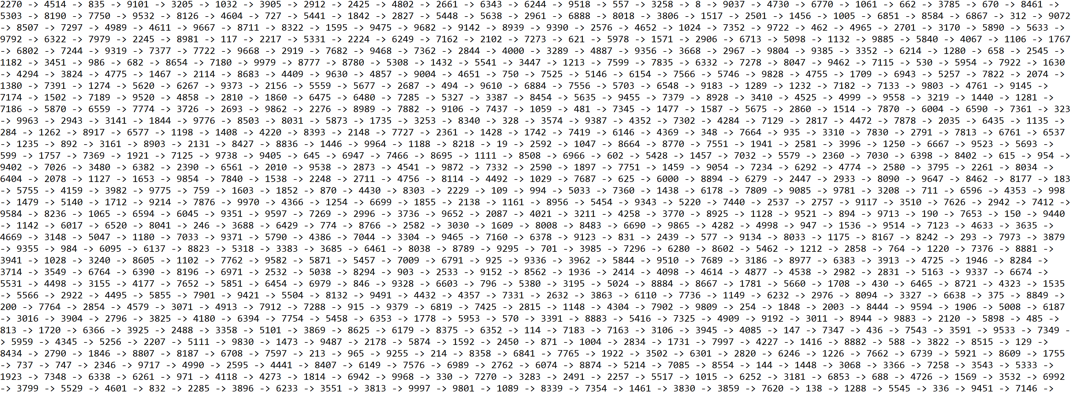

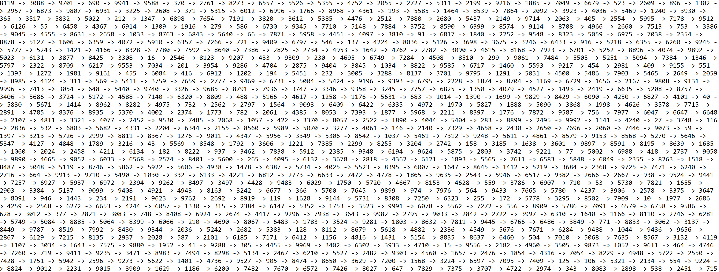

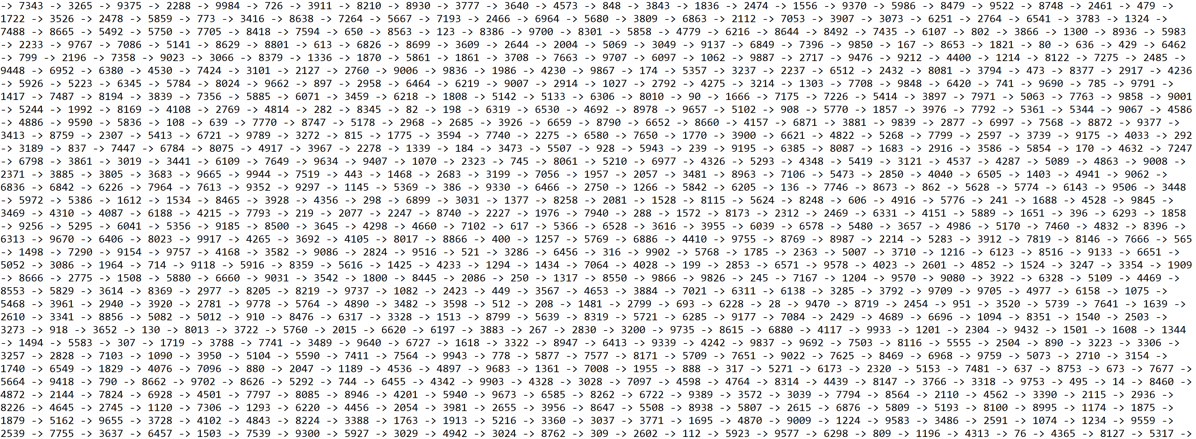

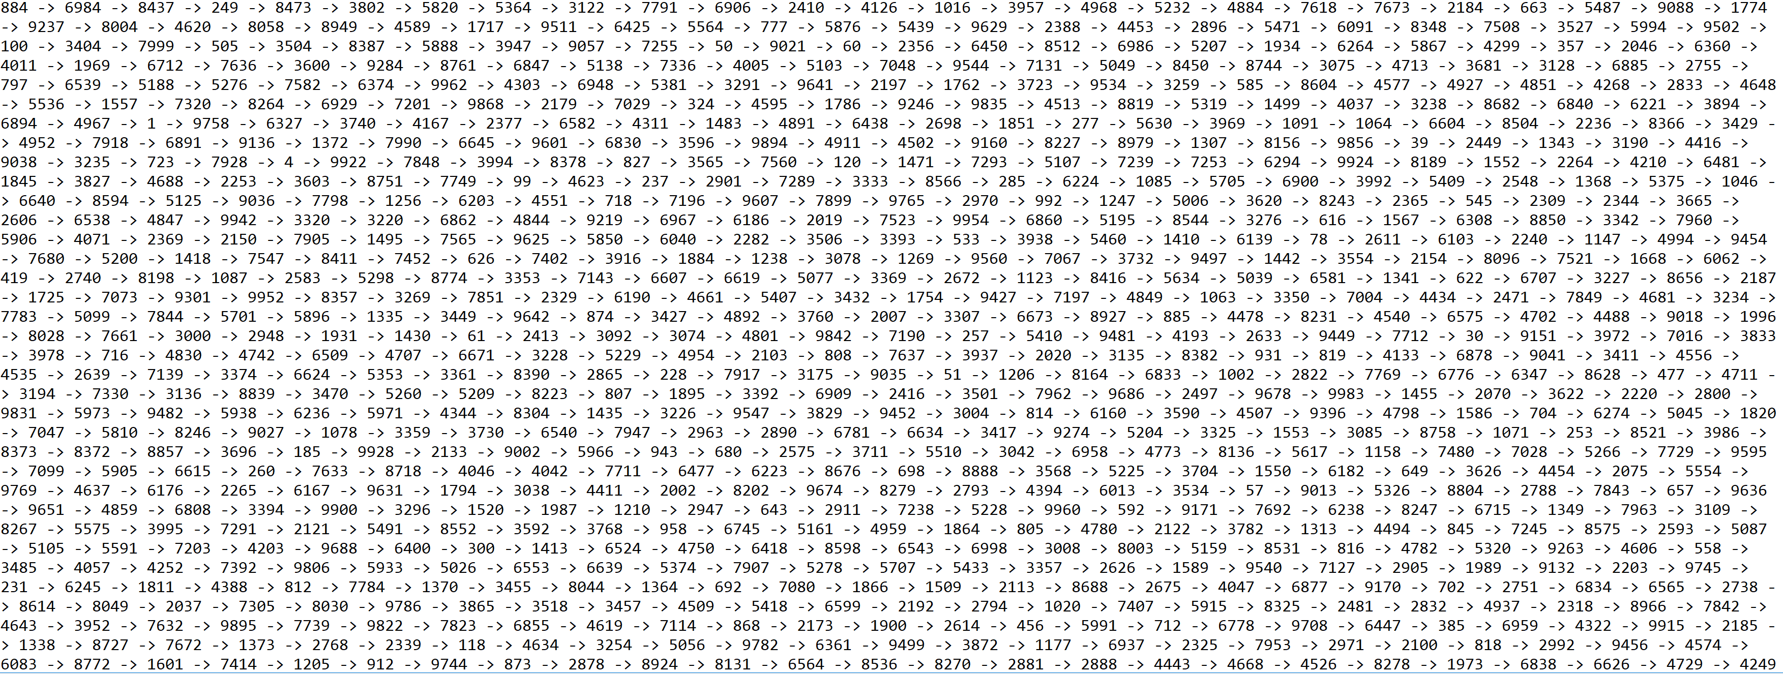

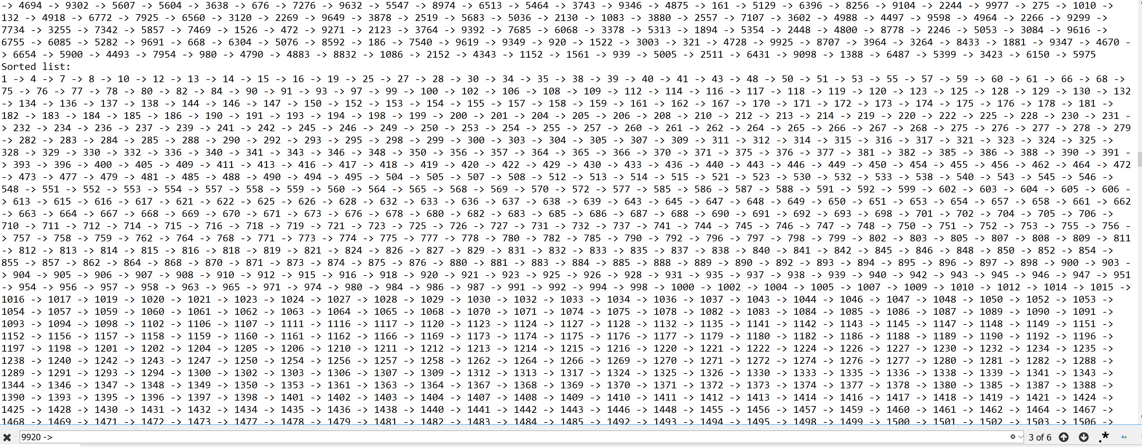

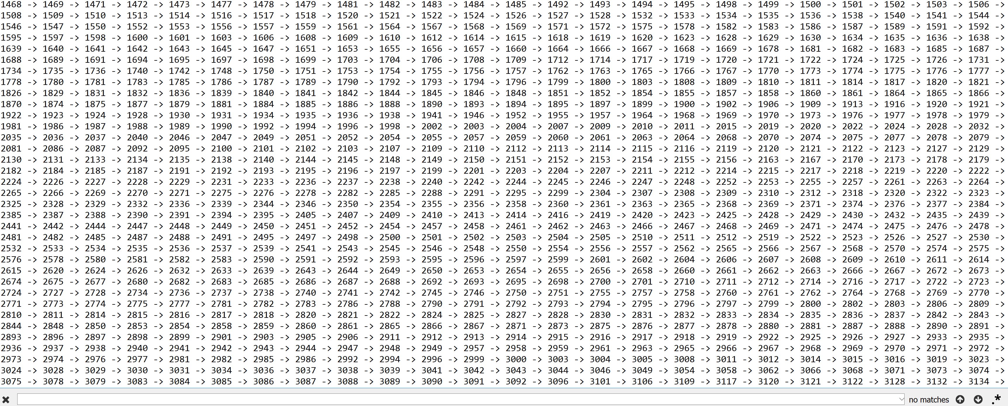

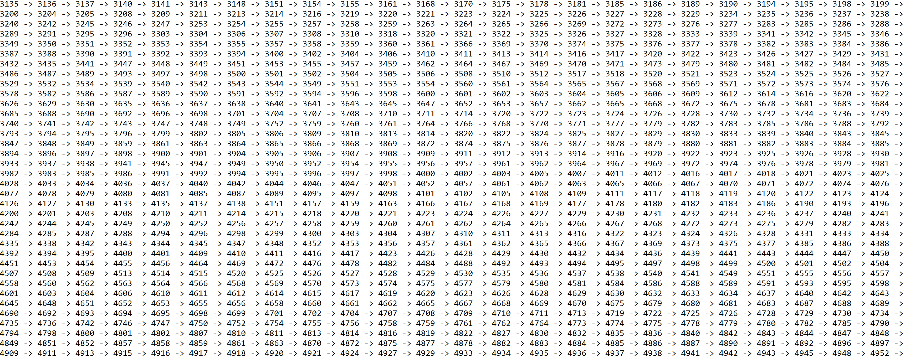

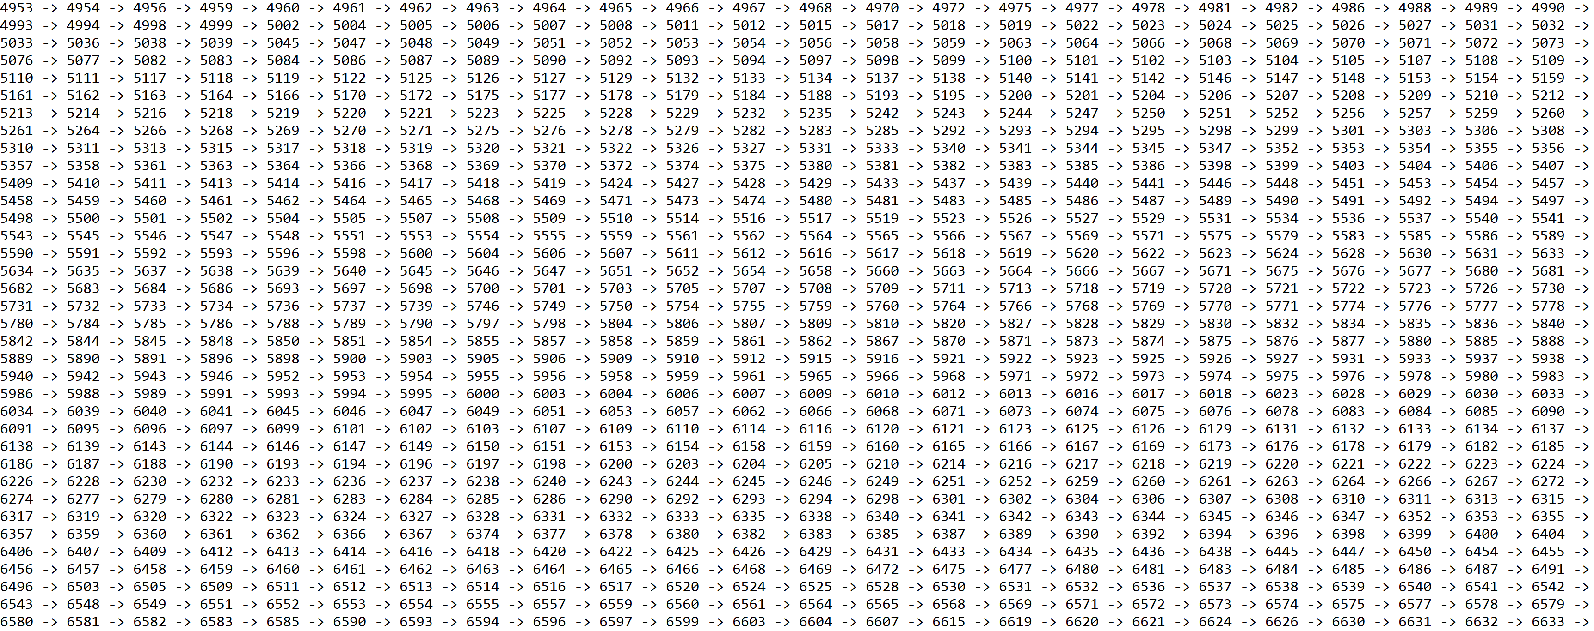

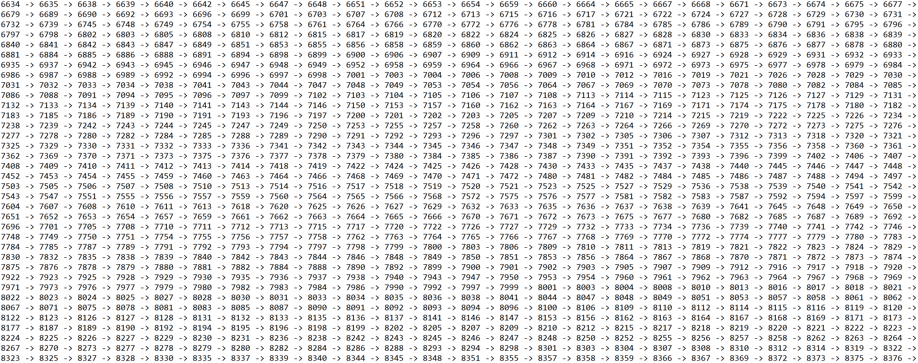

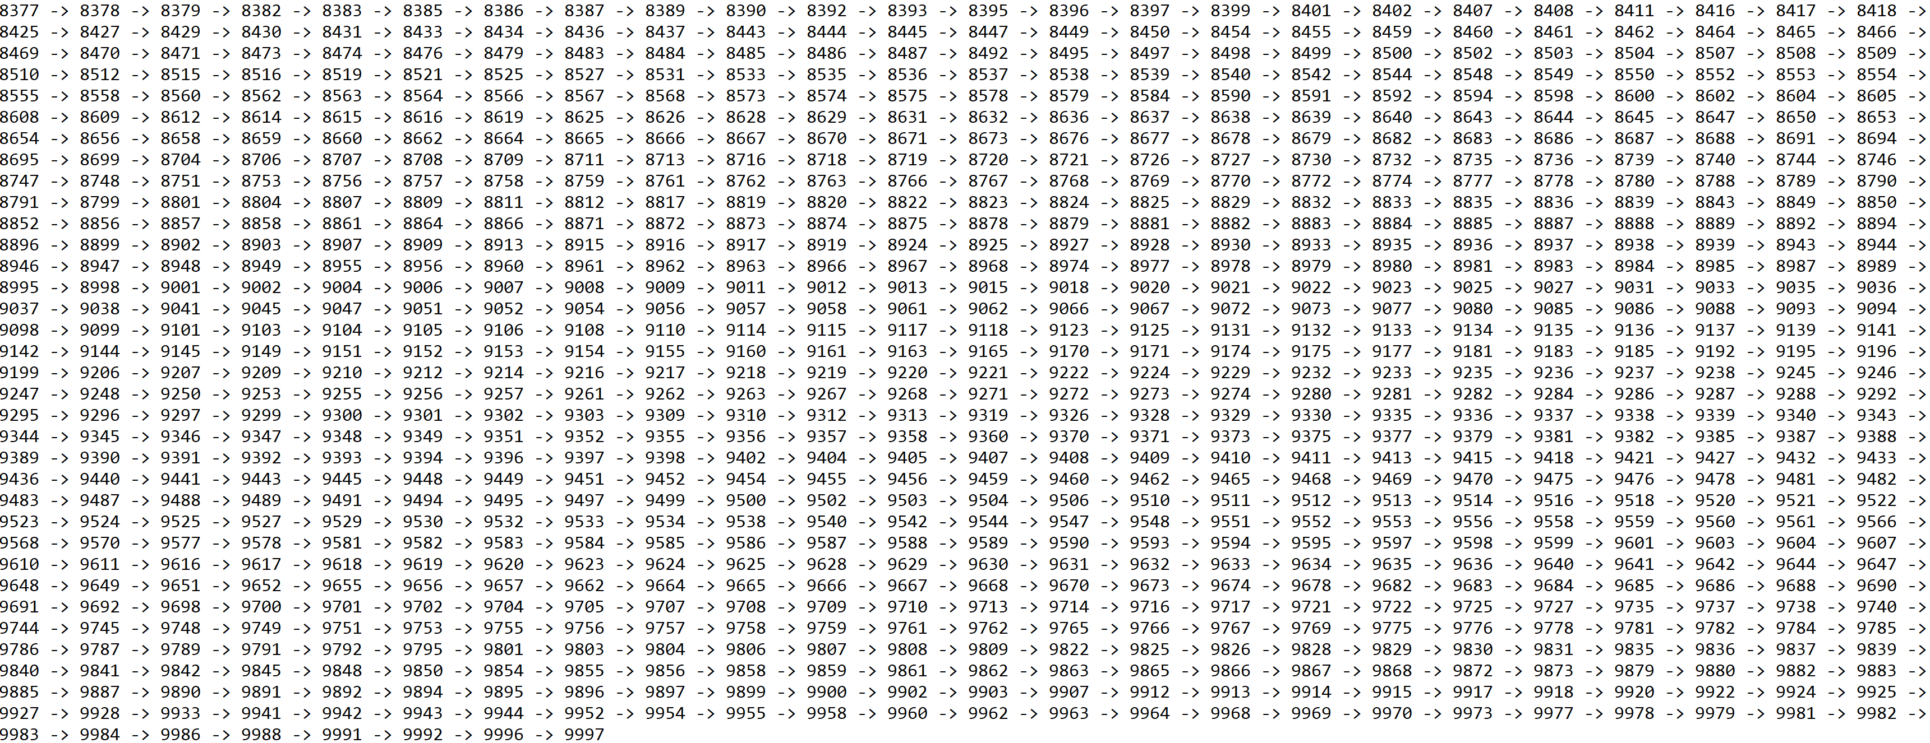

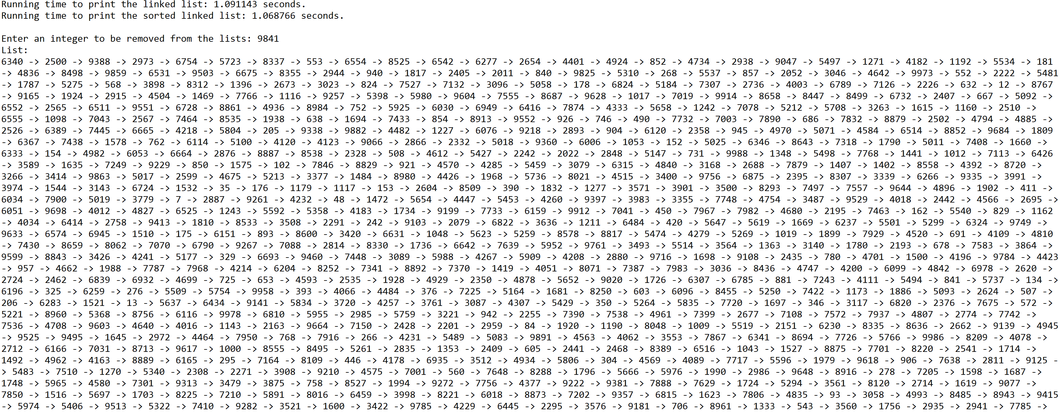

**Operation #2:**

For this operation, I will test randomly generated lists of integers of sizes 50, 100, 500, 1000, and 5000.

Case 1: Size of list = 50



Case 2: Size of list = 100



Case 3: Size of list = 500



Case 4: Size of list = 1000



Case 5: Size of list = 5000



**Operation #3:**

For this operation, I will test randomly generated lists of integers of sizes 50, 100, 500, 1000, and 5000. Additionally, I will test random integers to be deleted from both lists in each case.

Case 1: Size of list = 50, i = 55



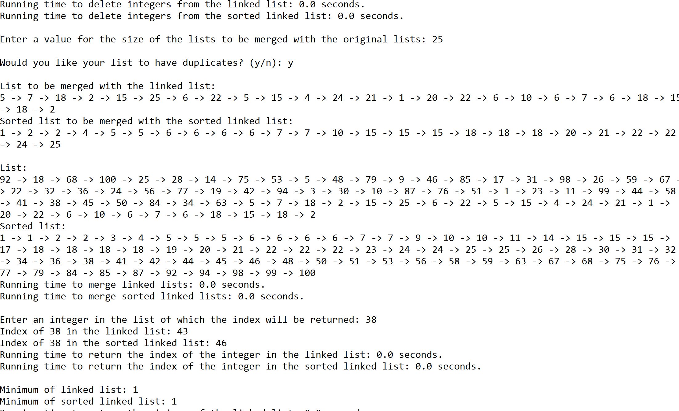

Case 2: Size of list = 100, i = 77



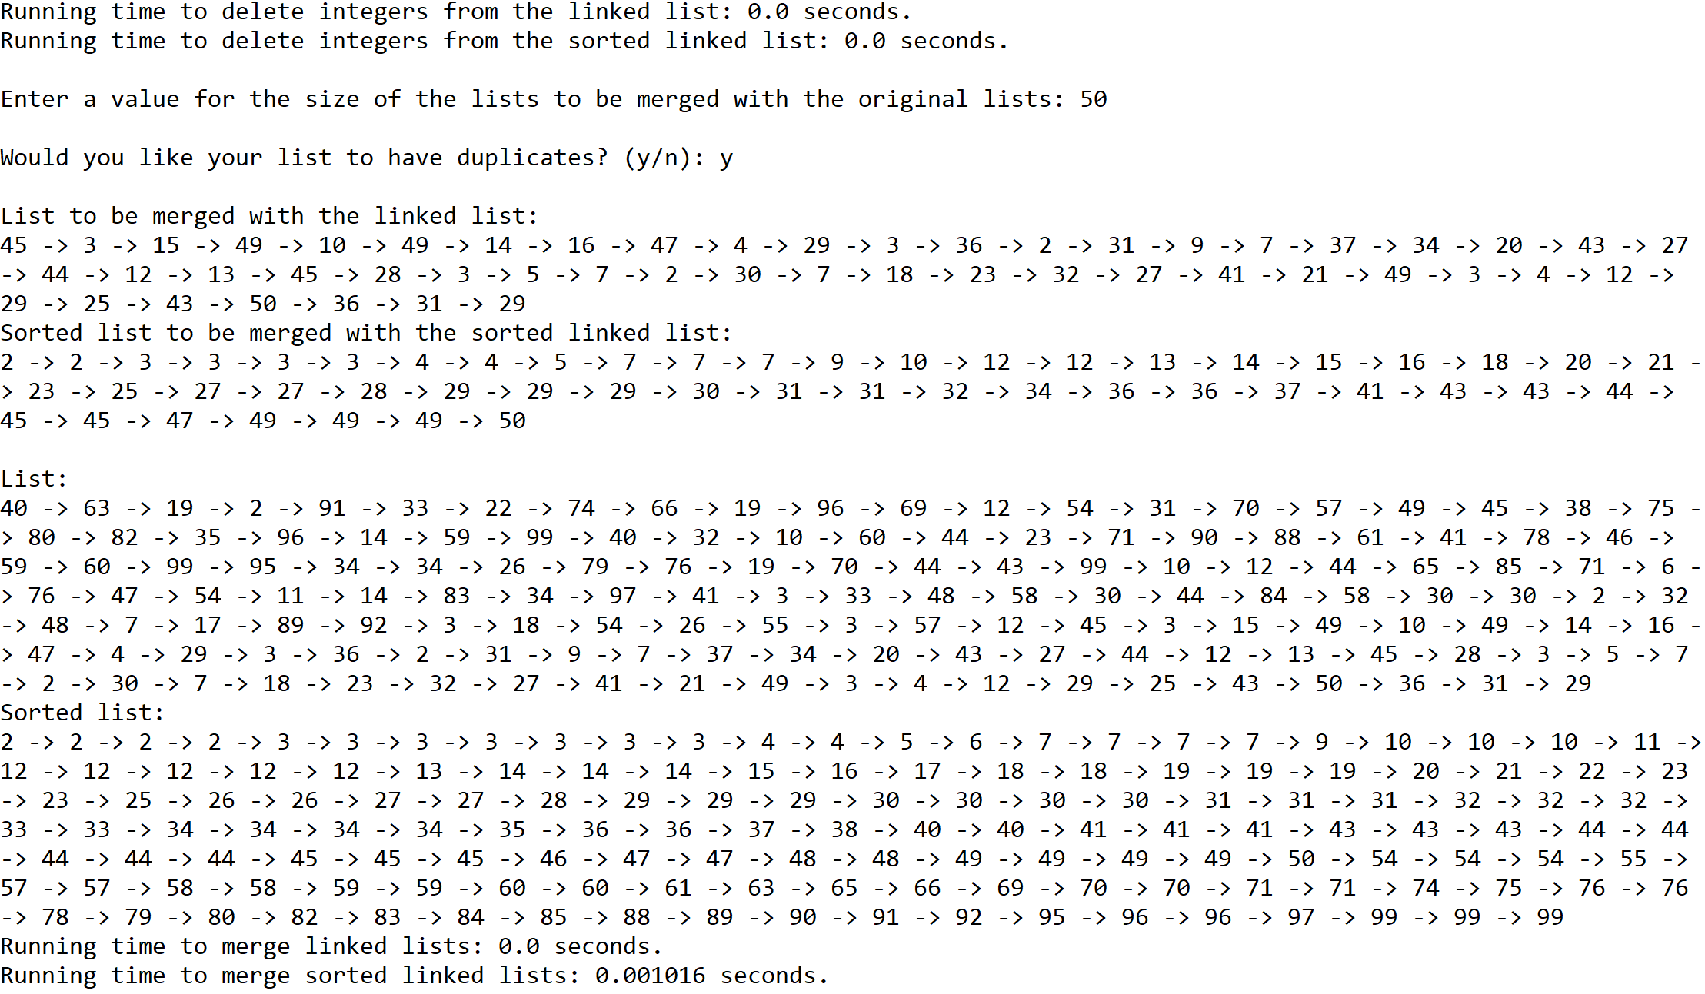

Case 3: Size of list = 500, i = 980



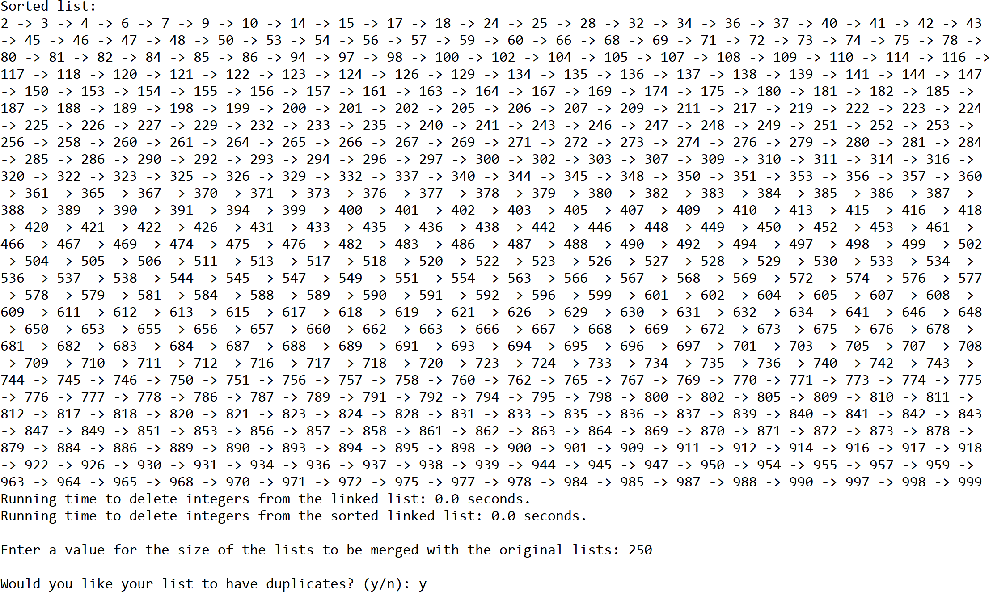

Case 4: Size of list = 1000, i = 52



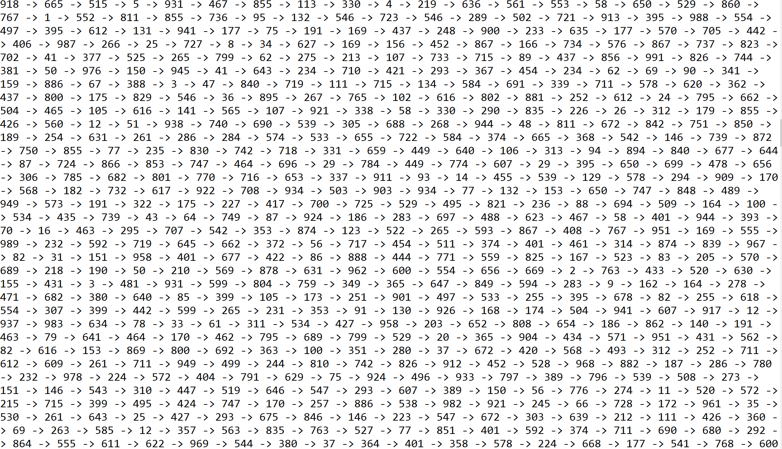

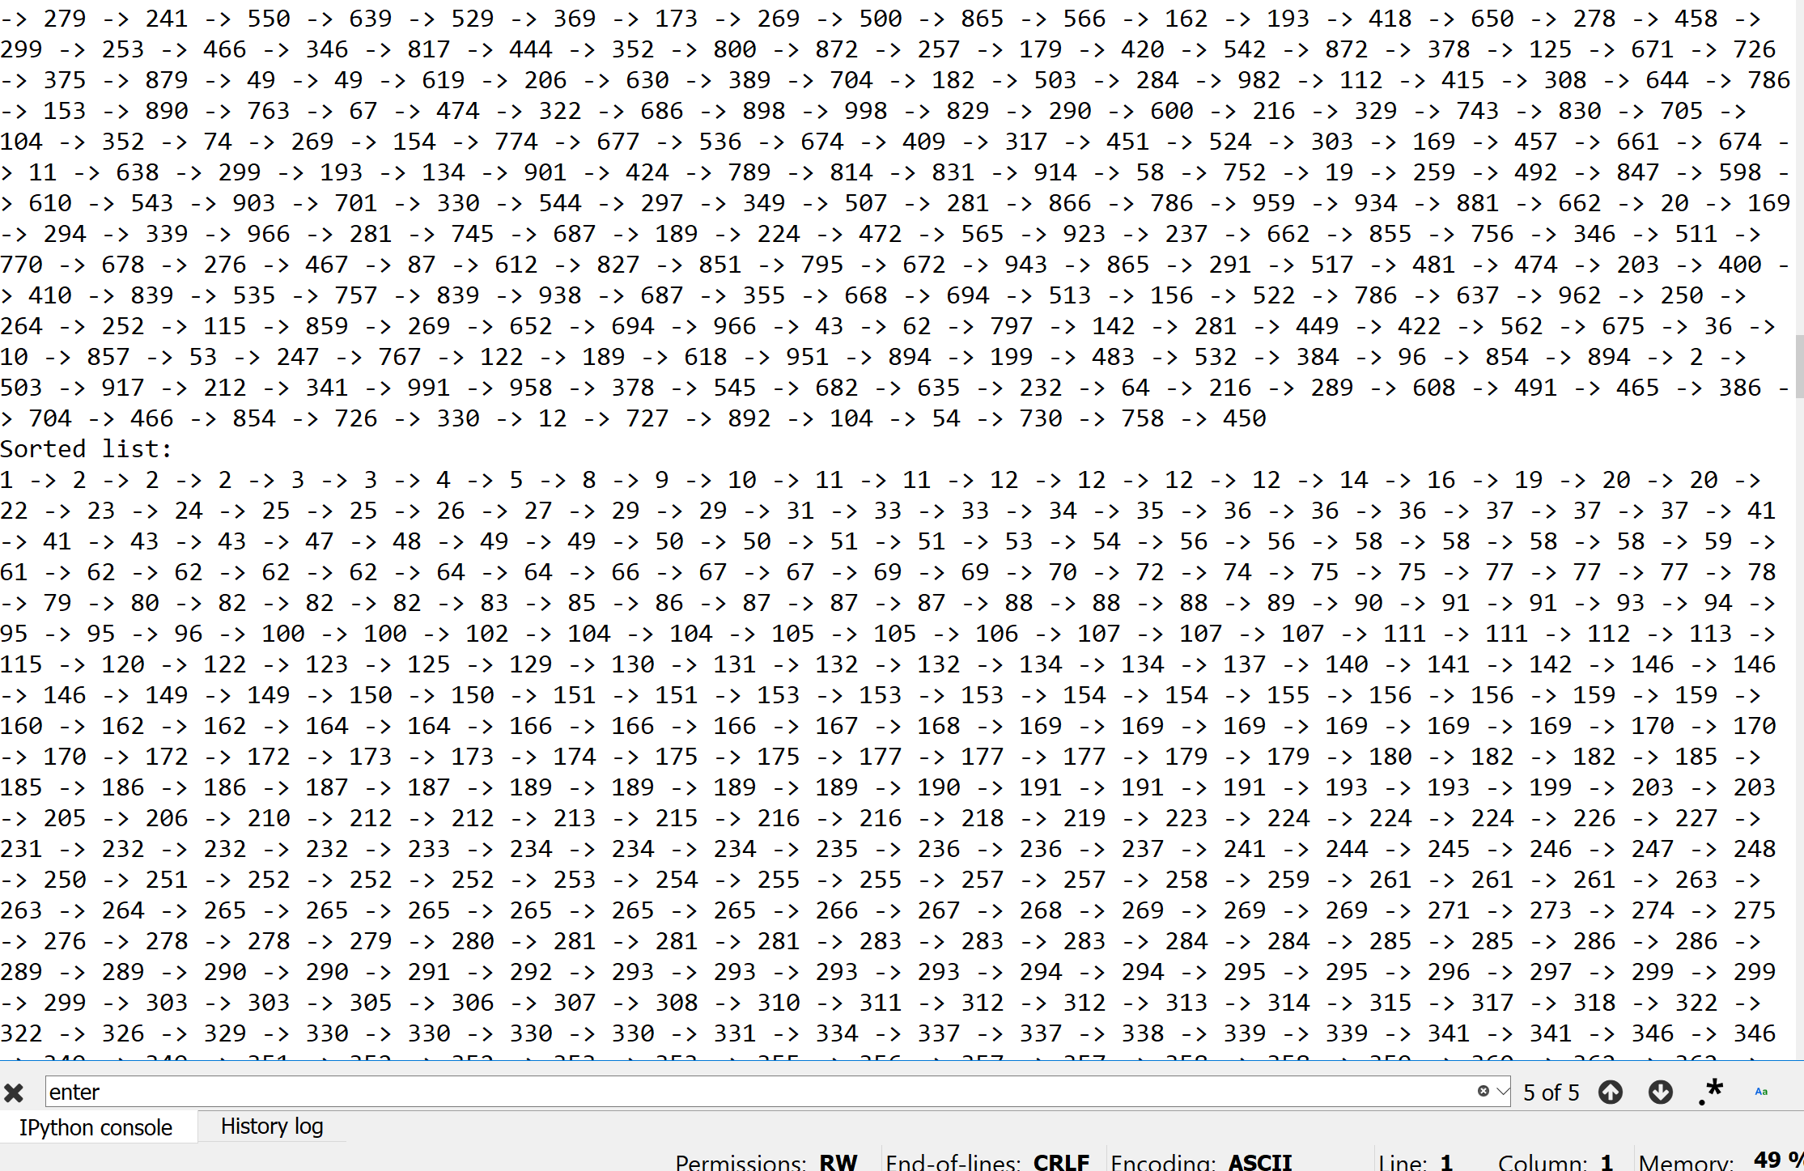

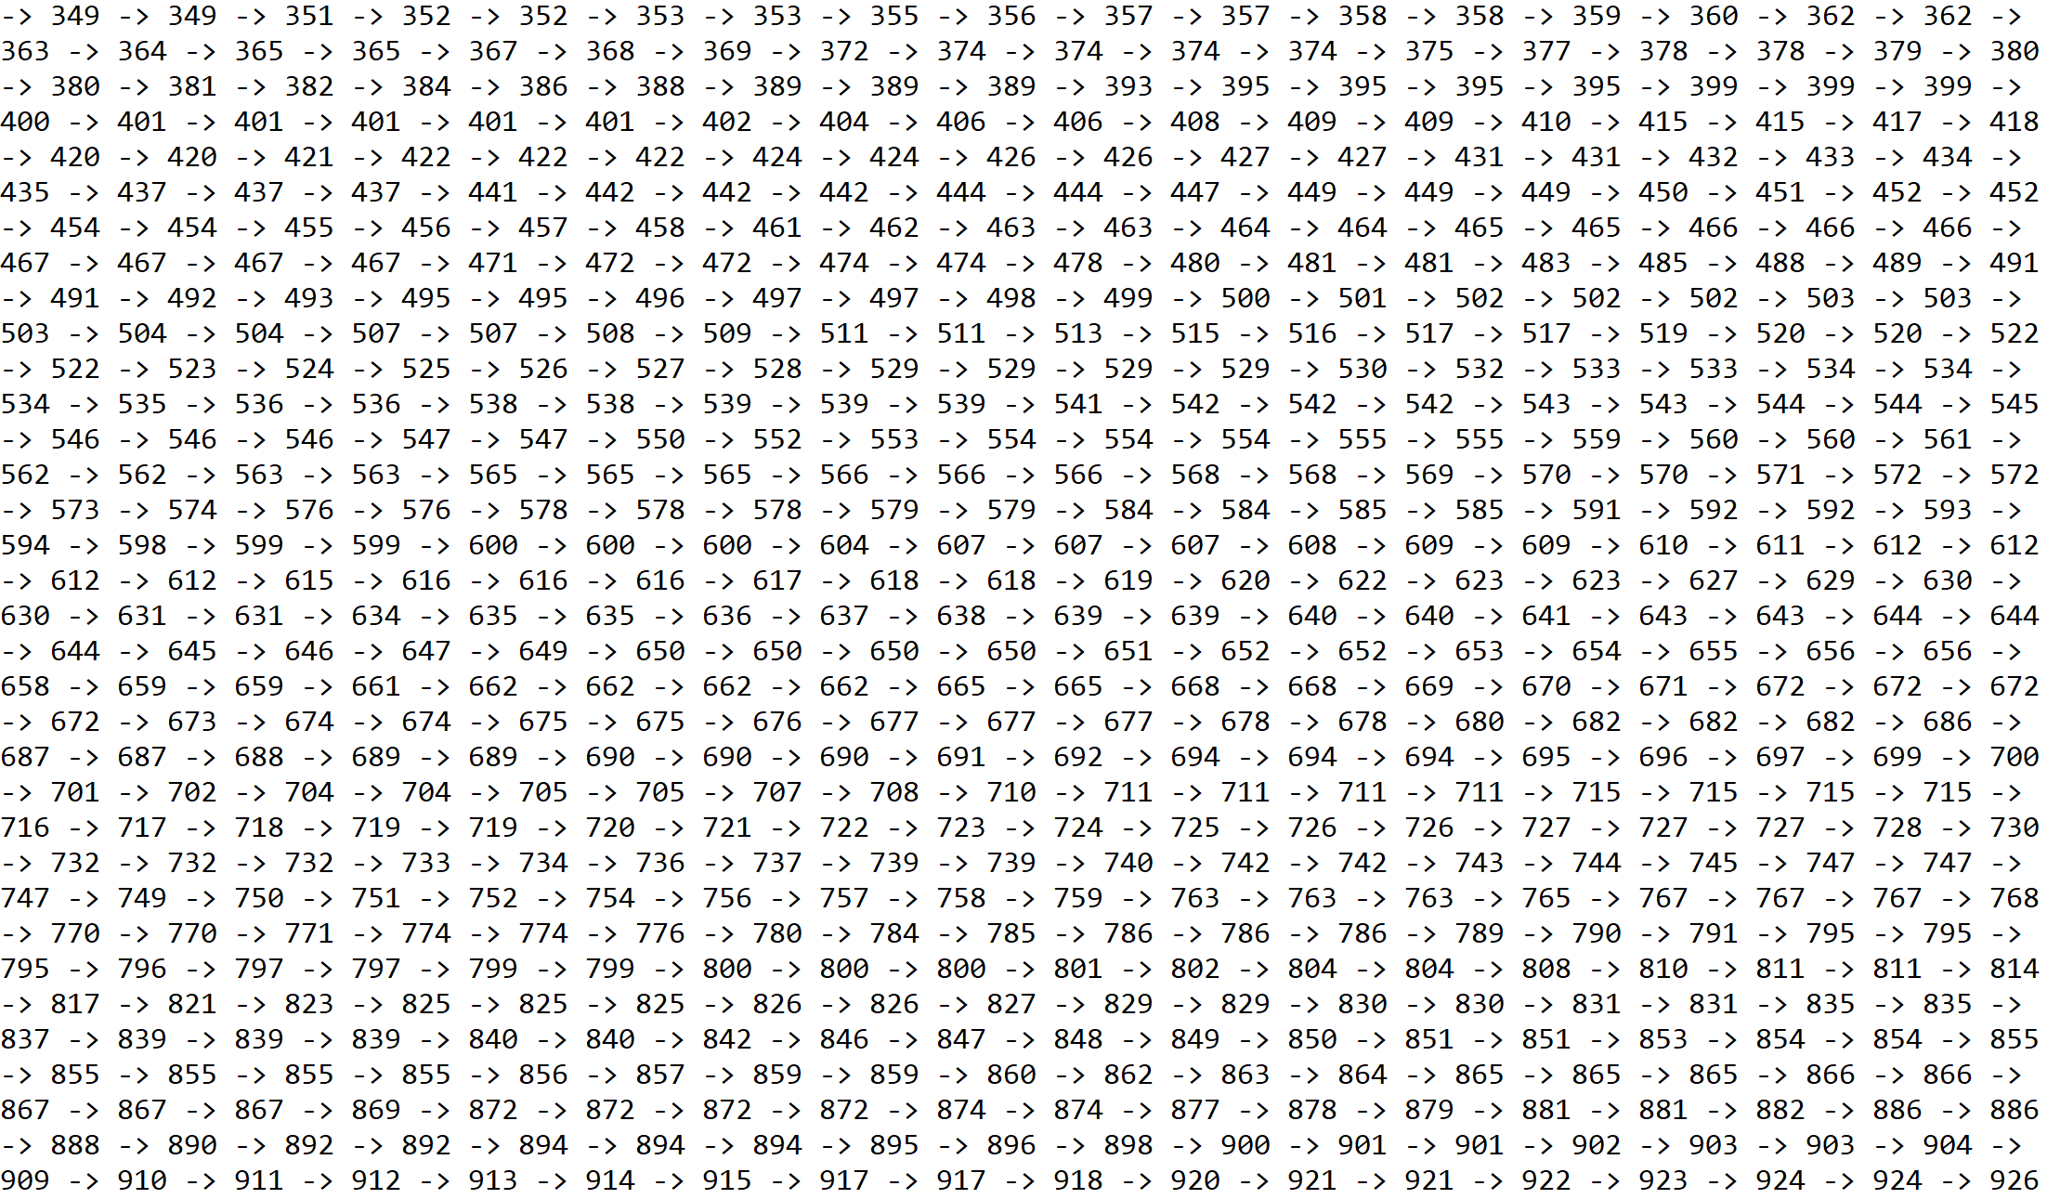

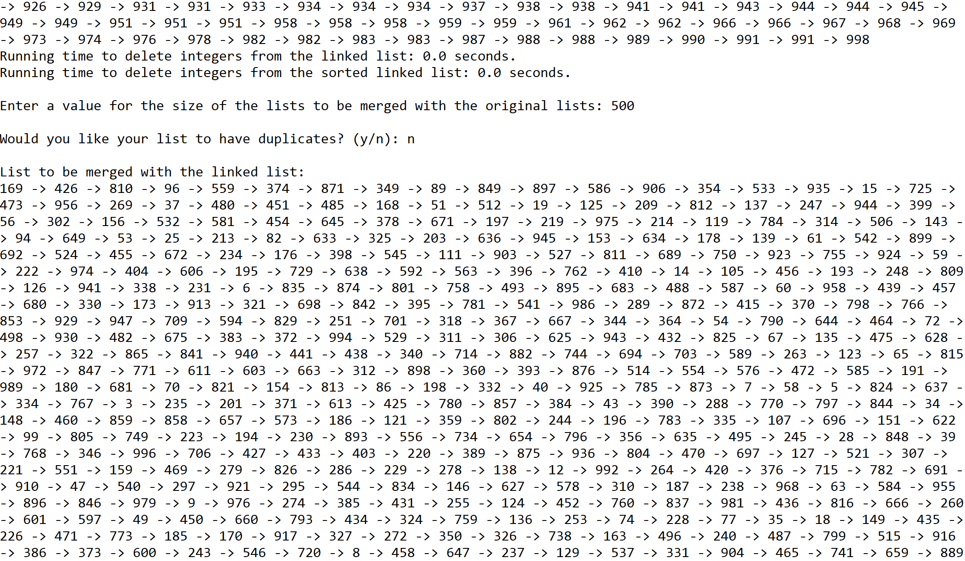

Case 5: Size of list = 5000, i = 9841



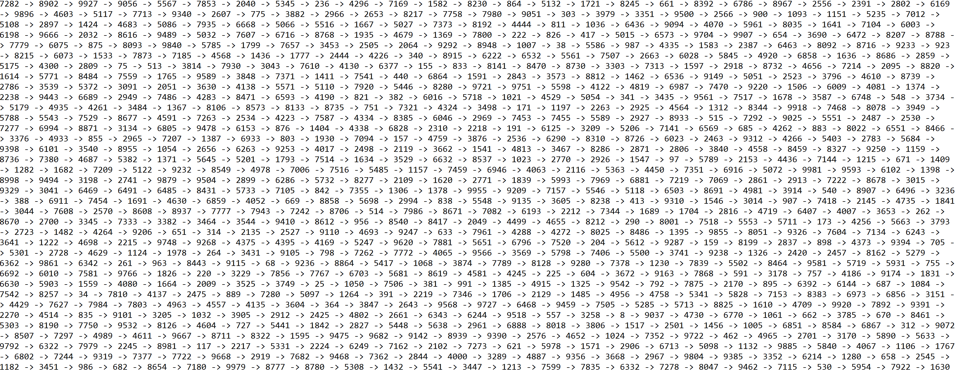

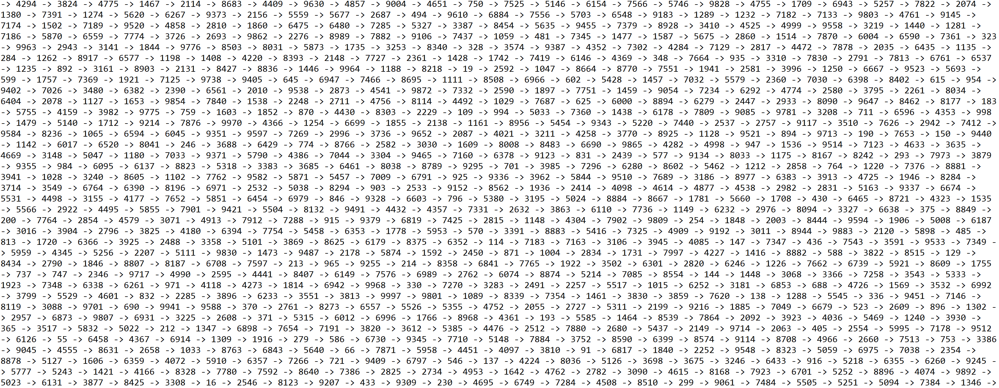

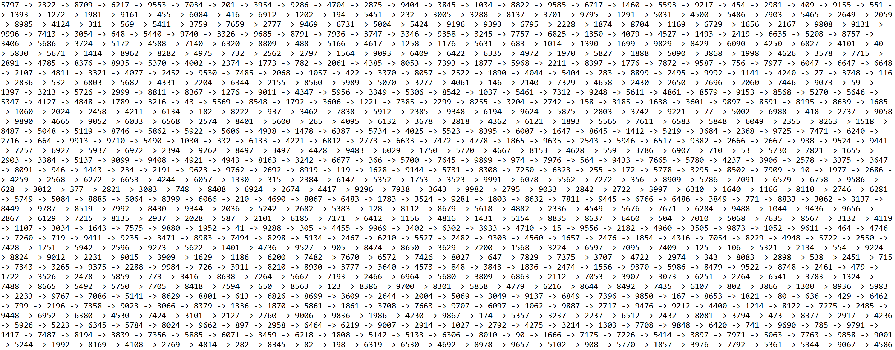

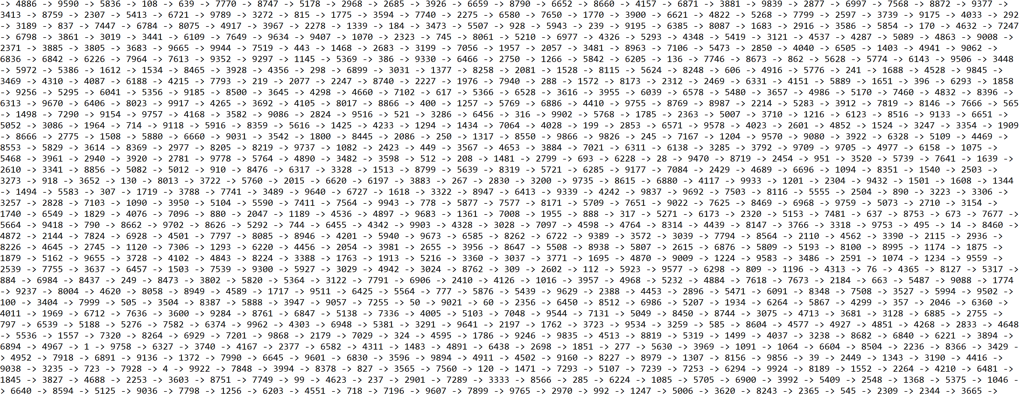

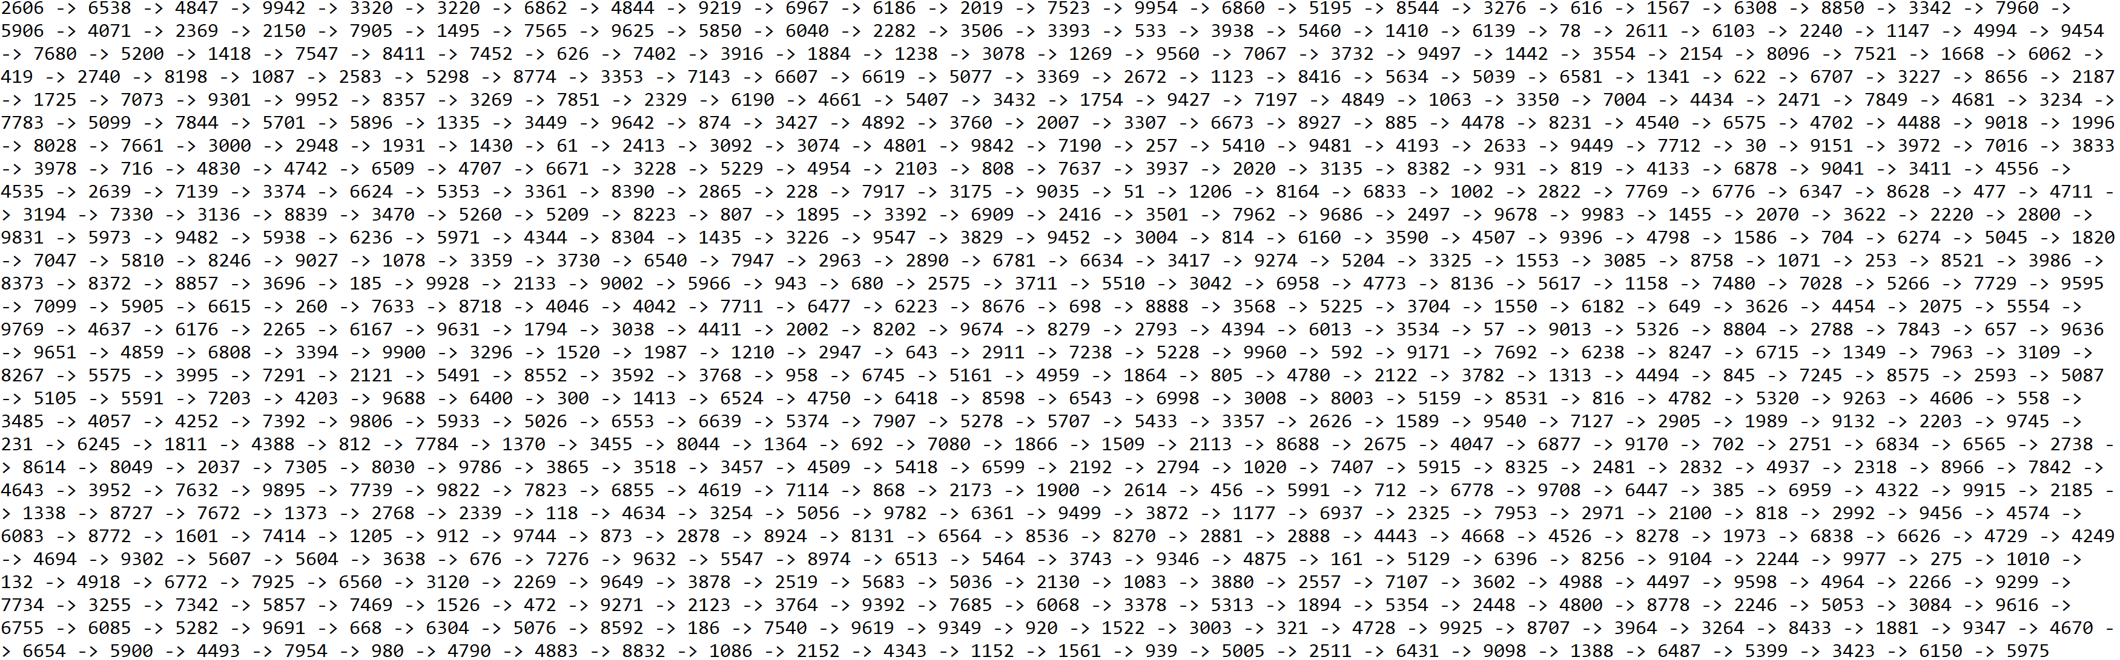

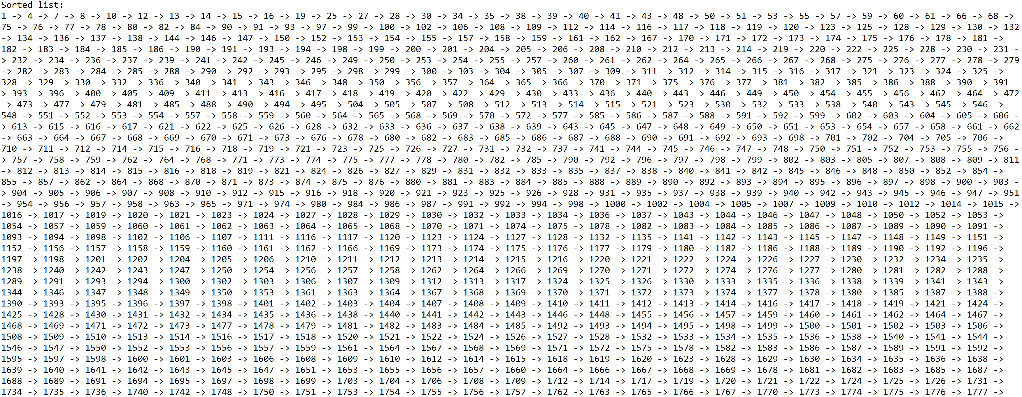

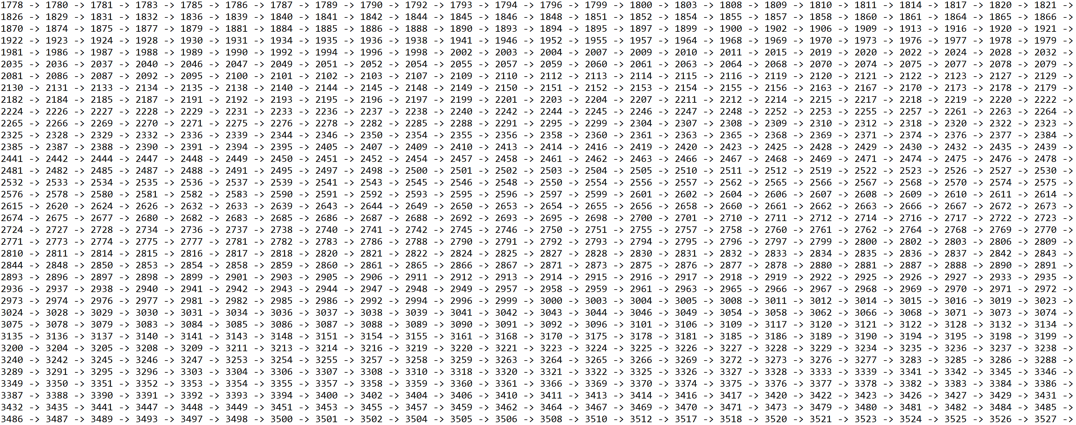

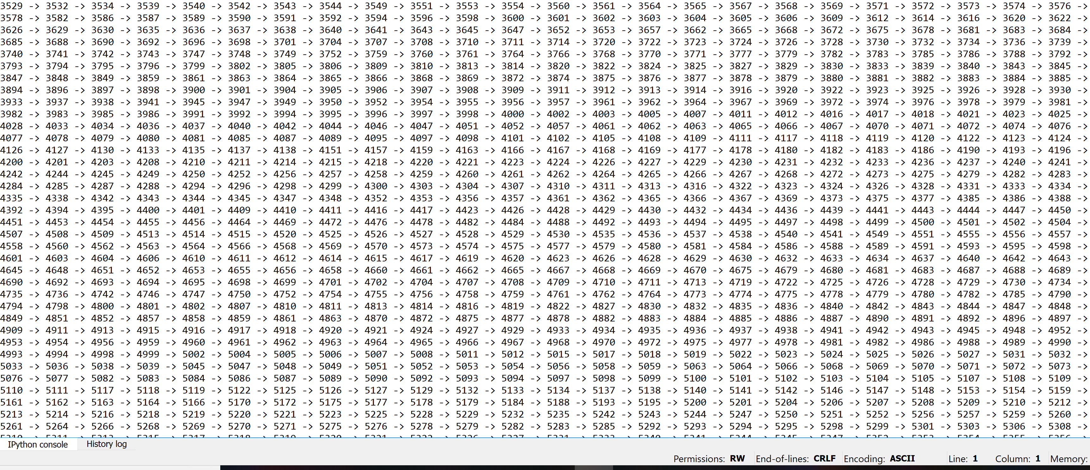

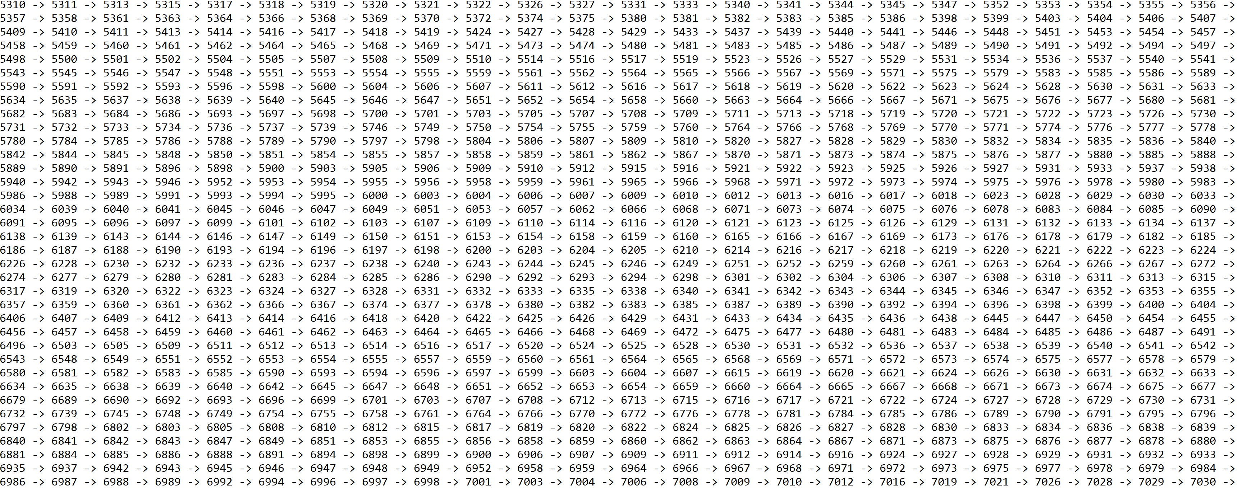

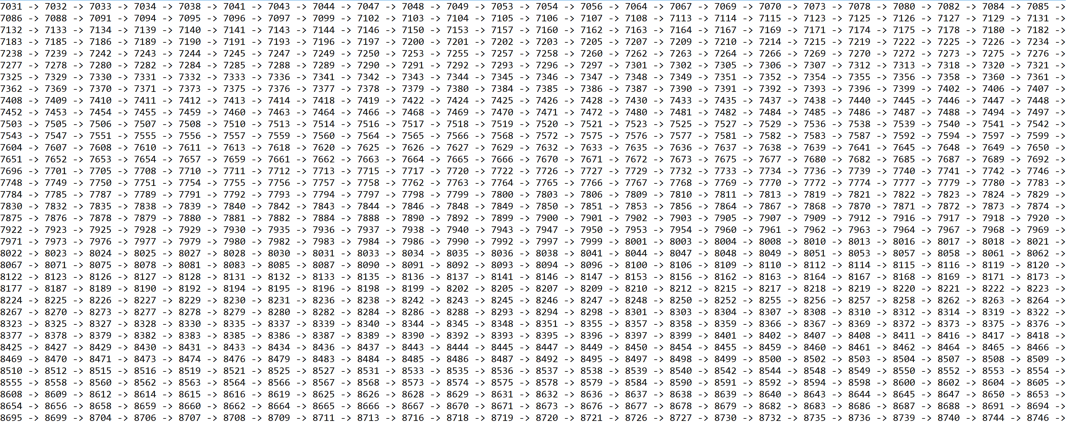

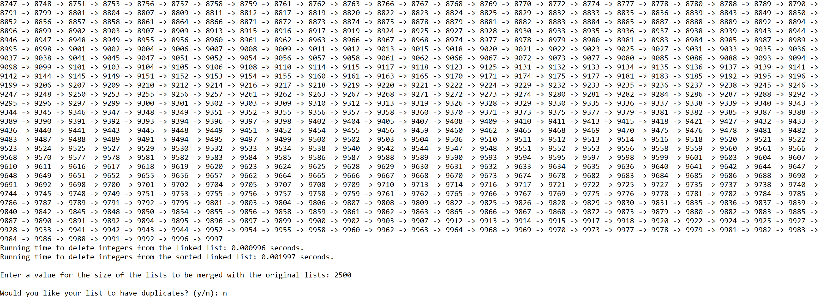

**Operation #4:**

For this operation, I will test randomly generated lists of integers of sizes 50, 100, 500, 1000, and 5000. Additionally, I will test this operation to merge a second list that is half the size of the original two lists.

Case 1: Size of list = 50, size of list to be merged with original list = 25



Case 2: Size of list = 100, size of list to be merged with original list = 50



Case 3: Size of list = 500, size of list to be merged with original list = 250



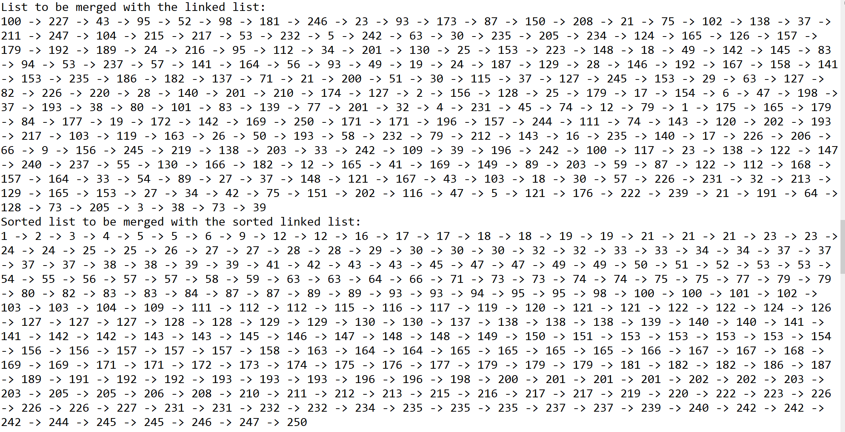

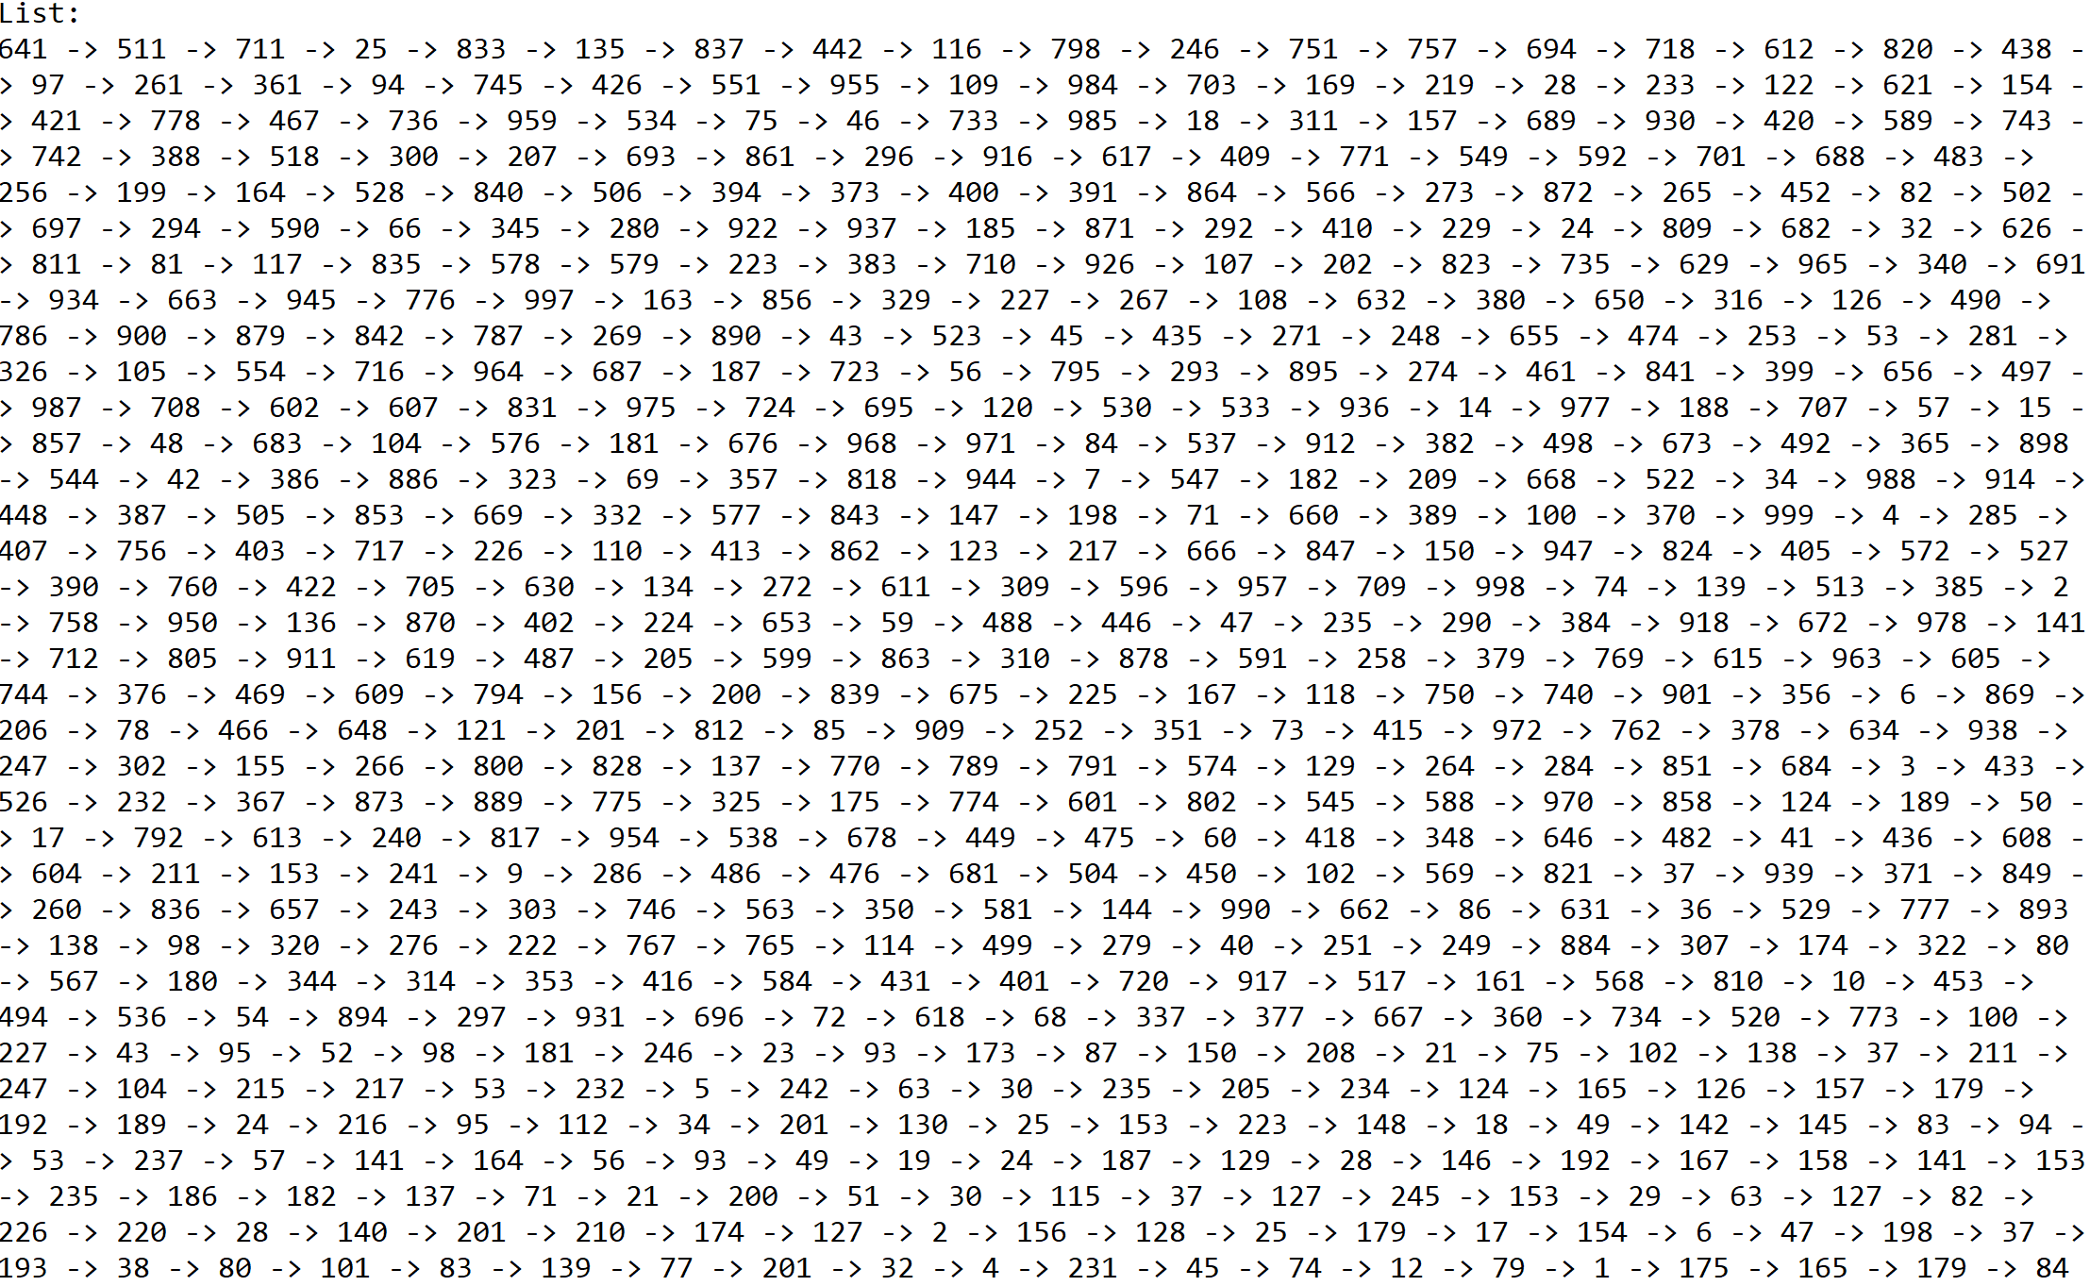

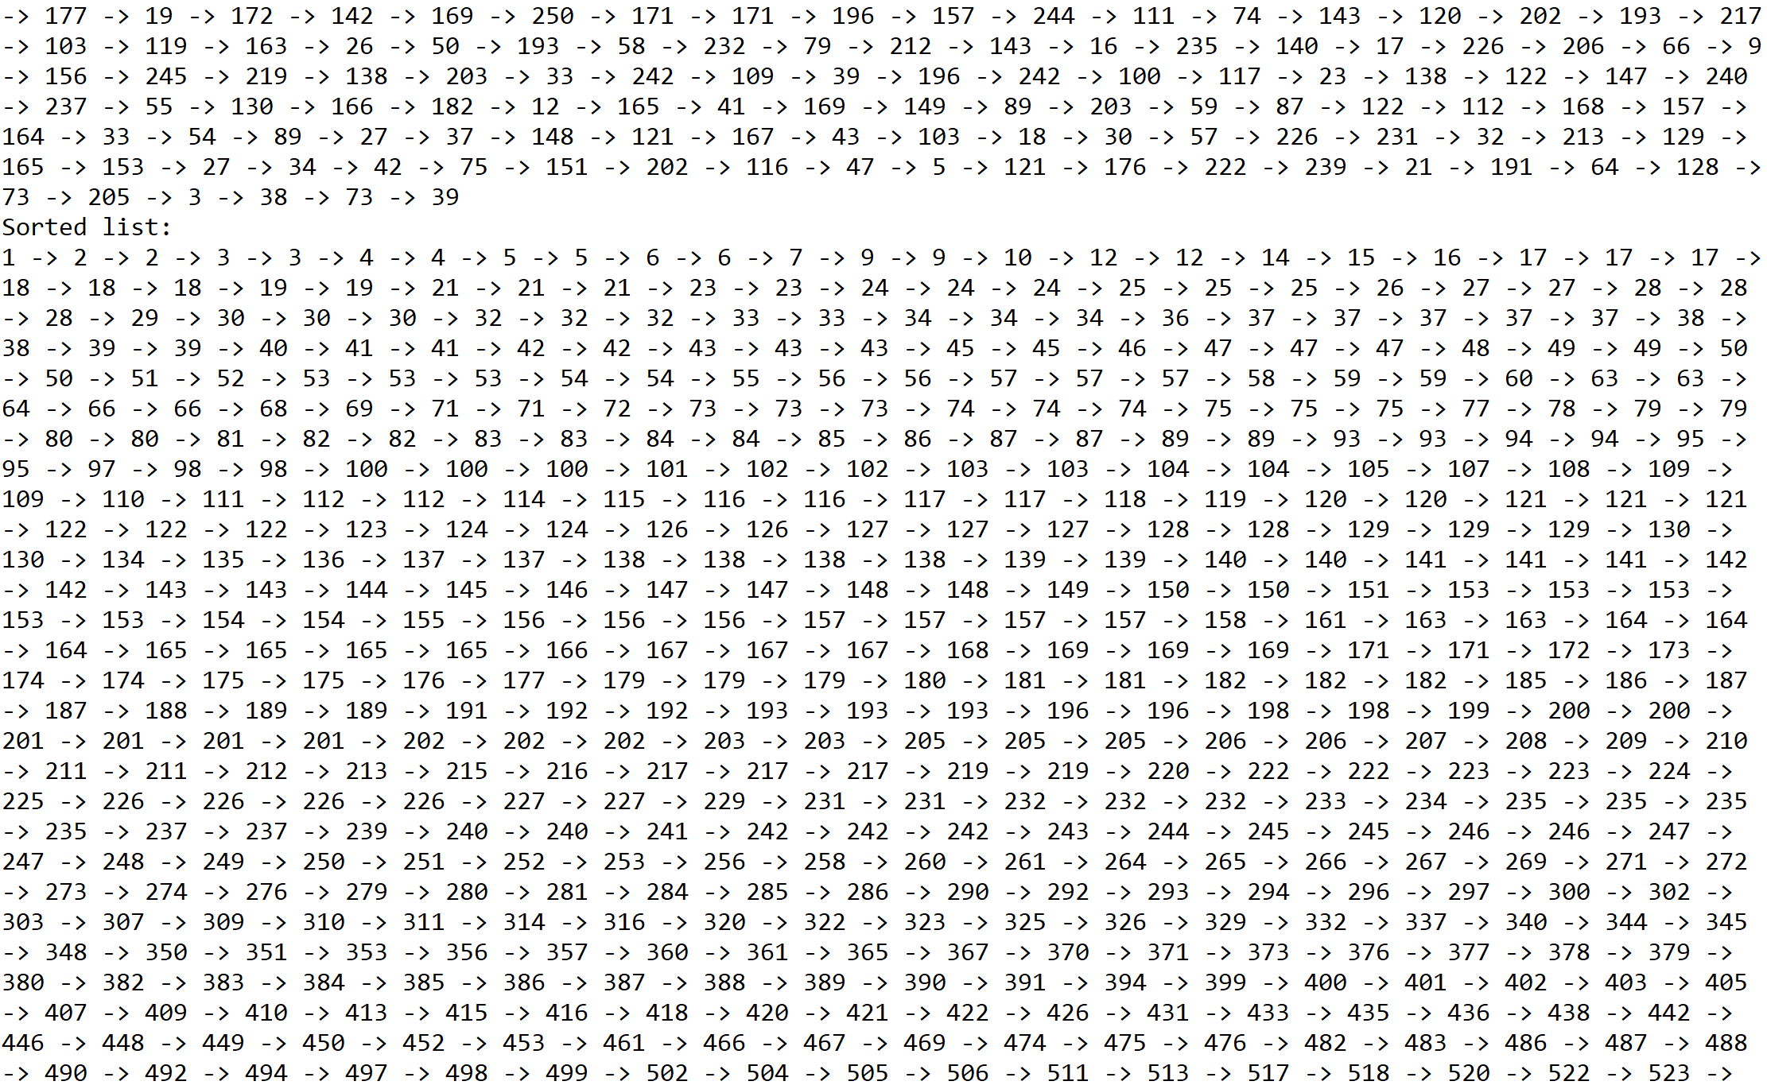

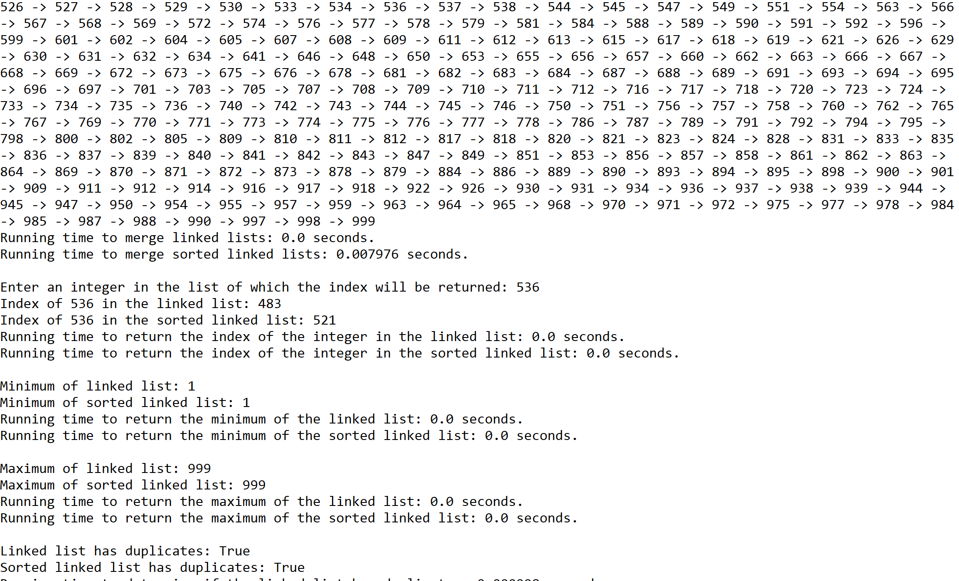

Case 4: Size of list = 1000, size of list to be merged with original list = 500



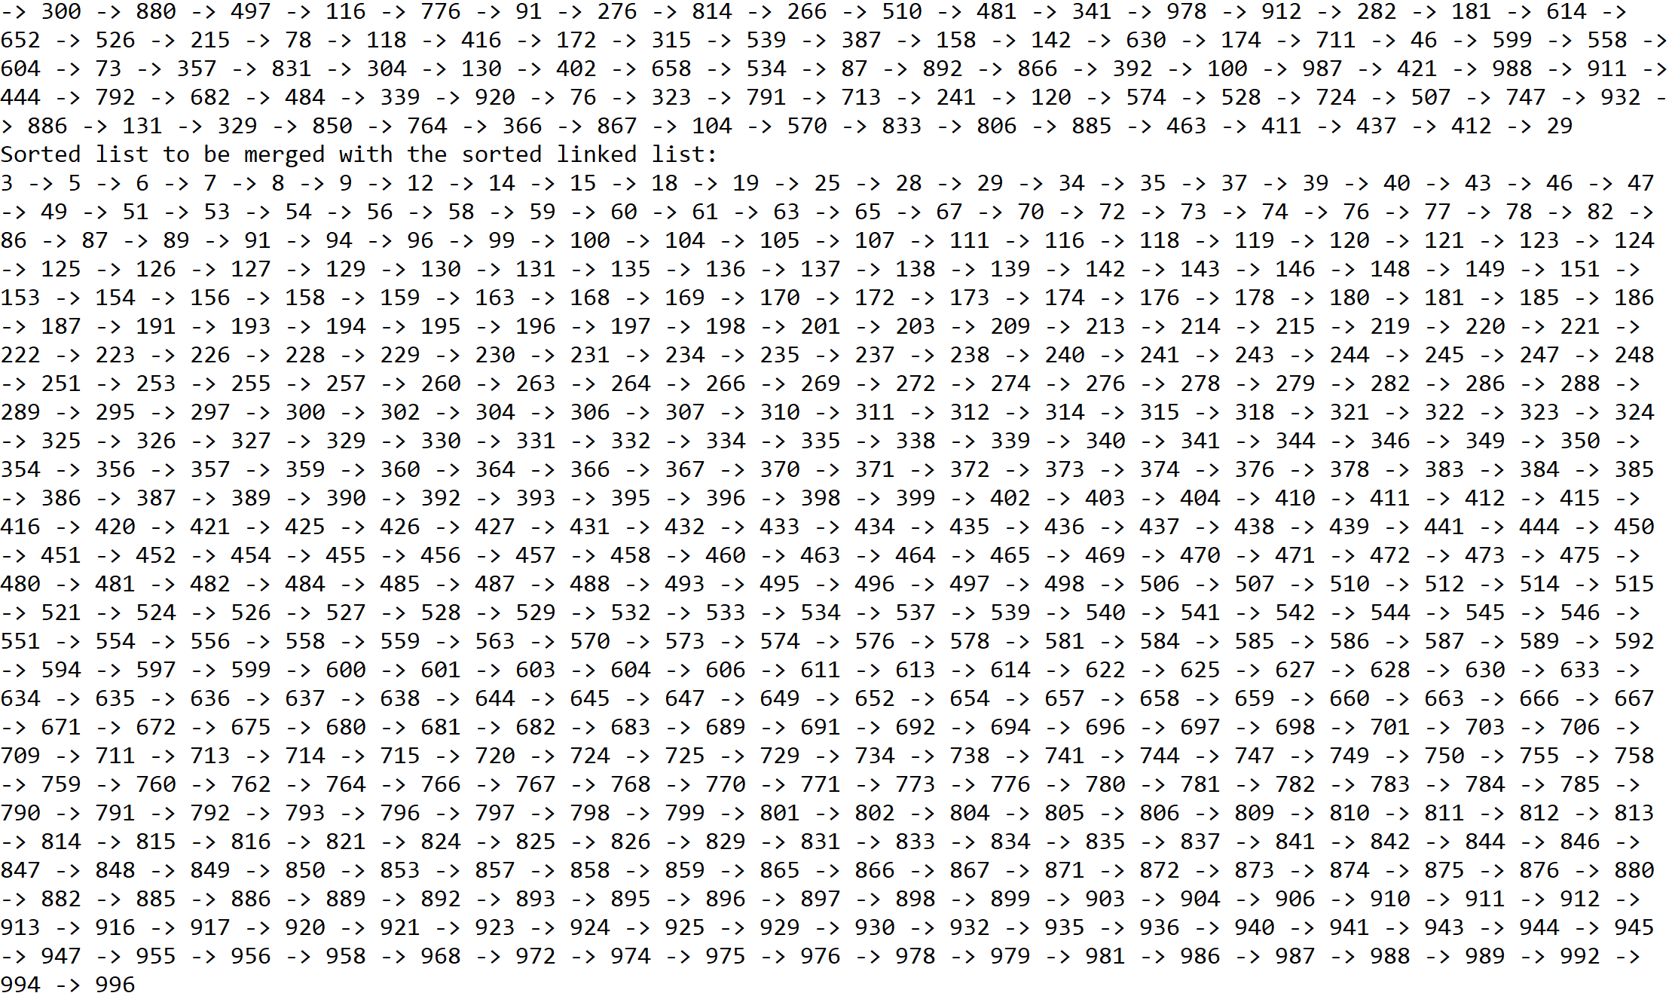

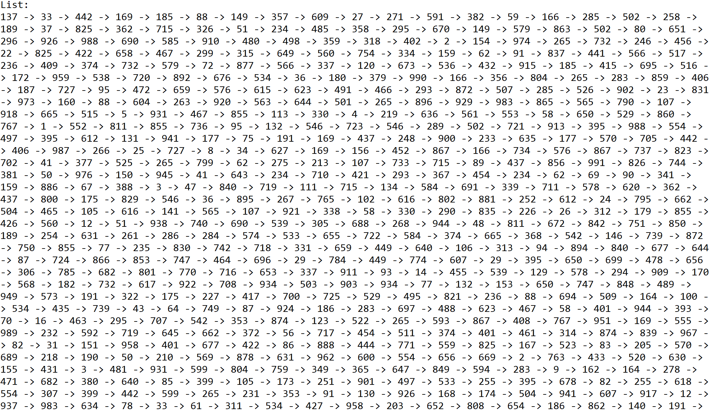

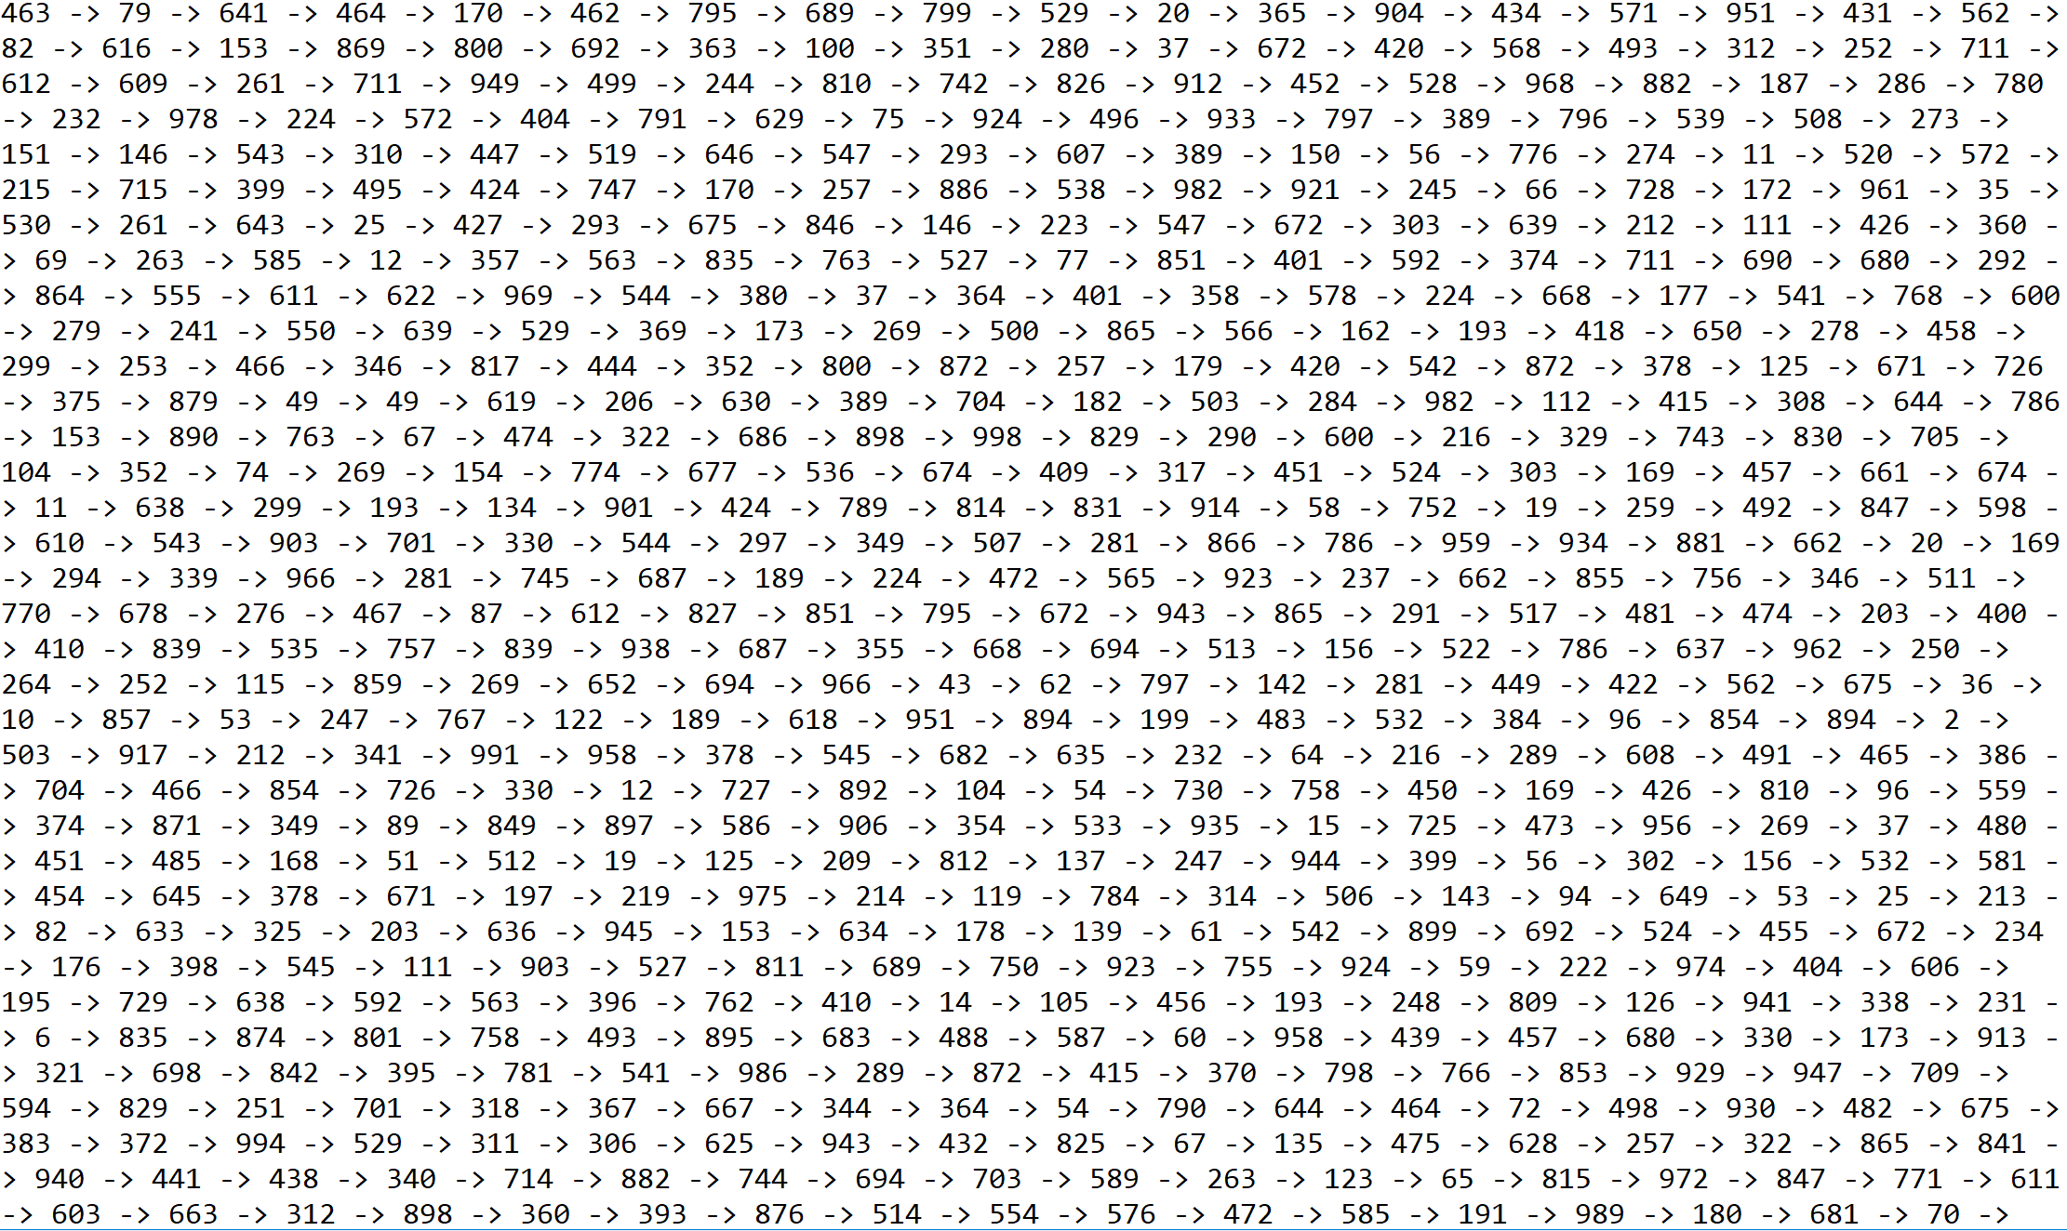

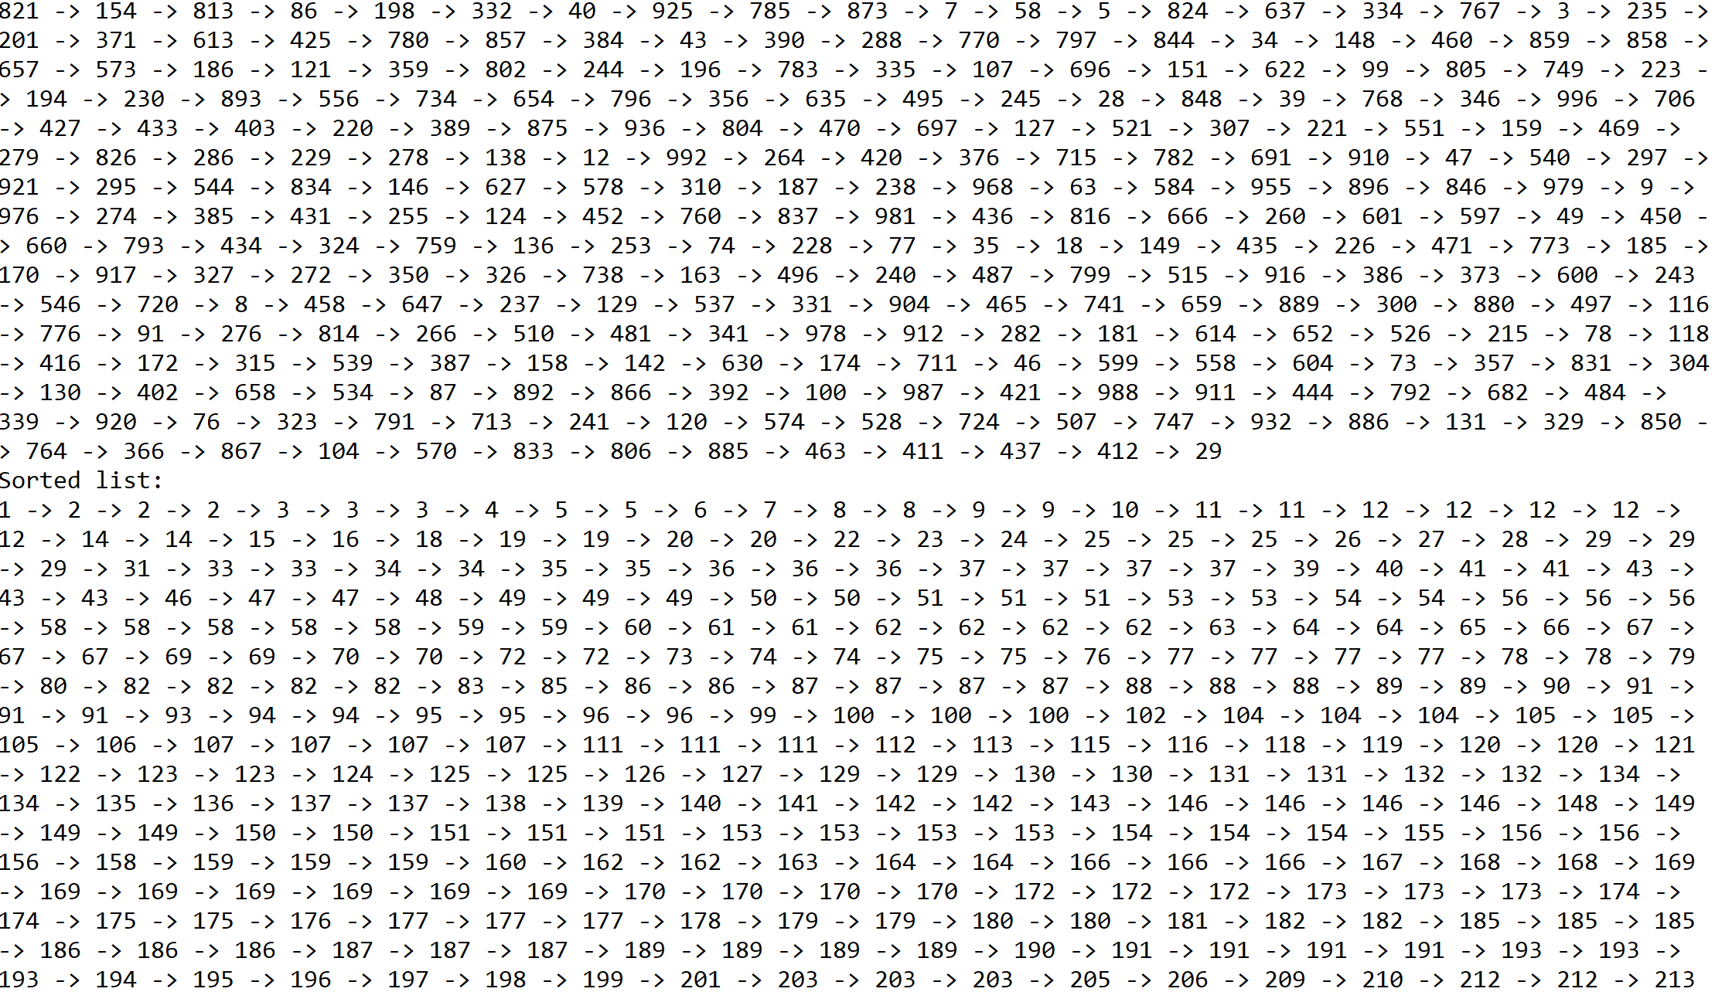

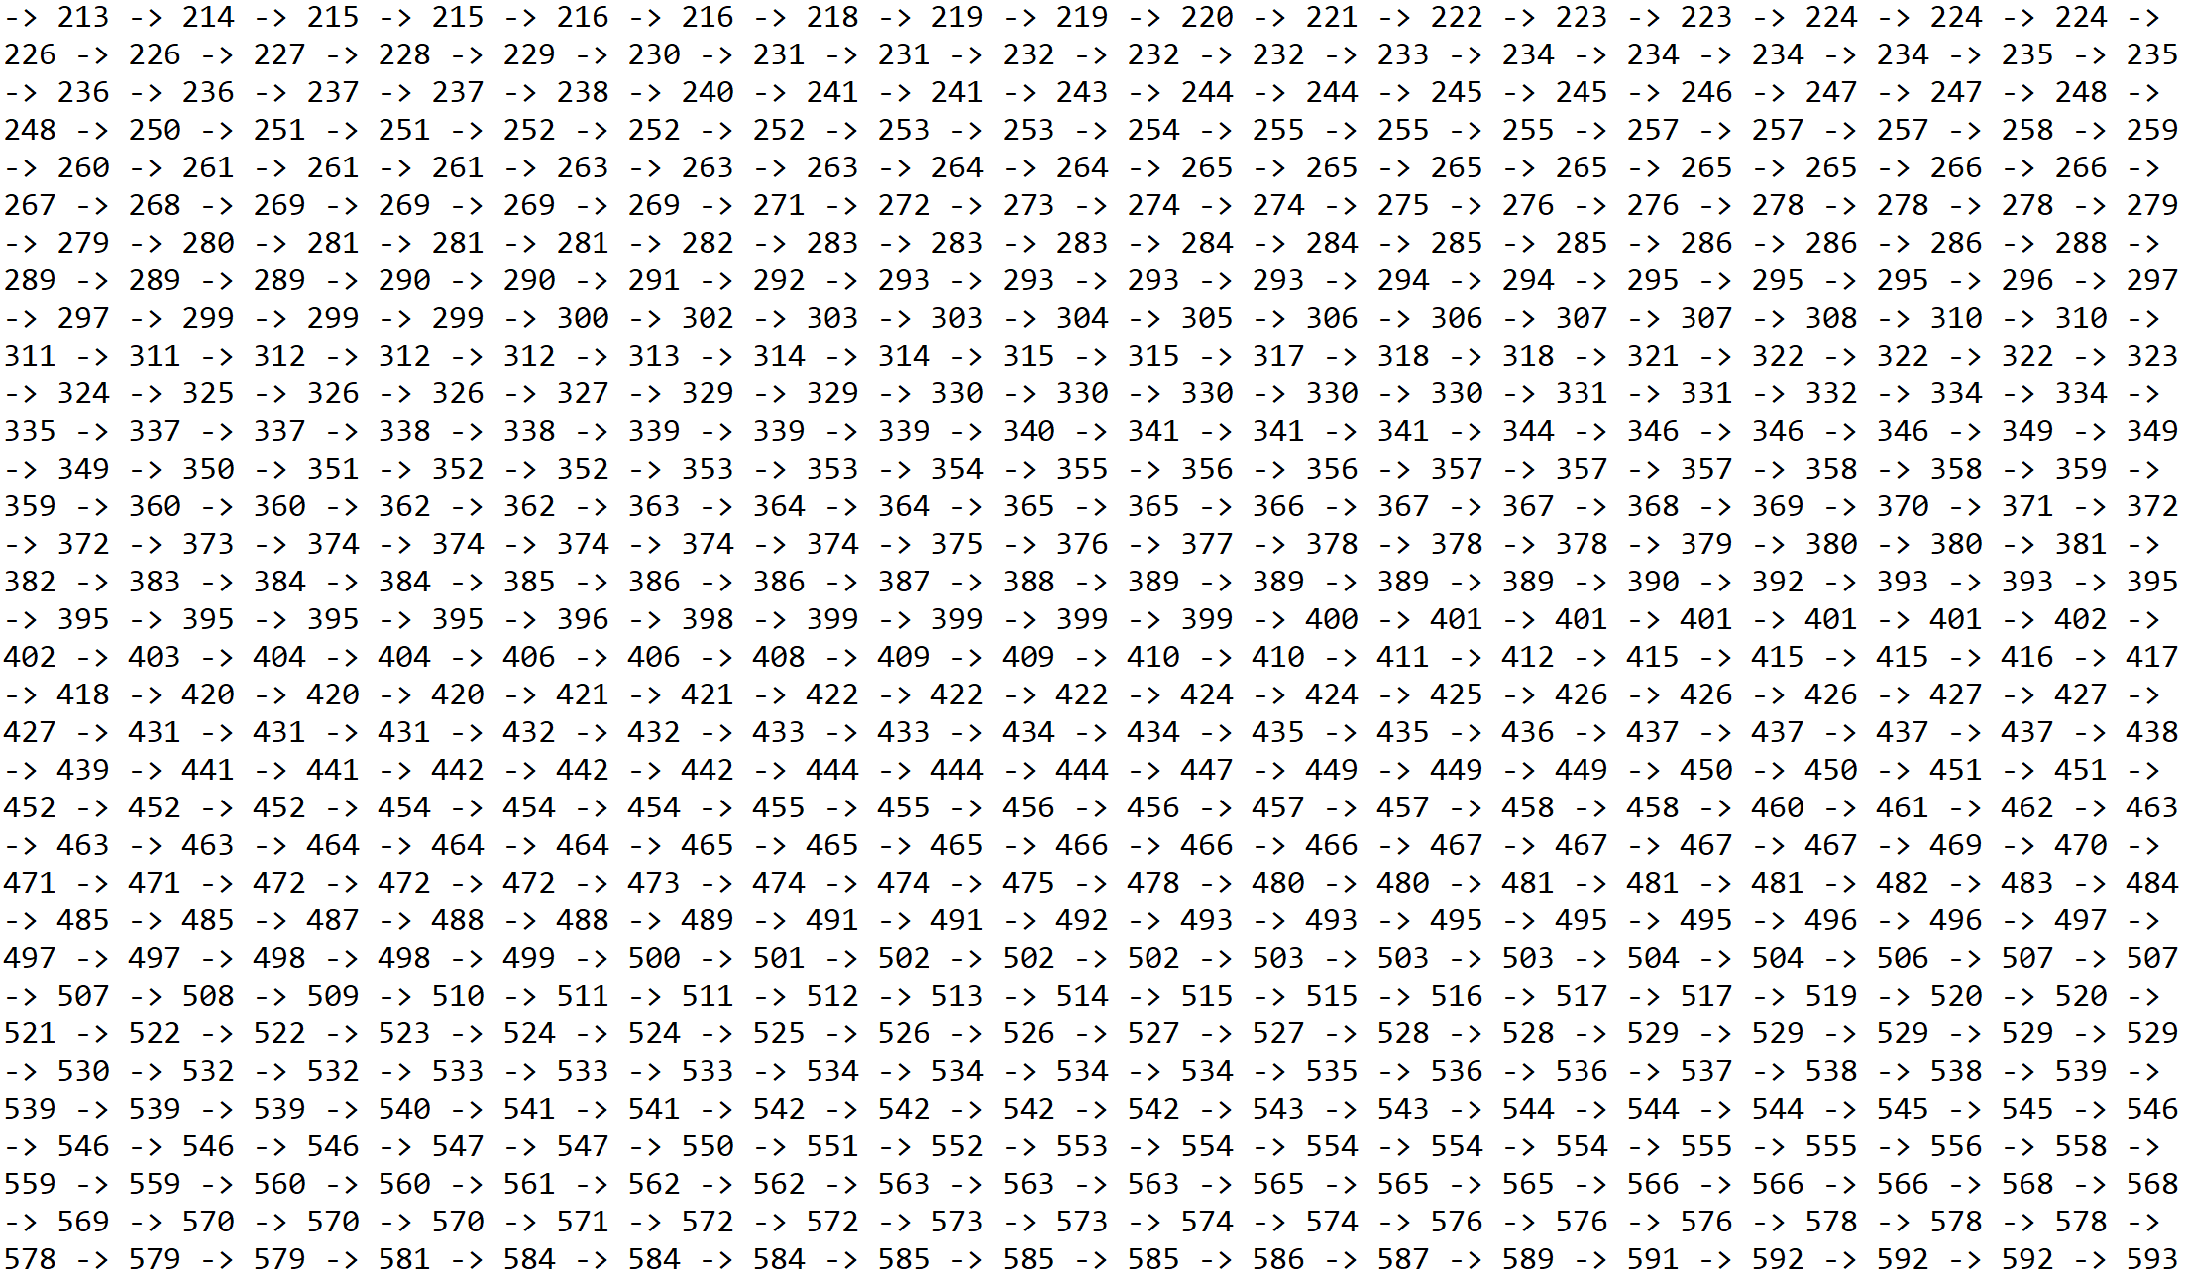

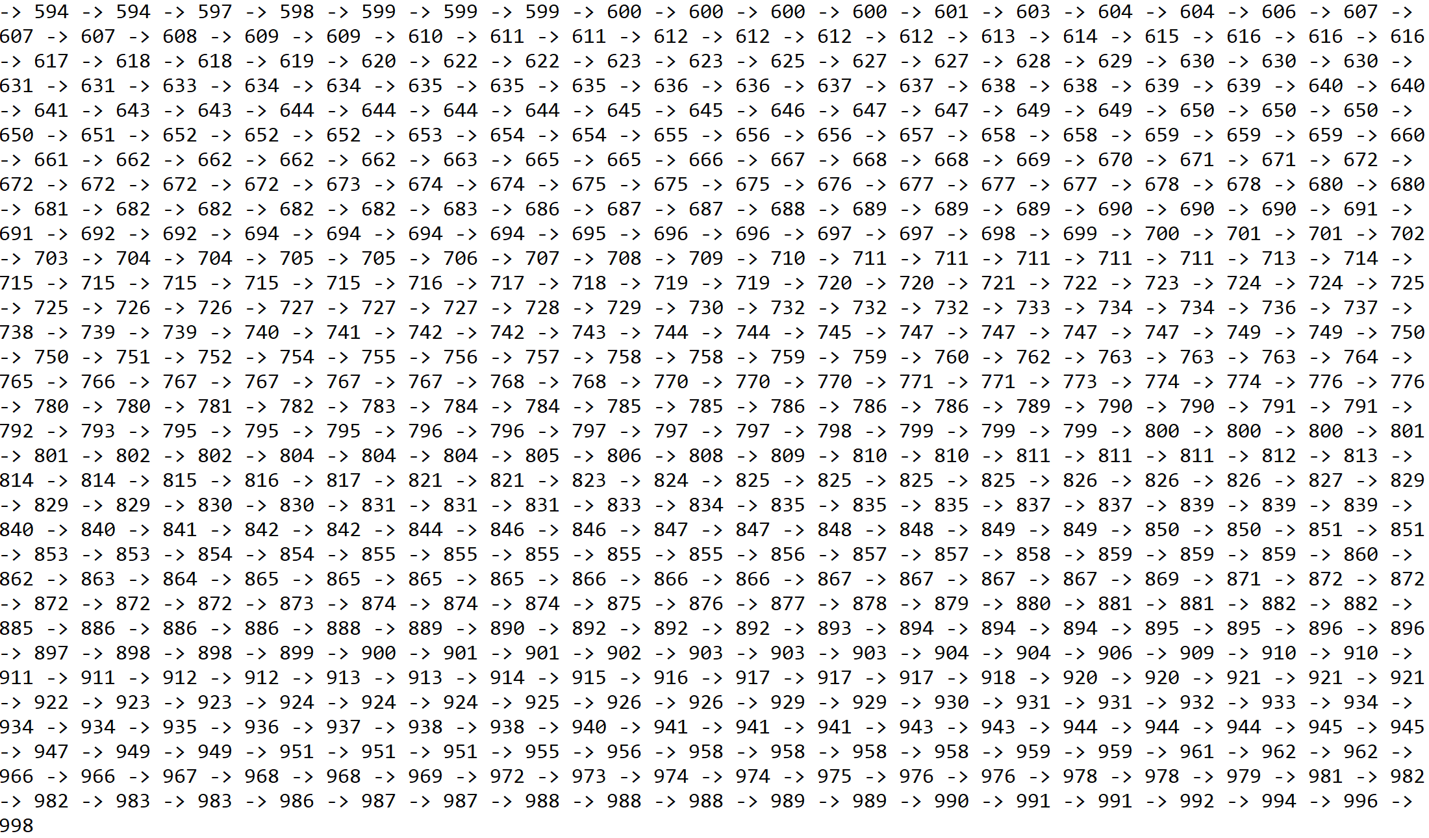

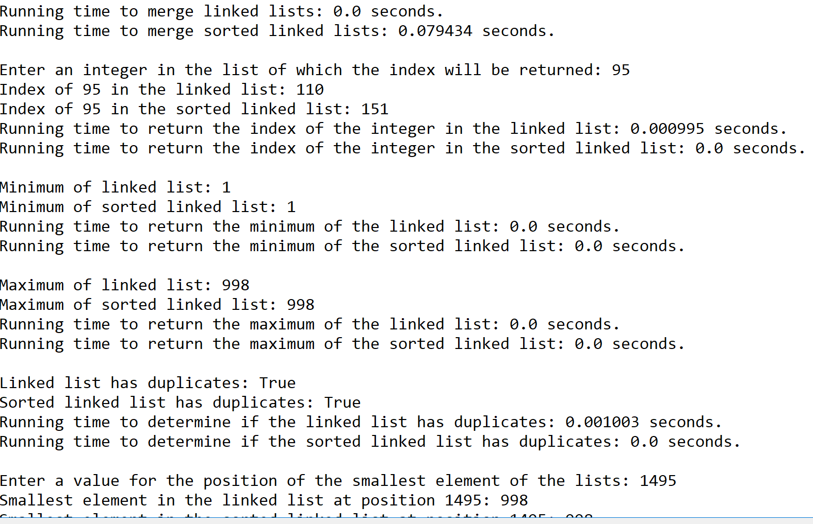

Case 5: Size of list = 5000, size of list to be merged with original list = 2500



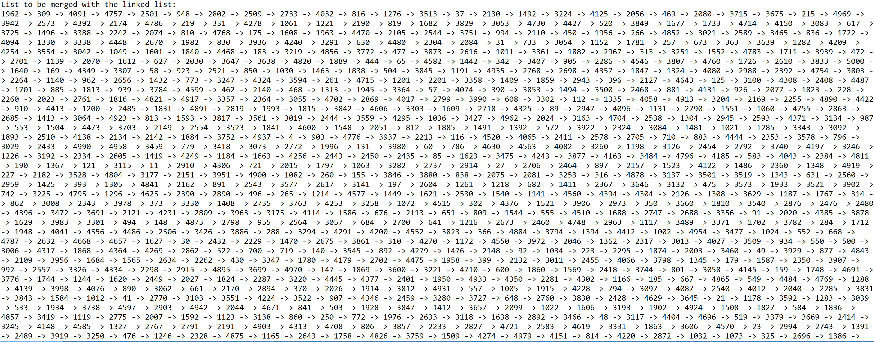

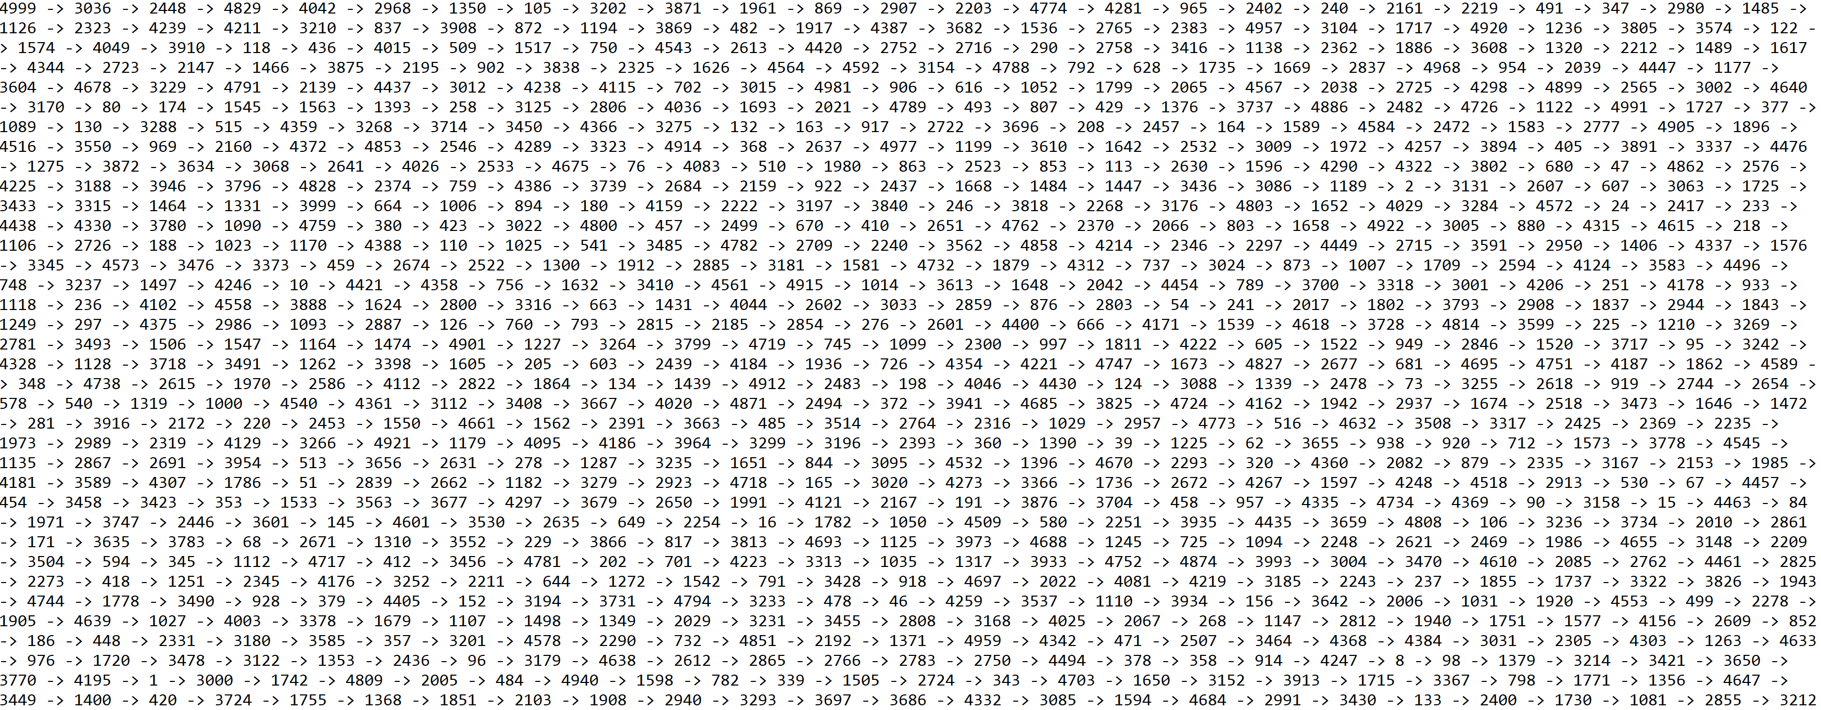

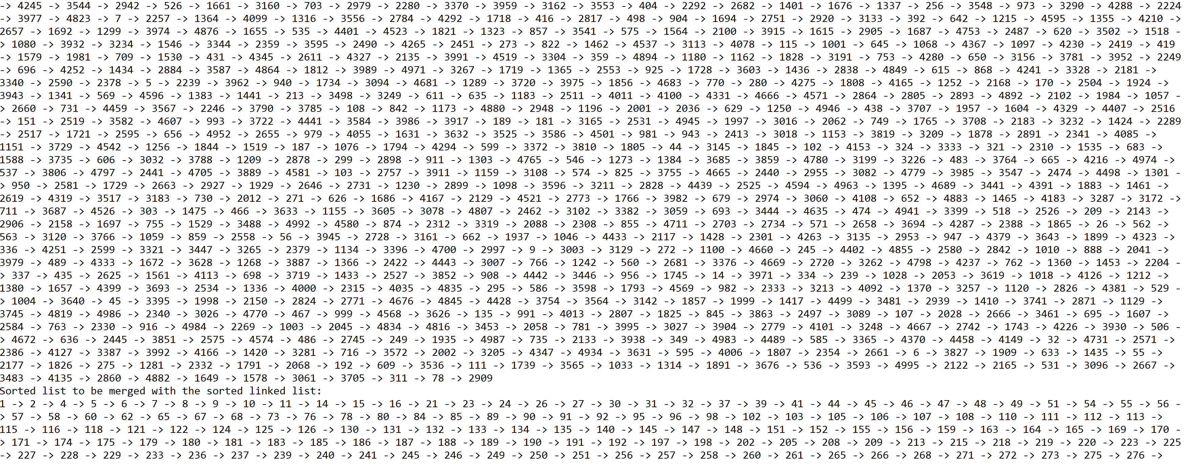

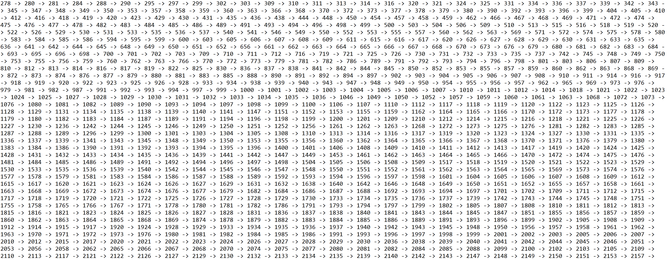

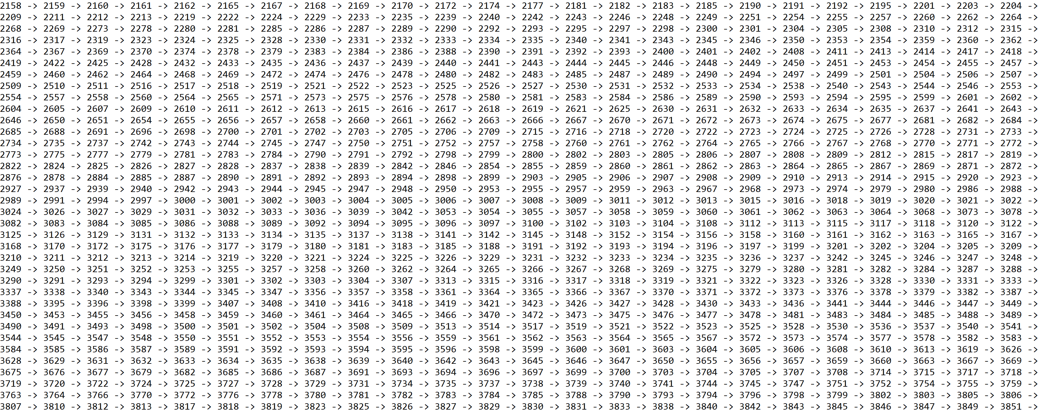

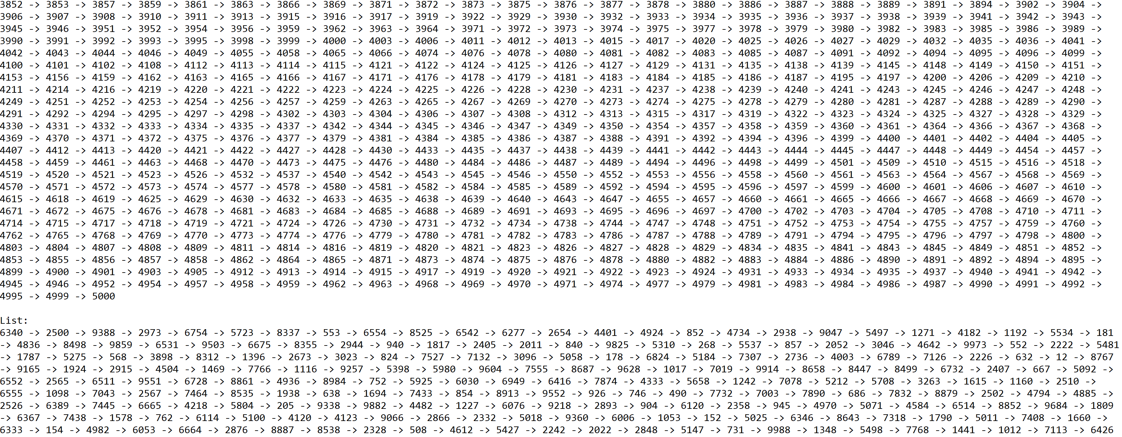

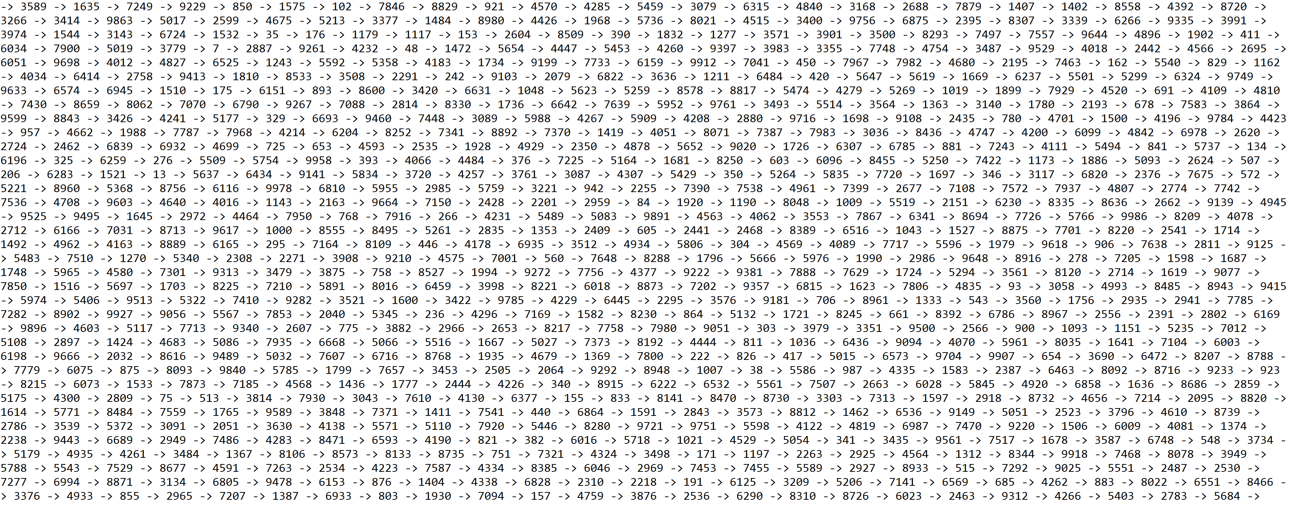

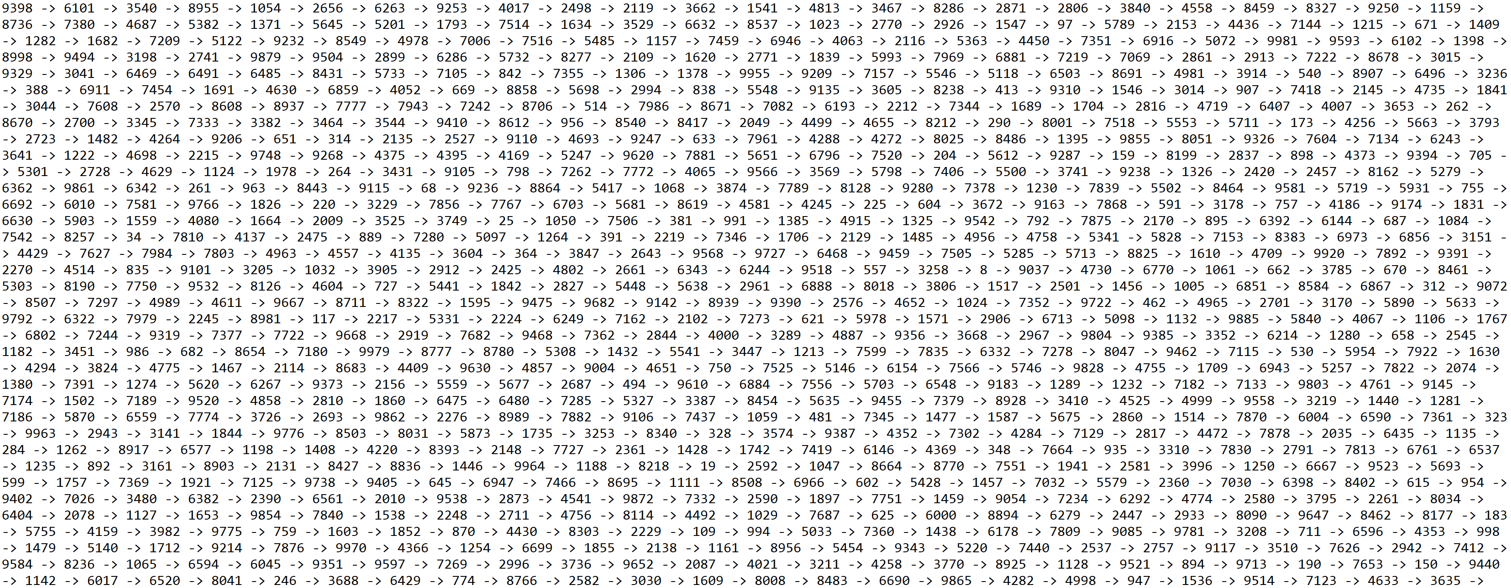

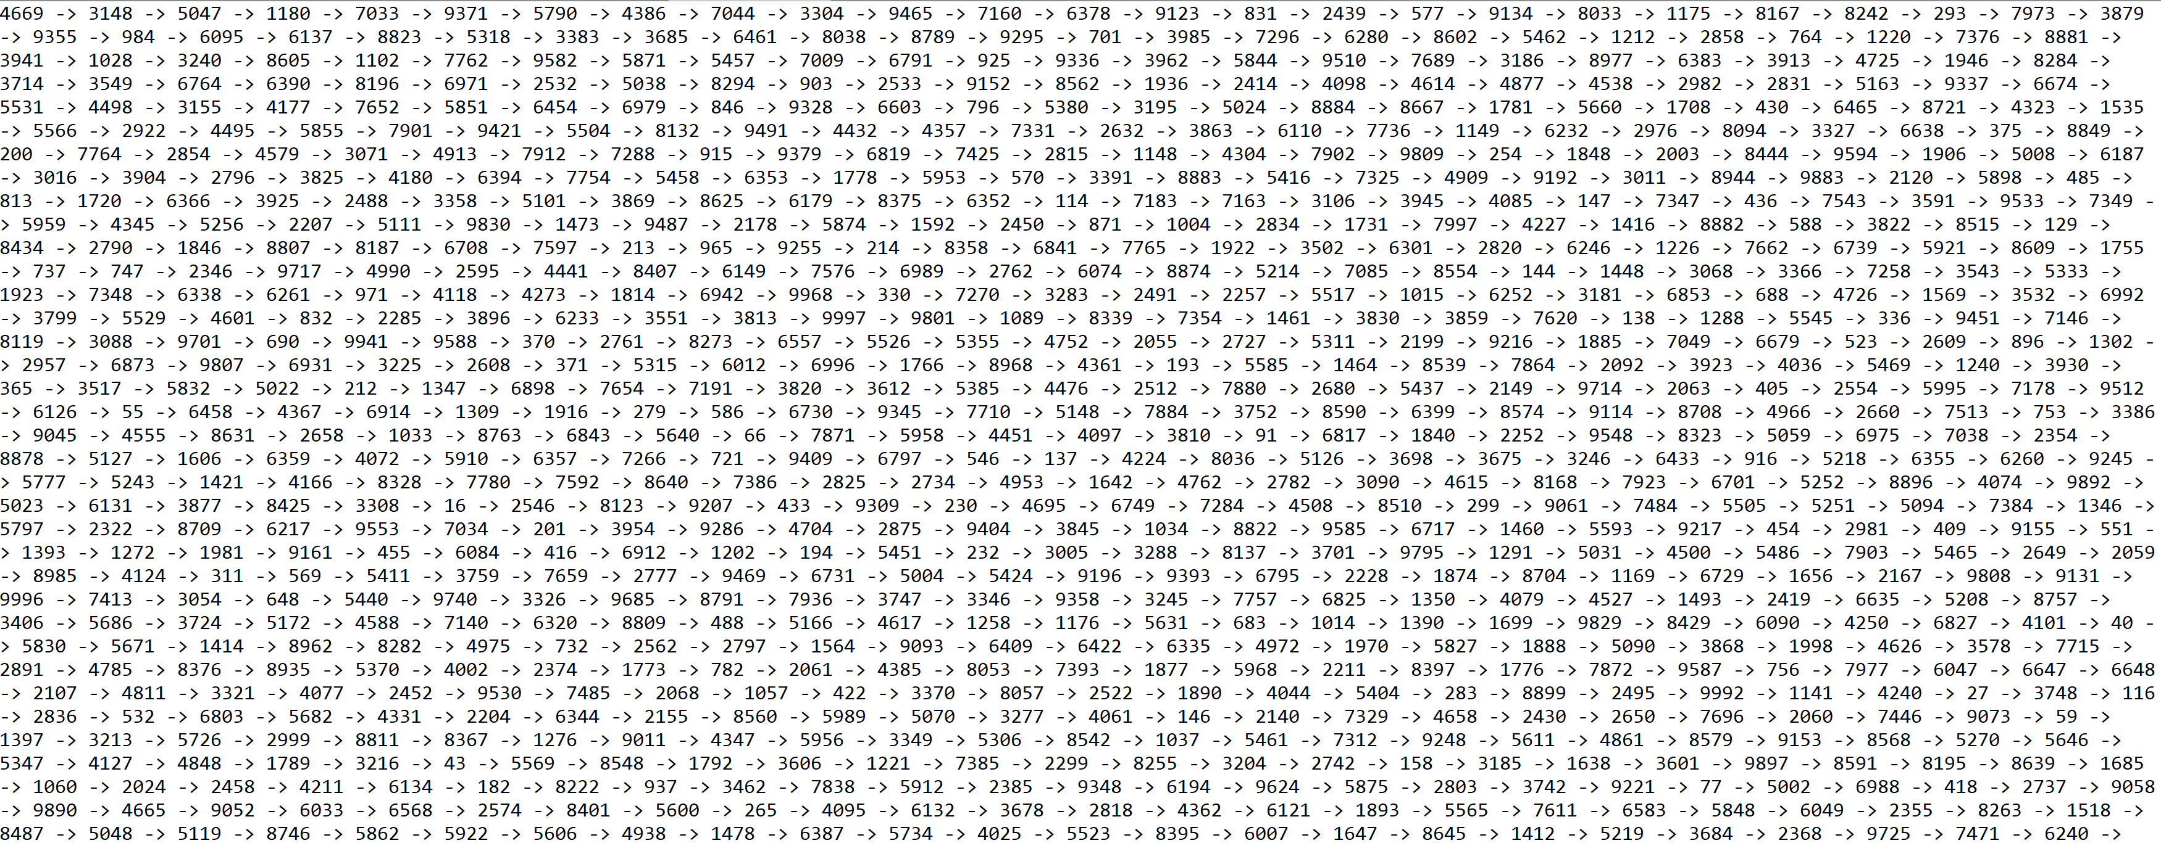

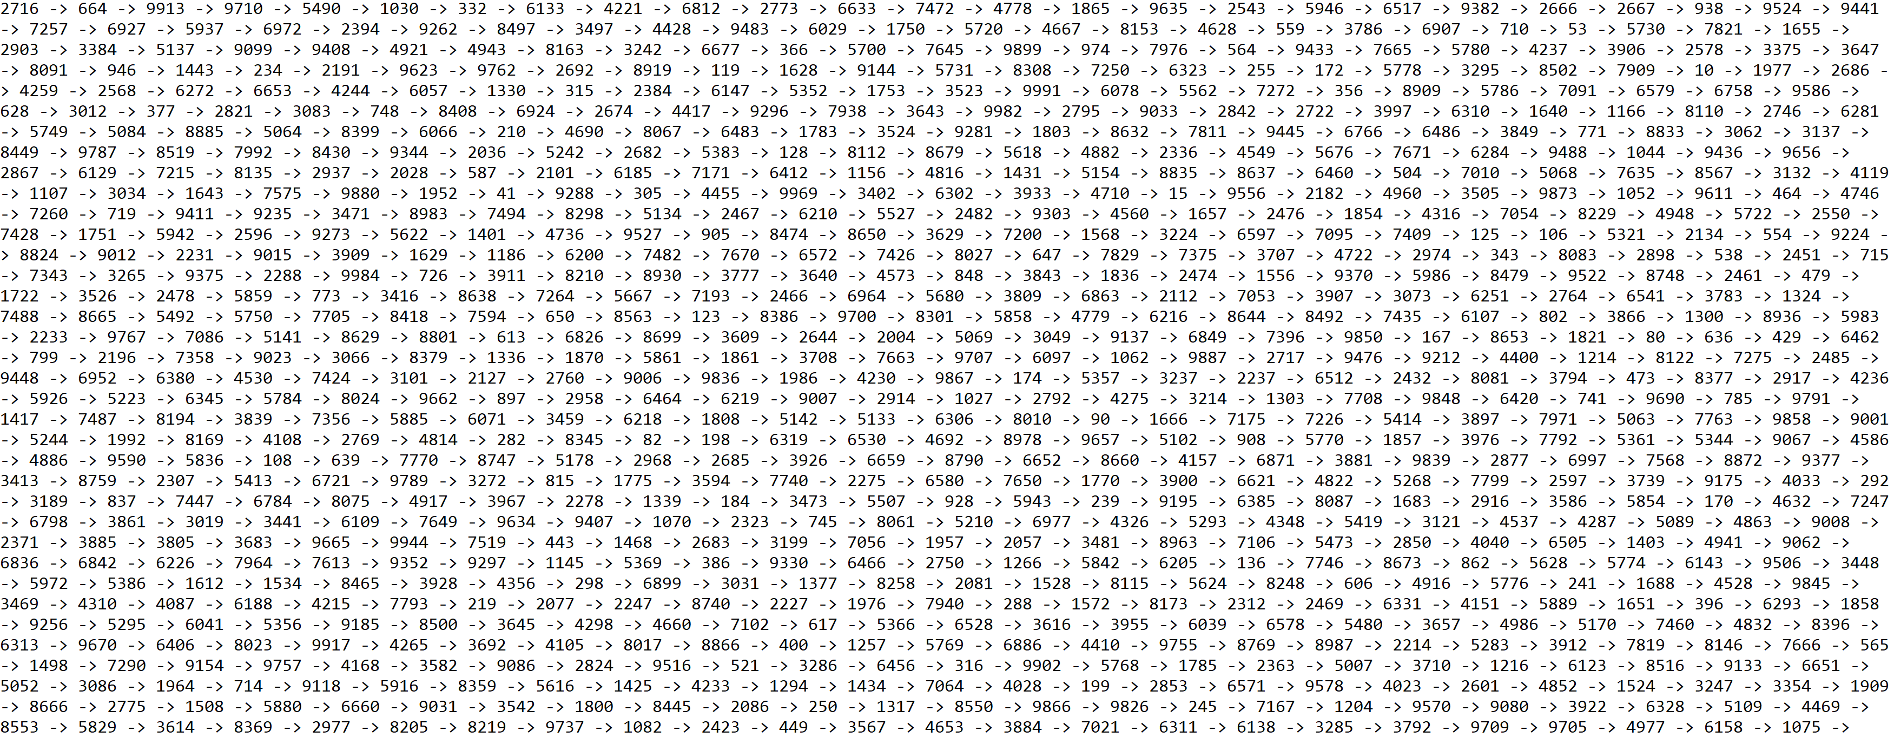

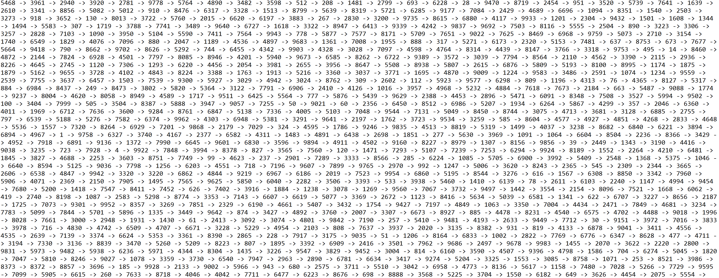

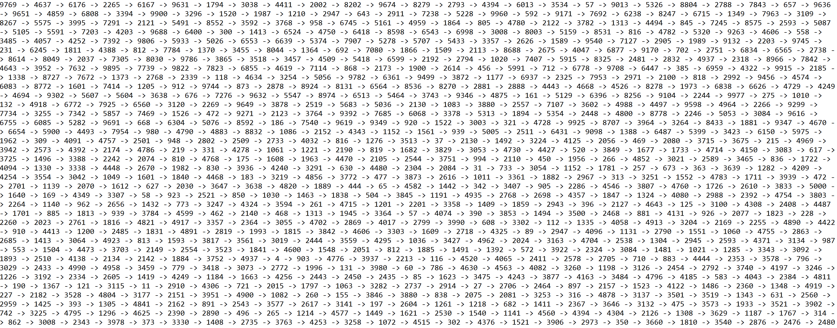

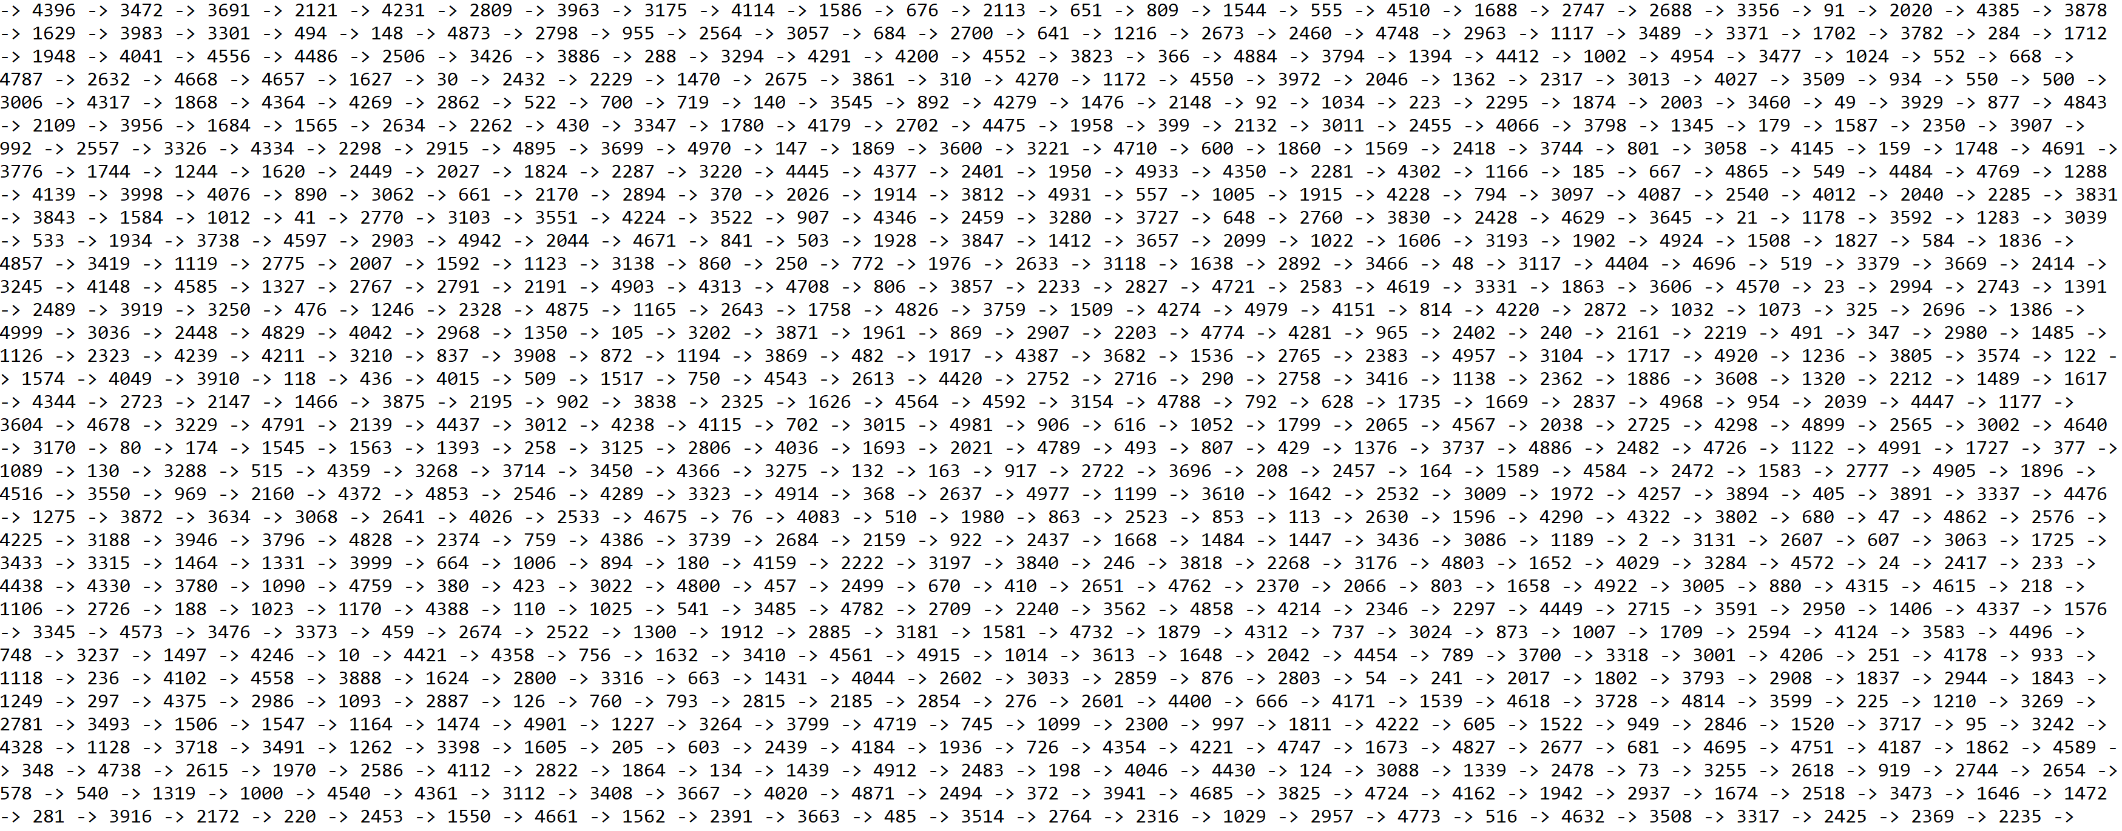

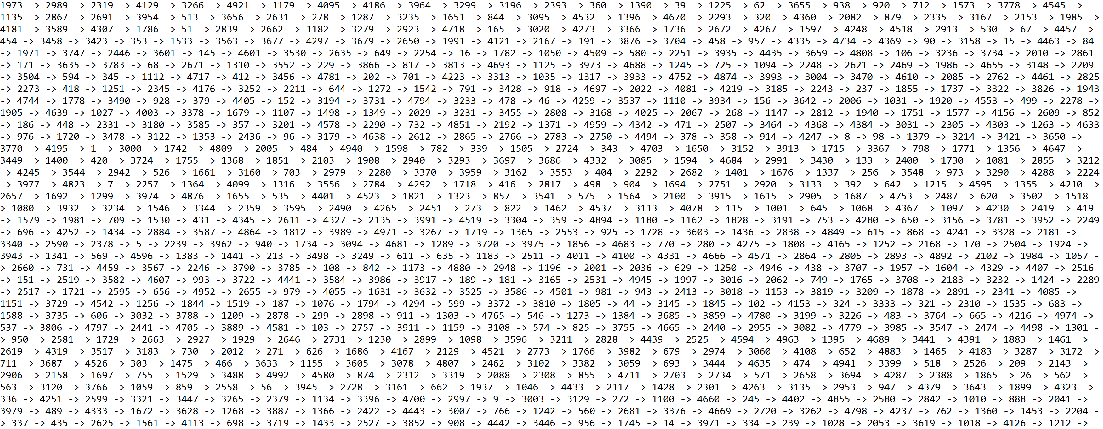

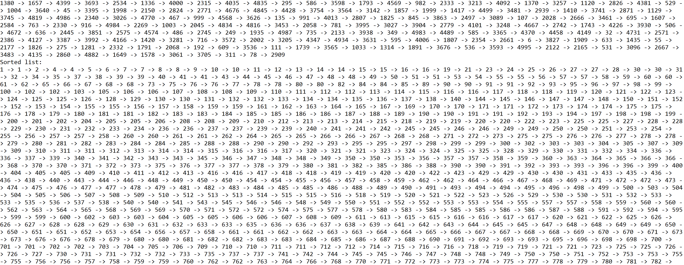

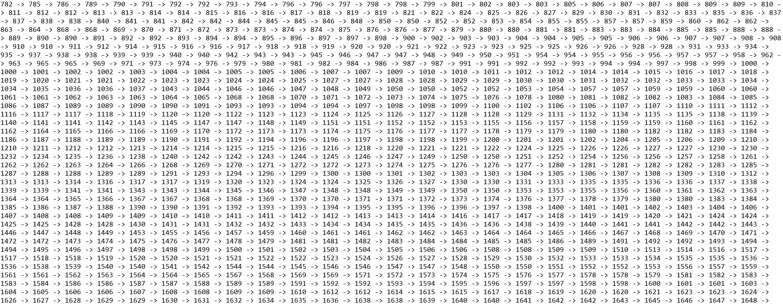

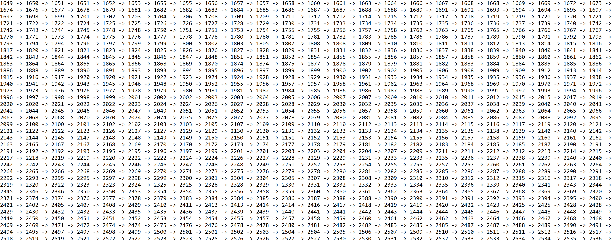

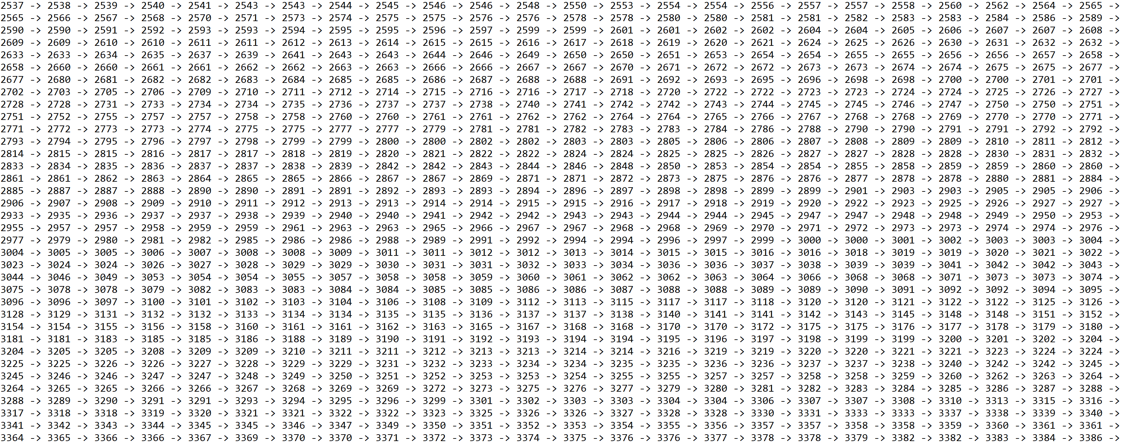

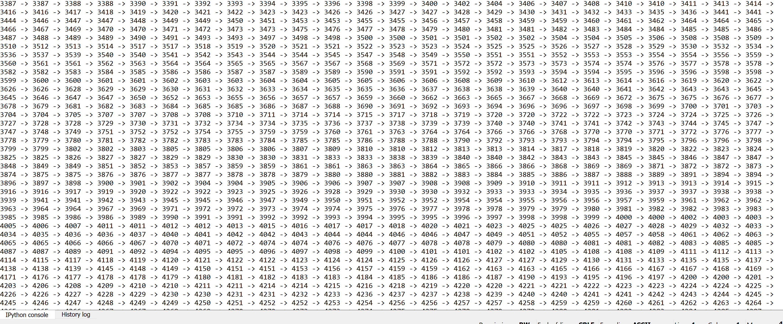

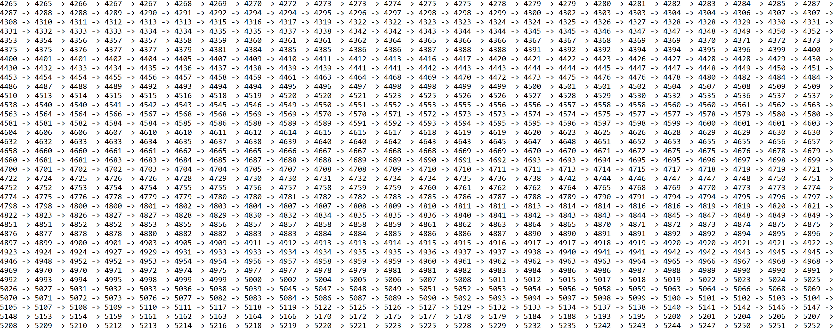

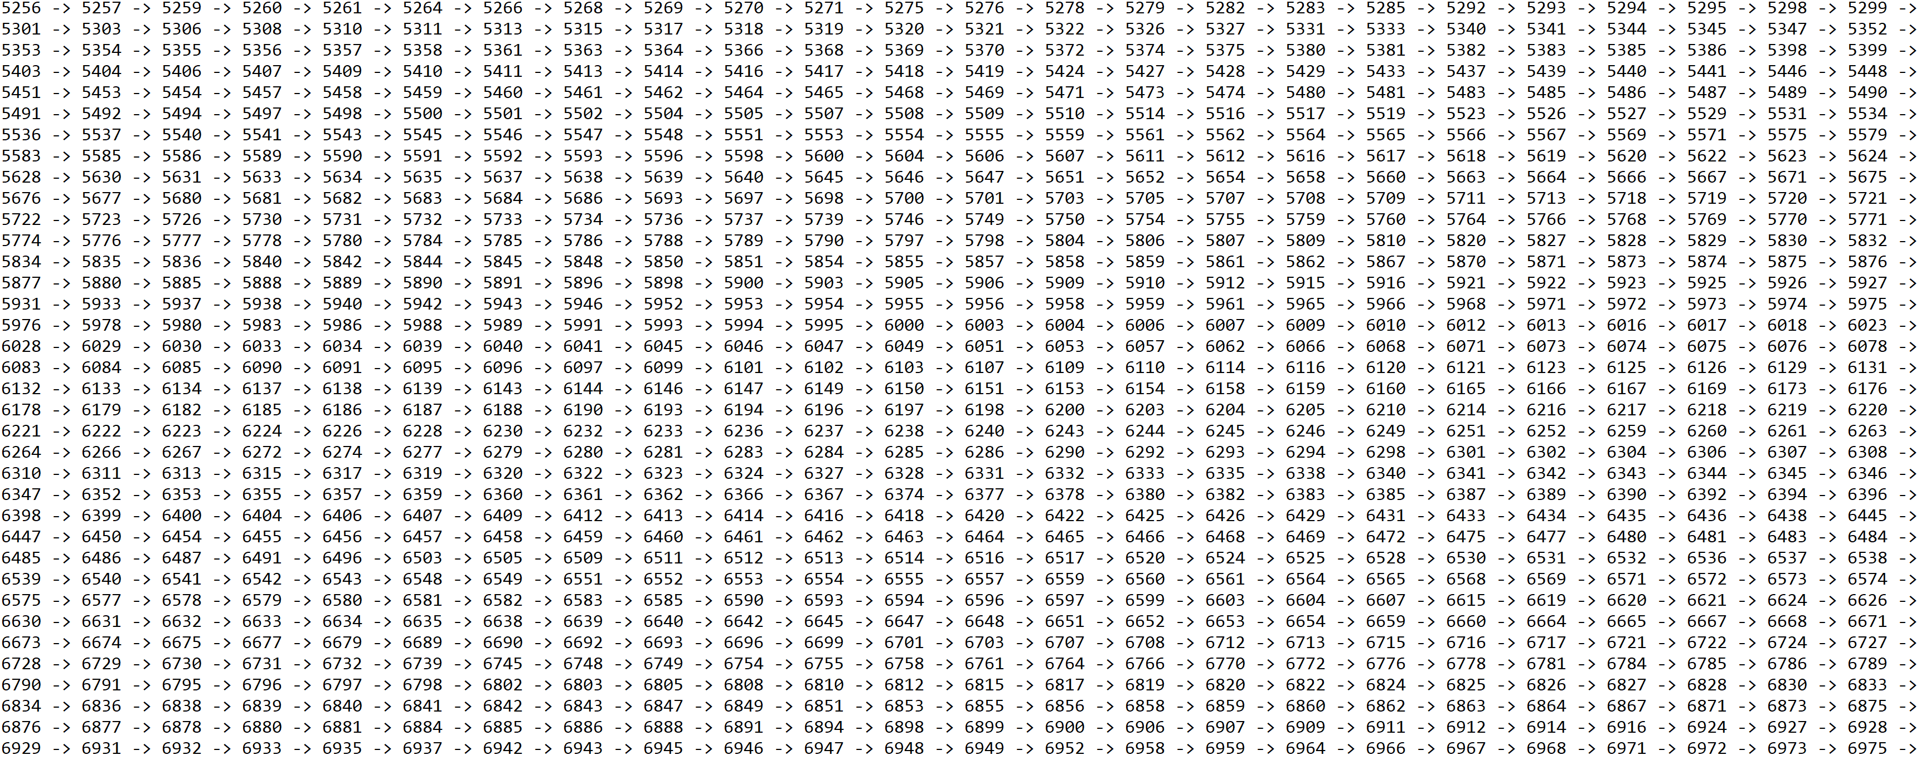

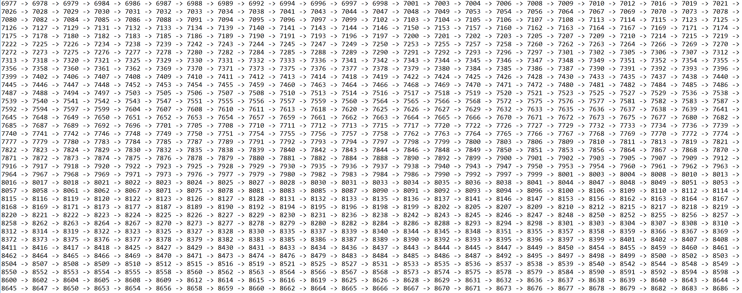

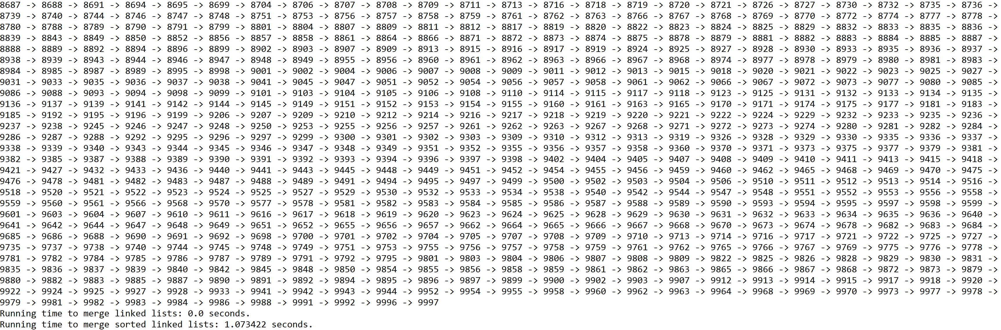

**Operation #5:**

For this operation, I will test randomly generated lists of integers of sizes 50, 100, 500, 1000, and 5000. Additionally, I will test random integers of which this operation will return the index for both lists in each case.

Case 1: Size of list = 50, i = 38



Case 2: Size of list = 100, i = 6

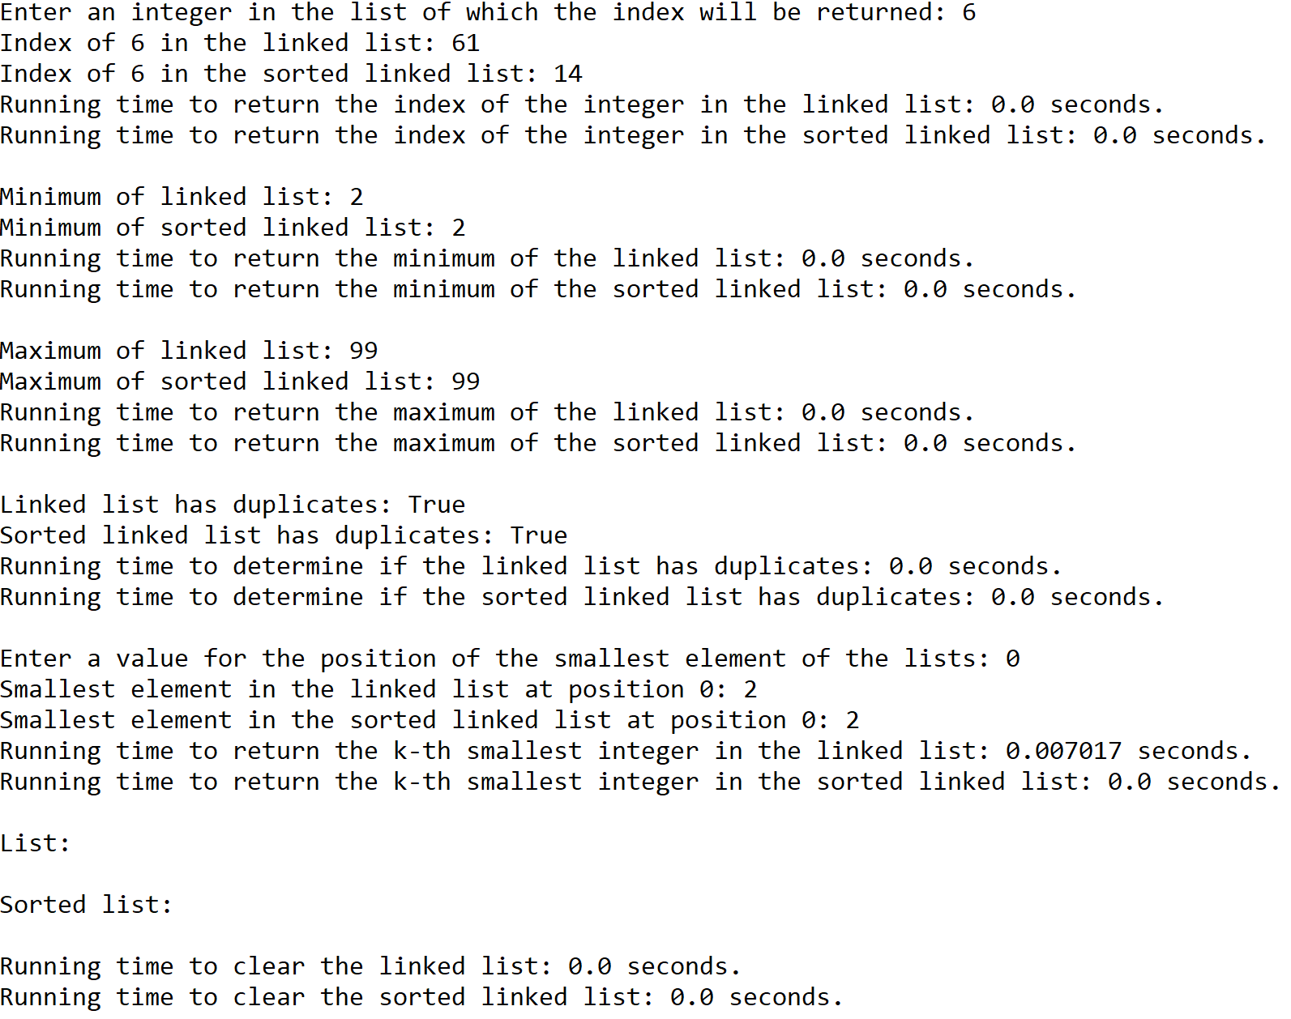

Case 3: Size of list = 500, i = 536



Case 4: Size of list = 1000, i = 95



Case 5: Size of list = 5000, i = 2903

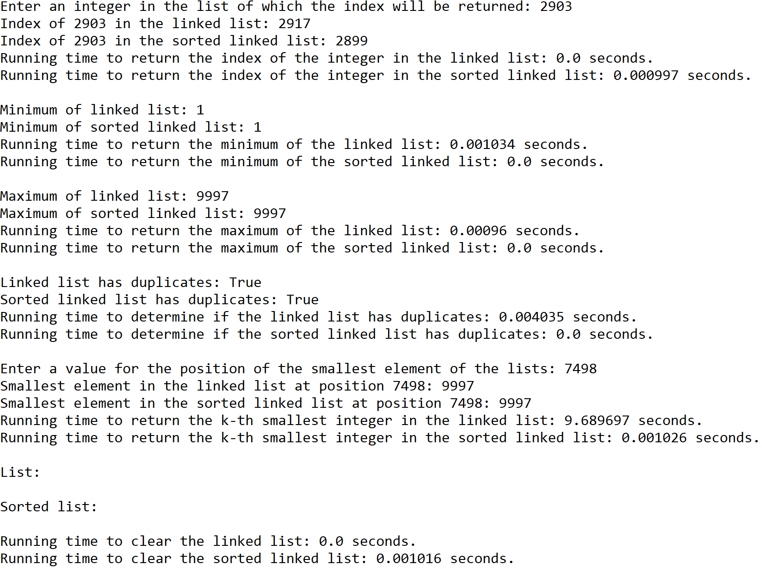

**Operation #6:**

For this operation, I will test randomly generated lists of integers of sizes 50, 100, 500, 1000, and 5000.

Case 1: Size of list = 50

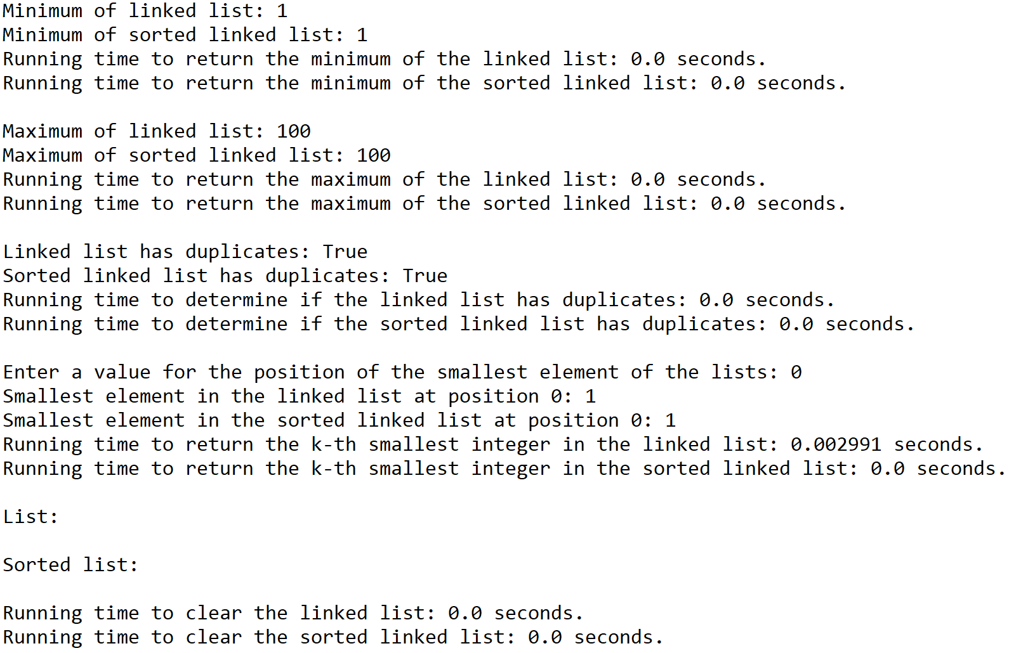

Case 2: Size of list = 100



Case 3: Size of list = 500

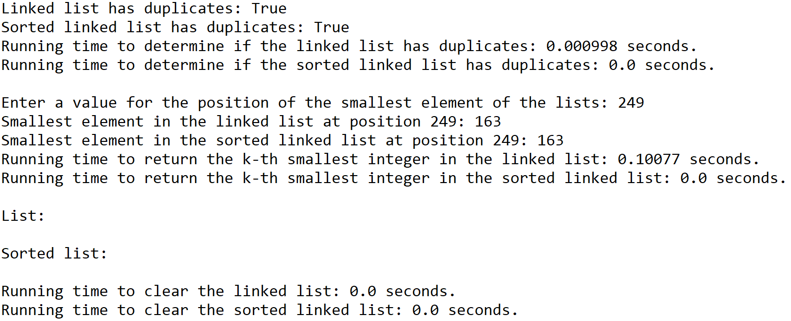

Case 4: Size of list = 1000

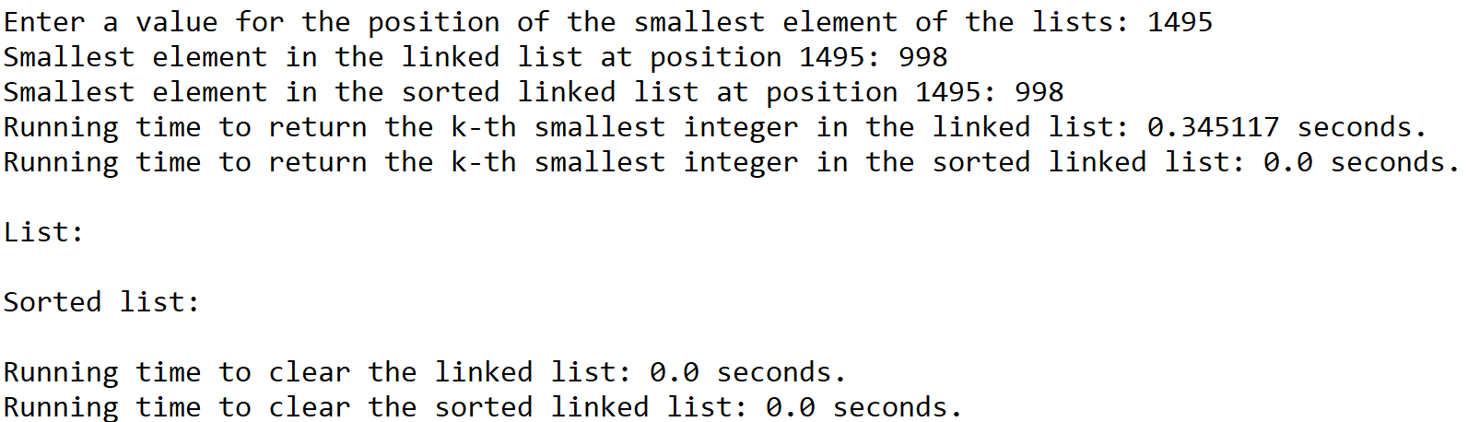

Case 5: Size of list = 5000



**Operation #7:**

For this operation, I will test randomly generated lists of integers of sizes 50, 100, 500, 1000, and 5000.

Case 1: Size of list = 50



Case 2: Size of list = 100



Case 3: Size of list = 500



Case 4: Size of list = 1000



Case 5: Size of list = 5000



**Operation #8:**

For this operation, I will test randomly generated lists of integers of sizes 50, 100, 500, 1000, and 5000.

Case 1: Size of list = 50



Case 2: Size of list = 100



Case 3: Size of list = 500



Case 4: Size of list = 1000



Case 5: Size of list = 5000



**Operation #9:**

For this operation, I will test randomly generated lists of integers of sizes 50, 100, 500, 1000, and 5000.

Case 1: Size of list = 50



Case 2: Size of list = 100



Case 3: Size of list = 500



Case 4: Size of list = 1000



Case 5: Size of list = 5000



**Operation #10:**

For this operation, I will test randomly generated lists of integers of sizes 50, 100, 500, 1000, and 5000. Additionally, I will test for this operation to return the smallest element at the beginning of the list (k == 0) for sizes 50 and 100, at the middle of the list (k == between 0 and the last index of the list) for size 500, and at the end of the list (k == the last index of the list) for sizes 1000 and 5000.

Case 1: Size of list = 50, k = 0



Case 2: Size of list = 100, k = 0



Case 3: Size of list = 500, k = 249



Case 4: Size of list = 1000, k = 1495 (k is the last index of the original list merged with the other list)



Case 5: Size of list = 5000, k = 7498 (k is the last index of the original list merged with the other list)



**Graphs of running times per operation in the *SortedList* and *List* classes**

N = Size of the singly-linked list(50, 100, 500, 1000, 5000)

|  |  |  |  |  |  |
| --- | --- | --- | --- | --- | --- |
|  | 50 | 100 | 500 | 1000 | 5000 |
| Operation 1 | 0.006983 | 0.014979 | 0.090758 | 0.227984 | 1.068766 |

|  |  |  |  |  |  |
| --- | --- | --- | --- | --- | --- |
|  | 50 | 100 | 500 | 1000 | 5000 |
| Operation 1 | 0.006978 | 0.015941 | 0.069334 | 0.123663 | 1.091143 |

|  |  |  |  |  |  |
| --- | --- | --- | --- | --- | --- |
|  | 50 | 100 | 500 | 1000 | 5000 |
| Operation 2 | 0.000000 | 0.001001 | 0.011968 | 0.039986 | 1.257050 |

|  |  |  |  |  |  |
| --- | --- | --- | --- | --- | --- |
|  | 50 | 100 | 500 | 1000 | 5000 |
| Operation 2 | 0.000000 | 0.000000 | 0.004024 | 0.000969 | 0.028938 |

|  |  |  |  |  |  |
| --- | --- | --- | --- | --- | --- |
|  | 50 | 100 | 500 | 1000 | 5000 |
| Operation 3 | 0.000000 | 0.000000 | 0.000000 | 0.000000 | 0.001997 |

|  |  |  |  |  |  |
| --- | --- | --- | --- | --- | --- |
|  | 50 | 100 | 500 | 1000 | 5000 |
| Operation 3 | 0.000000 | 0.000000 | 0.000000 | 0.000000 | 0.000996 |

|  |  |  |  |  |  |
| --- | --- | --- | --- | --- | --- |
|  | 50 | 100 | 500 | 1000 | 5000 |
| Operation 4 | 0.000000 | 0.001016 | 0.007976 | 0.079434 | 1.073422 |

|  |  |  |  |  |  |
| --- | --- | --- | --- | --- | --- |
|  | 50 | 100 | 500 | 1000 | 5000 |
| Operation 4 | 0.000000 | 0.000000 | 0.000000 | 0.000000 | 0.000000 |

|  |  |  |  |  |  |
| --- | --- | --- | --- | --- | --- |
|  | 50 | 100 | 500 | 1000 | 5000 |
| Operation 5 | 0.000000 | 0.000000 | 0.000000 | 0.000000 | 0.000997 |

|  |  |  |  |  |  |
| --- | --- | --- | --- | --- | --- |
|  | 50 | 100 | 500 | 1000 | 5000 |
| Operation 5 | 0.000000 | 0.000000 | 0.000000 | 0.000995 | 0.000000 |

|  |  |  |  |  |  |
| --- | --- | --- | --- | --- | --- |
|  | 50 | 100 | 500 | 1000 | 5000 |
| Operation 6 | 0.000000 | 0.000000 | 0.000000 | 0.000000 | 0.001016 |

|  |  |  |  |  |  |
| --- | --- | --- | --- | --- | --- |
|  | 50 | 100 | 500 | 1000 | 5000 |
| Operation 6 | 0.000000 | 0.000000 | 0.000000 | 0.000000 | 0.000000 |

|  |  |  |  |  |  |
| --- | --- | --- | --- | --- | --- |
|  | 50 | 100 | 500 | 1000 | 5000 |
| Operation 7 | 0.000000 | 0.000000 | 0.000000 | 0.000000 | 0.000000 |

|  |  |  |  |  |  |
| --- | --- | --- | --- | --- | --- |
|  | 50 | 100 | 500 | 1000 | 5000 |
| Operation 7 | 0.000000 | 0.000000 | 0.000000 | 0.000000 | 0.001034 |

|  |  |  |  |  |  |
| --- | --- | --- | --- | --- | --- |
|  | 50 | 100 | 500 | 1000 | 5000 |
| Operation 8 | 0.000000 | 0.000000 | 0.000000 | 0.000000 | 0.000000 |

|  |  |  |  |  |  |
| --- | --- | --- | --- | --- | --- |
|  | 50 | 100 | 500 | 1000 | 5000 |
| Operation 8 | 0.000000 | 0.000000 | 0.000000 | 0.000000 | 0.000960 |

|  |  |  |  |  |  |
| --- | --- | --- | --- | --- | --- |
|  | 50 | 100 | 500 | 1000 | 5000 |
| Operation 9 | 0.000000 | 0.000000 | 0.000000 | 0.000000 | 0.000000 |

|  |  |  |  |  |  |
| --- | --- | --- | --- | --- | --- |
|  | 50 | 100 | 500 | 1000 | 5000 |
| Operation 9 | 0.000000 | 0.000000 | 0.000998 | 0.001003 | 0.004035 |

|  |  |  |  |  |  |
| --- | --- | --- | --- | --- | --- |
|  | 50 | 100 | 500 | 1000 | 5000 |
| Operation 10 | 0.000000 | 0.000000 | 0.000000 | 0.000000 | 0.001026 |

|  |  |  |  |  |  |
| --- | --- | --- | --- | --- | --- |
|  | 50 | 100 | 500 | 1000 | 5000 |
| Operation 10 | 0.002991 | 0.007017 | 0.100770 | 0.345117 | 9.689697 |

As the results show, there are functions in which a singly-linked list of type *SortedList* performs better than one of type *List*. These functions include Min(), Max(), and Select(k). On the other hand, there are functions in which a singly-linked list of type *List* performs better than one of type *SortedList*. These functions include Insert(i) and Merge(M). Regardless, there are functions in which both singly-linked lists perform equally well. These functions include Print() and Clear(). It is possible for one type of singly-linked list to perform different functions better than the other because of the nature of the list itself. For example, a singly-linked list of type *SortedList* (i.e. a sorted list) is best suited to perform functions that return a specific value in the list that is designated to be in its proper place within a sorted list (e.g. the minimum value is at the start of the list while the maximum value is at the end of the list). On the contrary, a singly-linked list of type *List* (i.e. an unsorted list) is best suited to perform functions that add elements or entire lists to the original list without needing to check that the original list is sorted.

However, there are functions in which there are discrepancies between the theoretical running times obtained by analyzing the function’s algorithm and the actual running times obtained from the graphs. These functions include Delete(i), IndexOf(i), Min(), Max(), and HasDuplicates(). For the Delete(i) function, the actual running time appears to be O(1) for both singly-linked lists, but the theoretical running time is O(n) for both lists. For the IndexOf(i) function, it is the same situation as the Delete(i) function. Furthermore, the actual running times of the Min() and Max() functions appear to be O(1) for the singly-linked list of type *List*, yet the theoretical running time is O(n) for the same type of list. One possible reason for these discrepancies between running times is that the time efficiency was neglectable up to the list of size 5000, where changes in time that could indicate the theoretical big-O running times started to appear. If there were singly-linked lists larger than 5000, then it would be possible for the theoretical and actual running times to agree. Lastly, the actual running times for the HasDuplicates() function appear to be O(1) for the singly-linked list of type *SortedList* and O(n) for the singly-linked list of type *List*, but the theoretical running times are O(n) and O(n2), respectively. If the duplicates were found near the end of the list for each test case, then it would be possible for the running times to agree.

**Conclusion**

This lab helped me understand singly-linked lists better by allowing me to use their properties in order to implement efficient functions that can be applied to sorted lists. For example, I learned that the head and tail of the singly-linked list correspond to the list’s minimum and maximum values, respectively. Once I understood that property of sorted singly-linked lists, I was able to implement functions that return these values without the need to traverse through the entire list in order to find them. Additionally, this lab helped me understand similar algorithms that take place between different functions. For example, inserting an integer or merging a singly-linked list to another list can be done by having the tail of the original list point to the added elements and updating the list’s tail pointer accordingly. However, this will only work for singly-linked lists that are not meant to be sorted. Overall, this lab helped me understand the properties of the head and tail of a singly-linked list in order to design and modify functions that can be utilized for sorted and unsorted singly-linked lists.

**Appendix**

SortedList.py

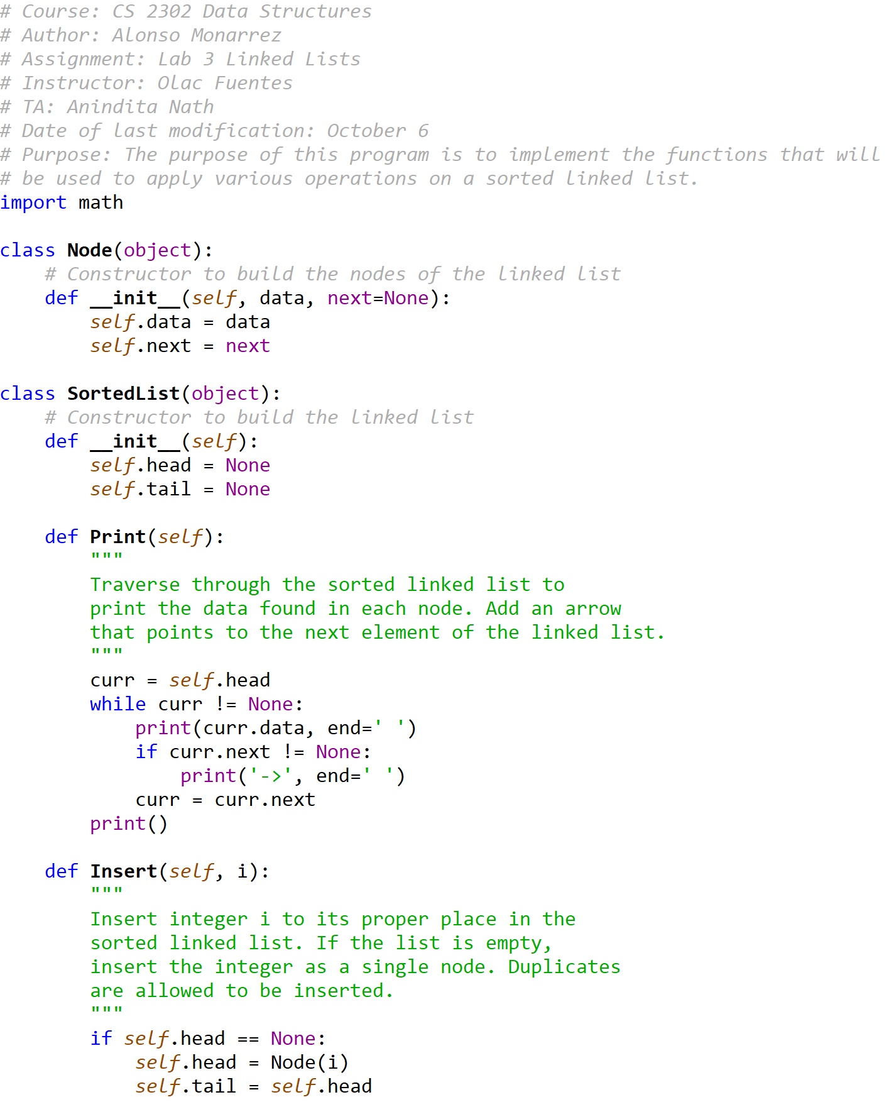

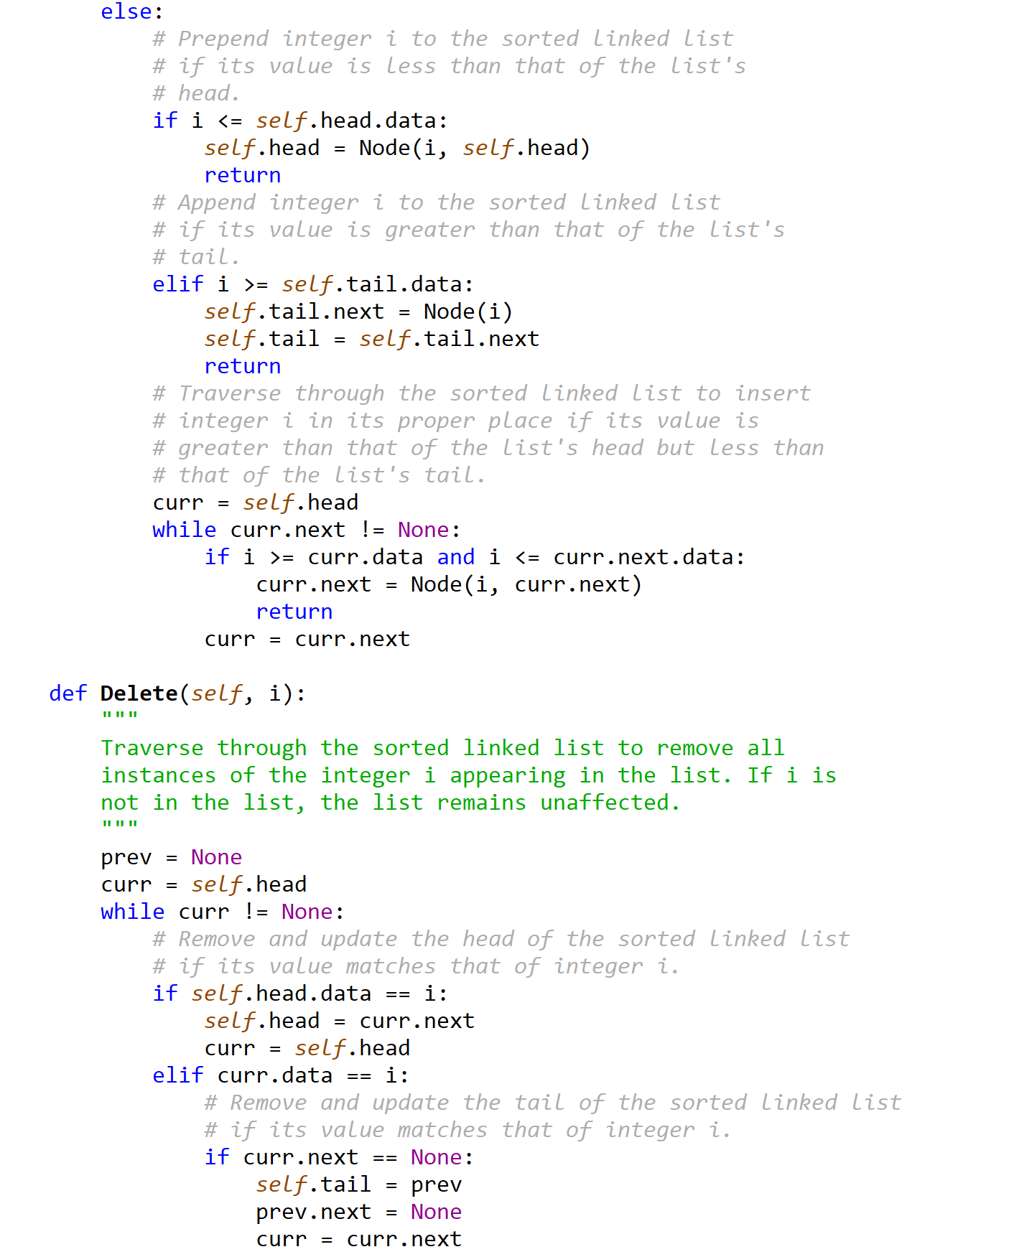

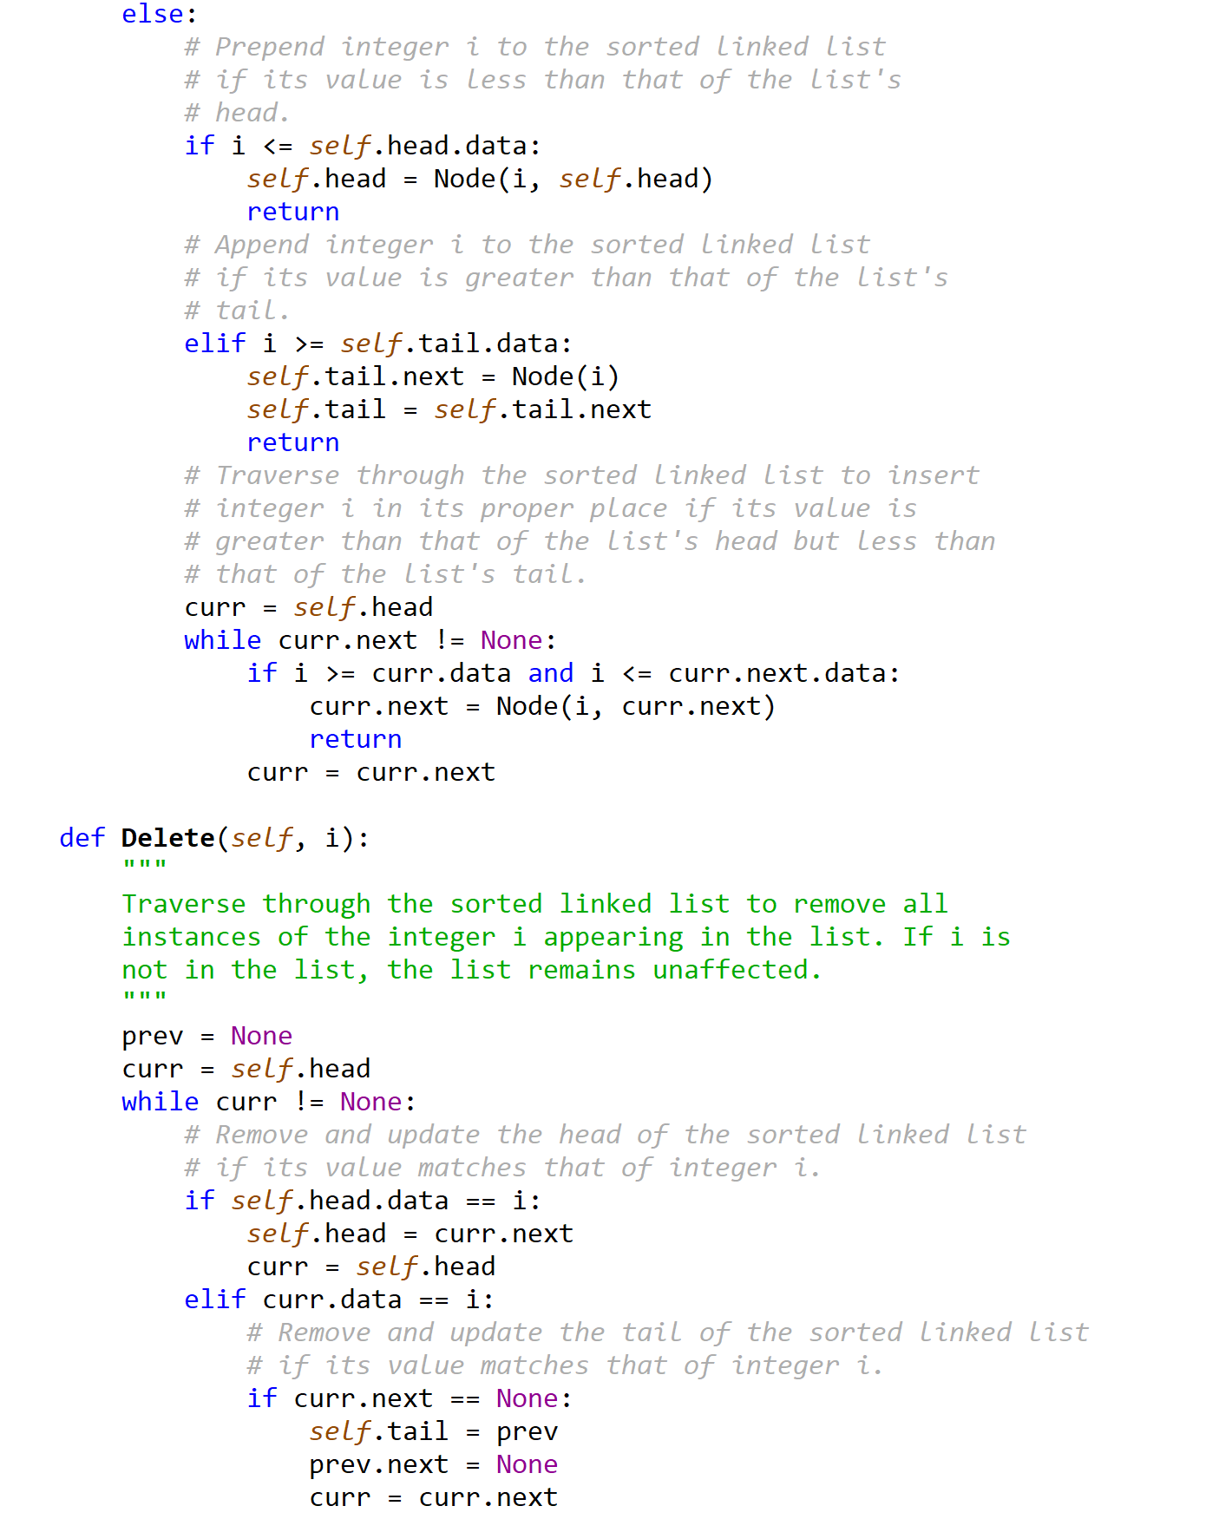

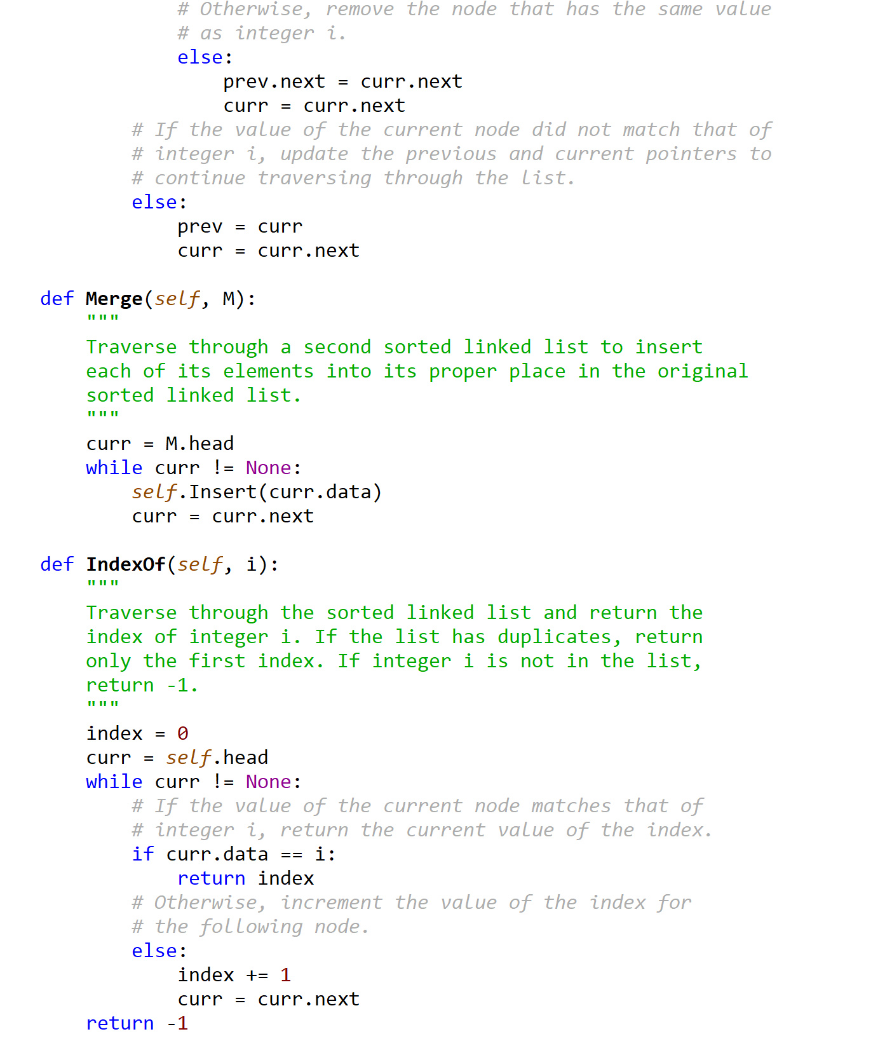



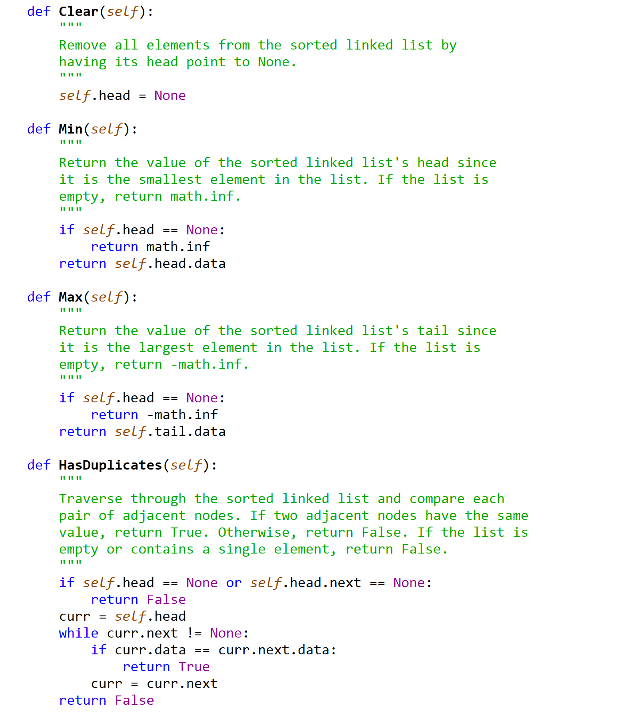



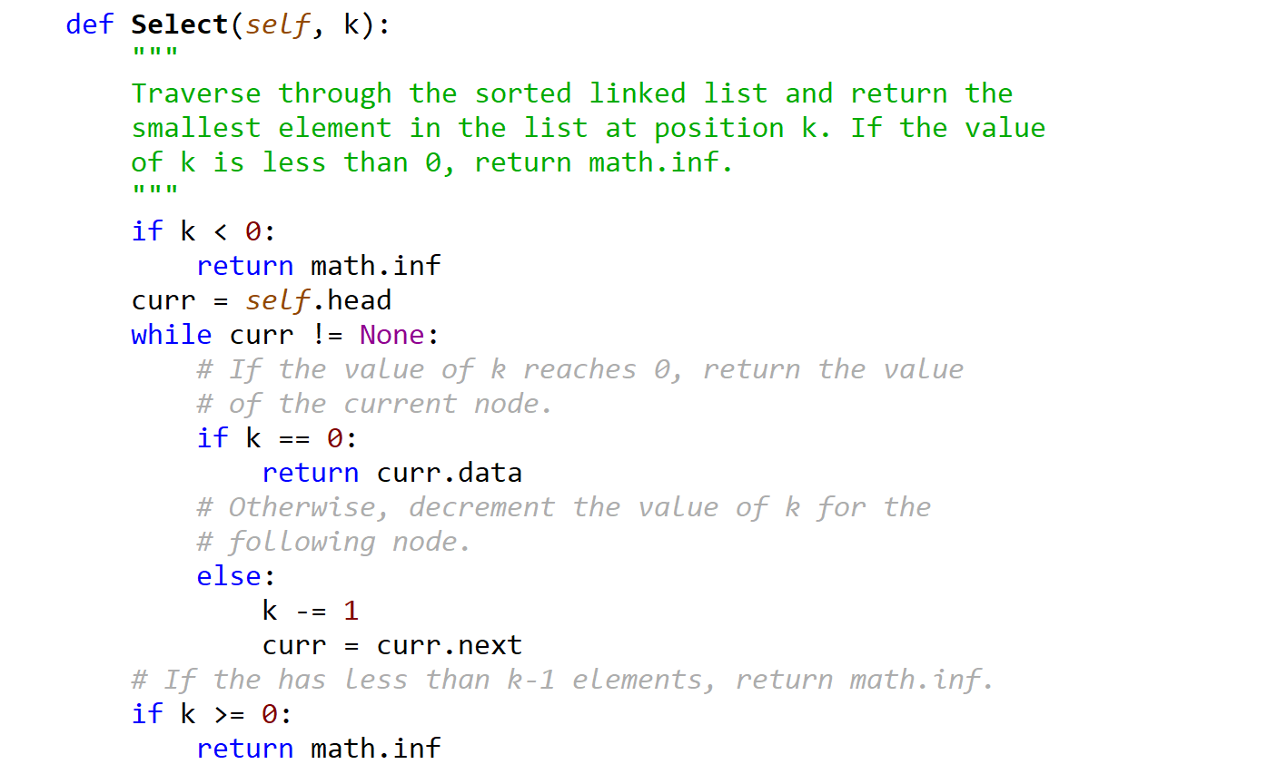



List.py

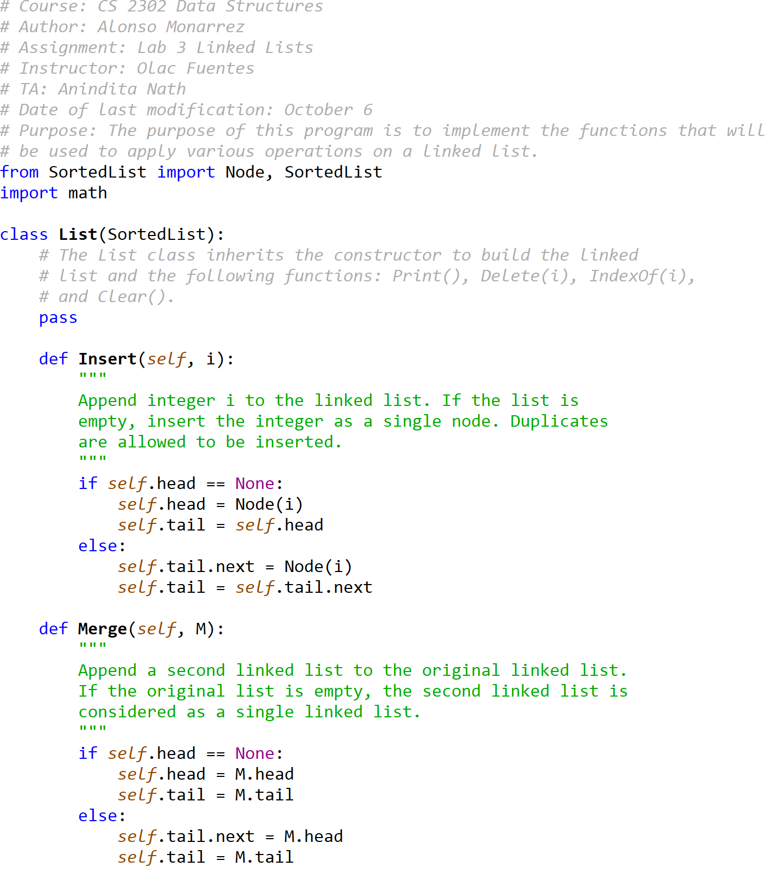

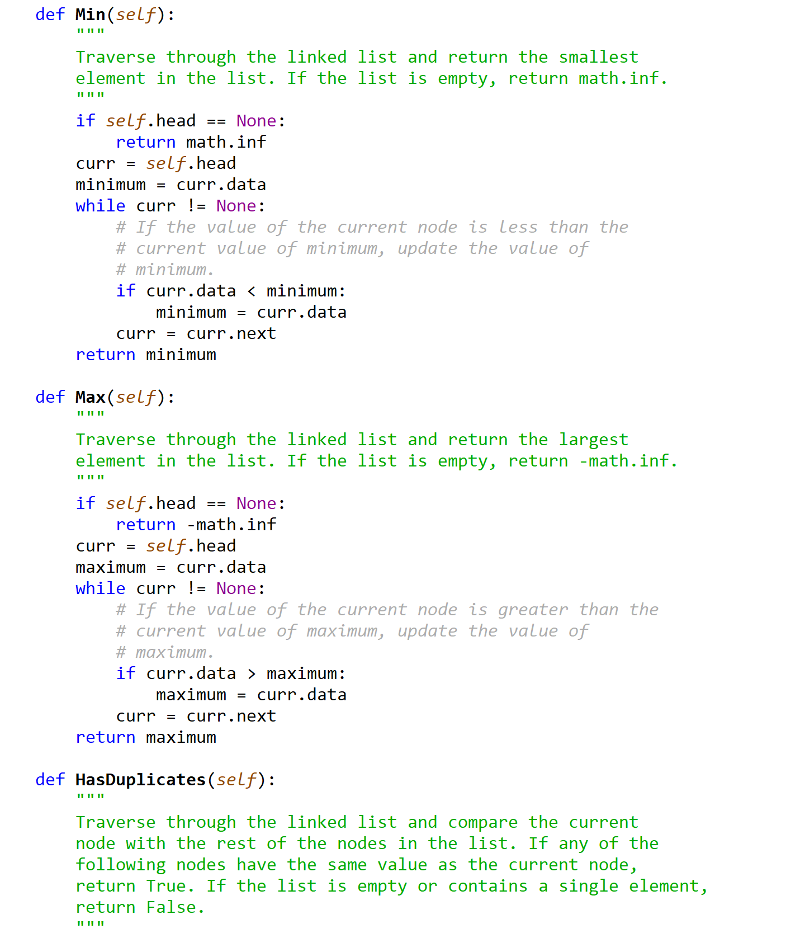

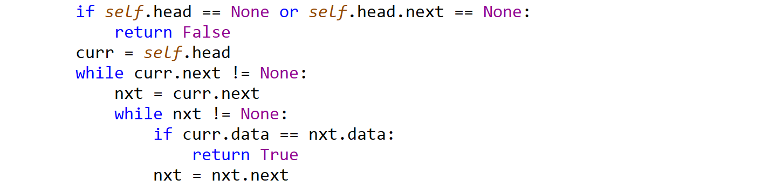

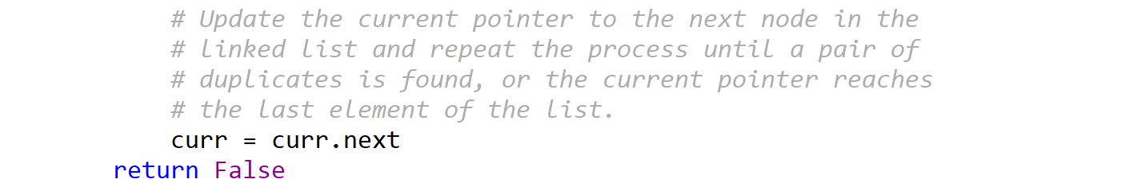

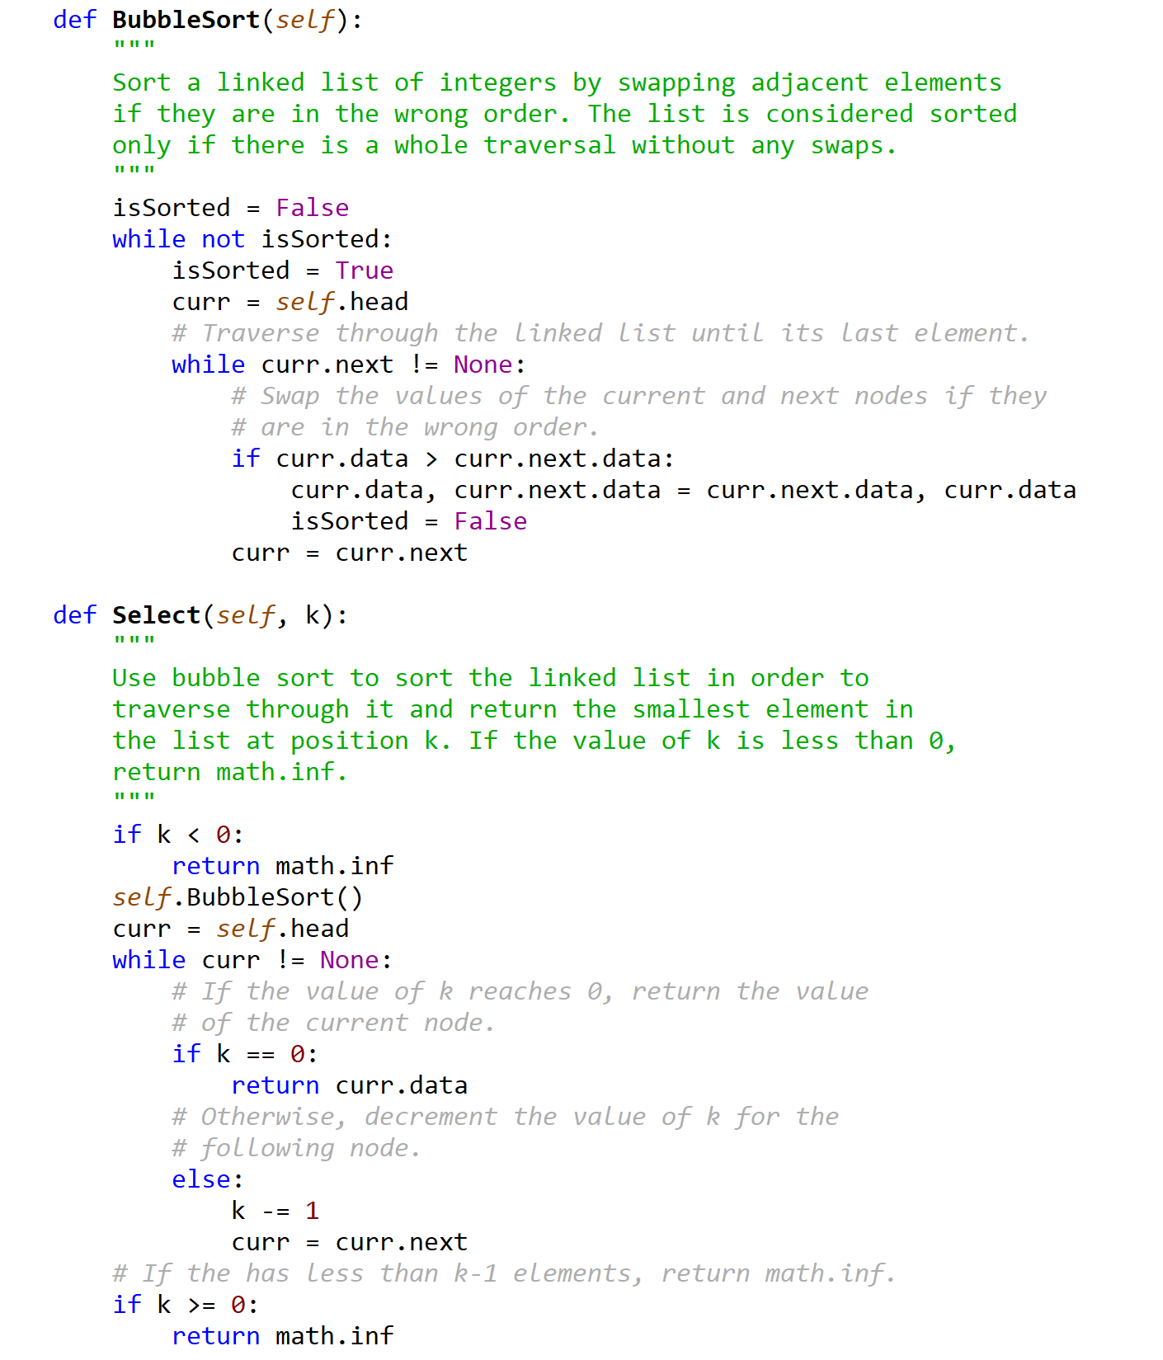

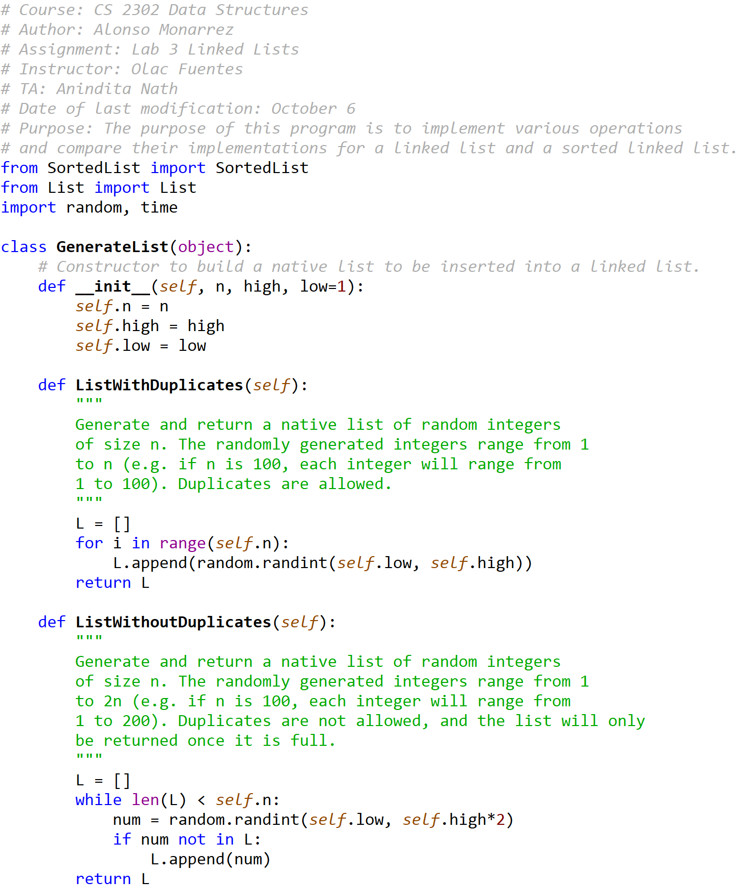

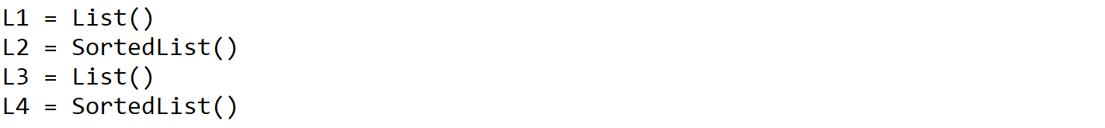

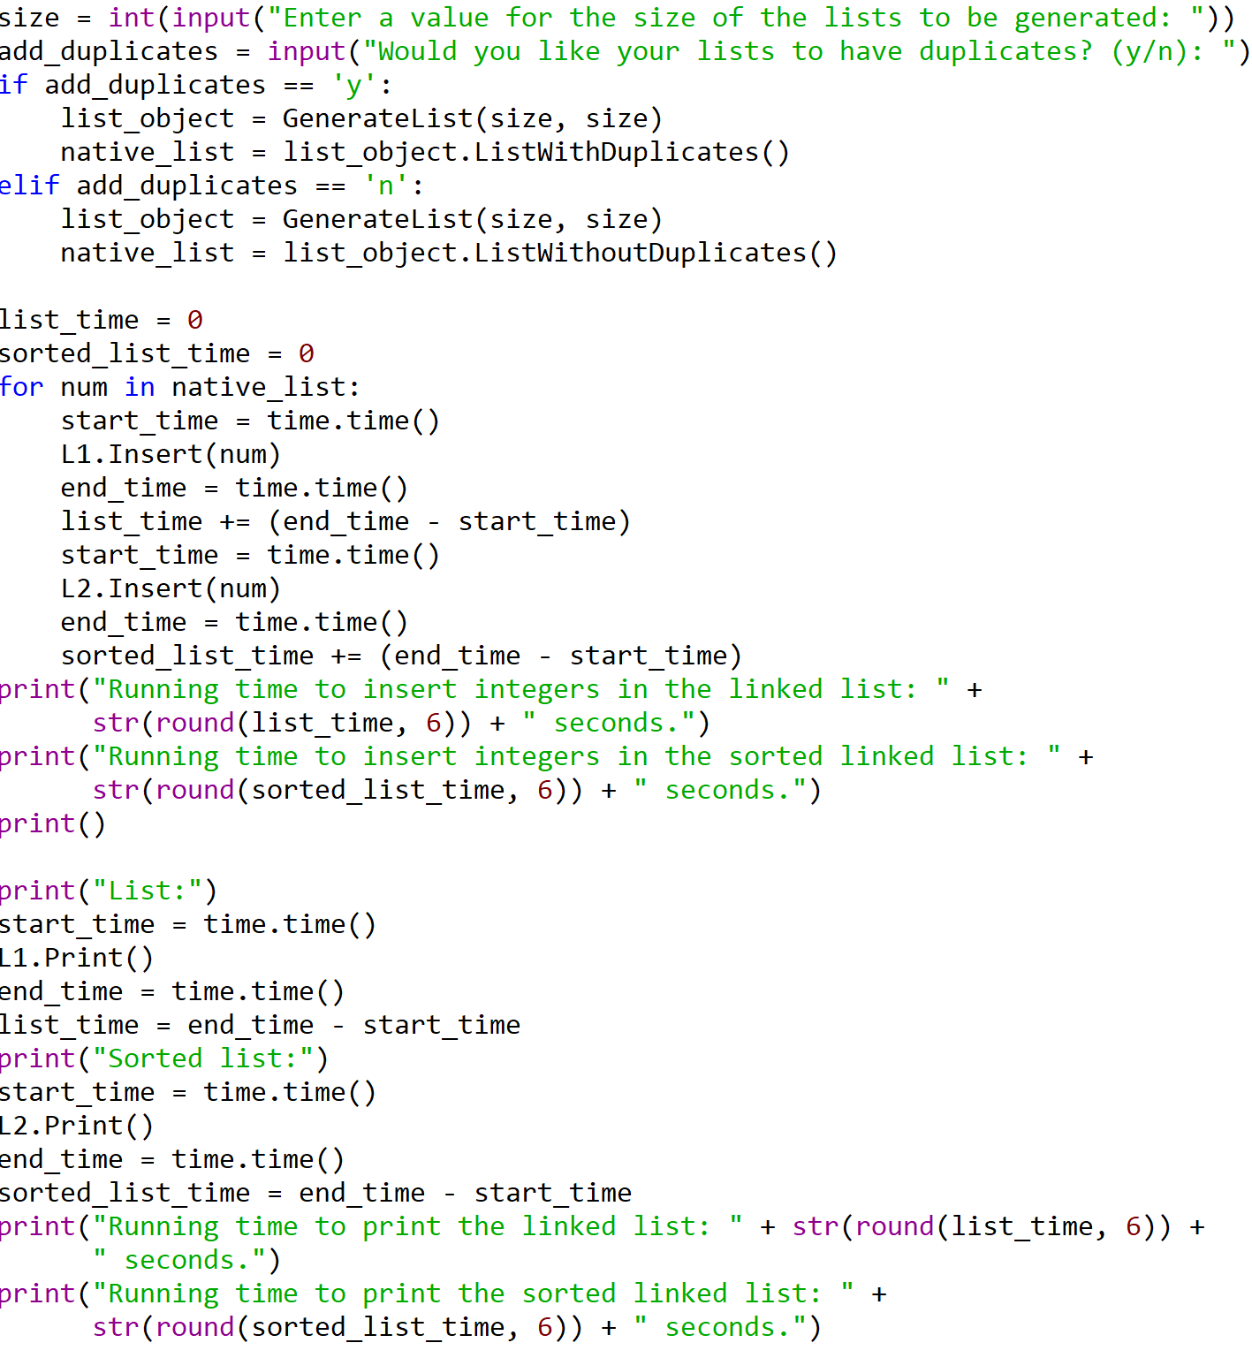



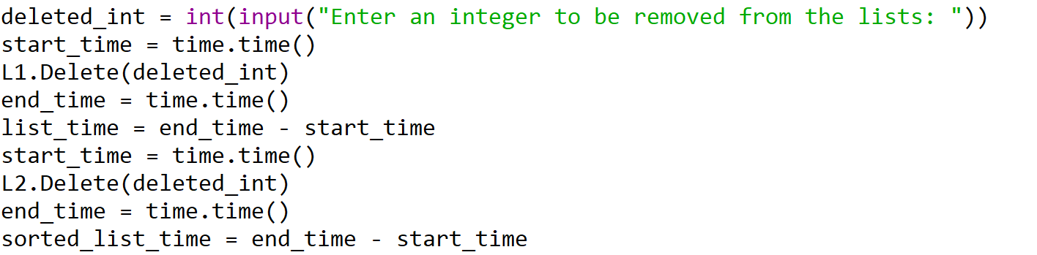

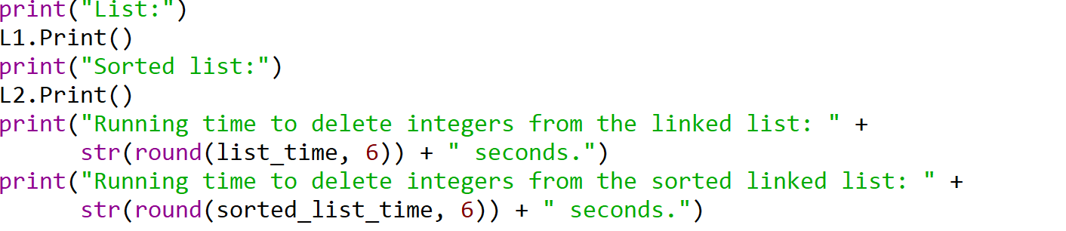

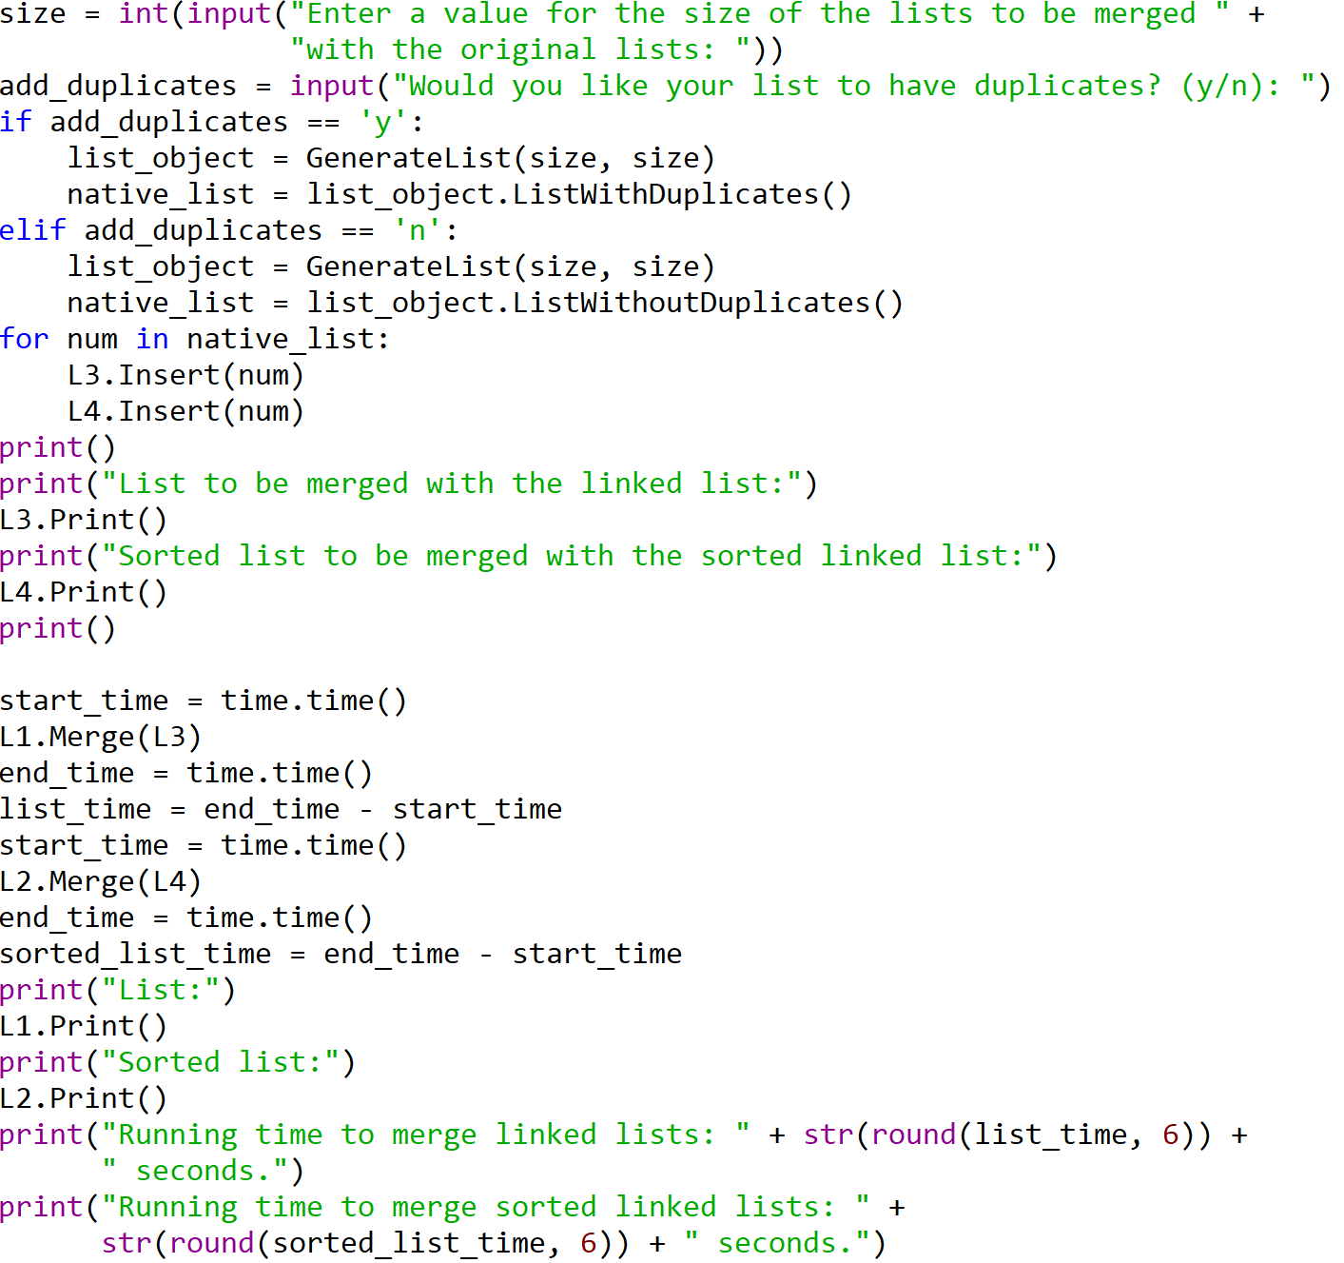

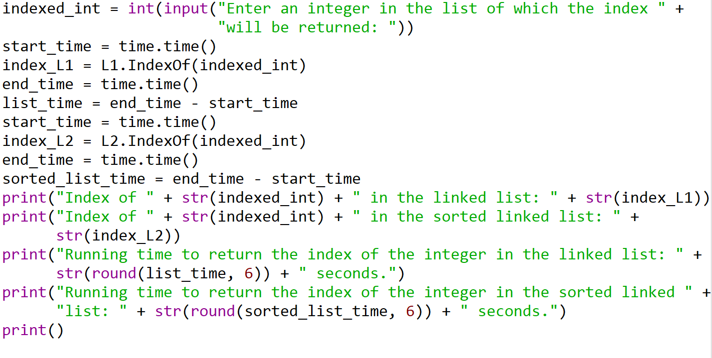

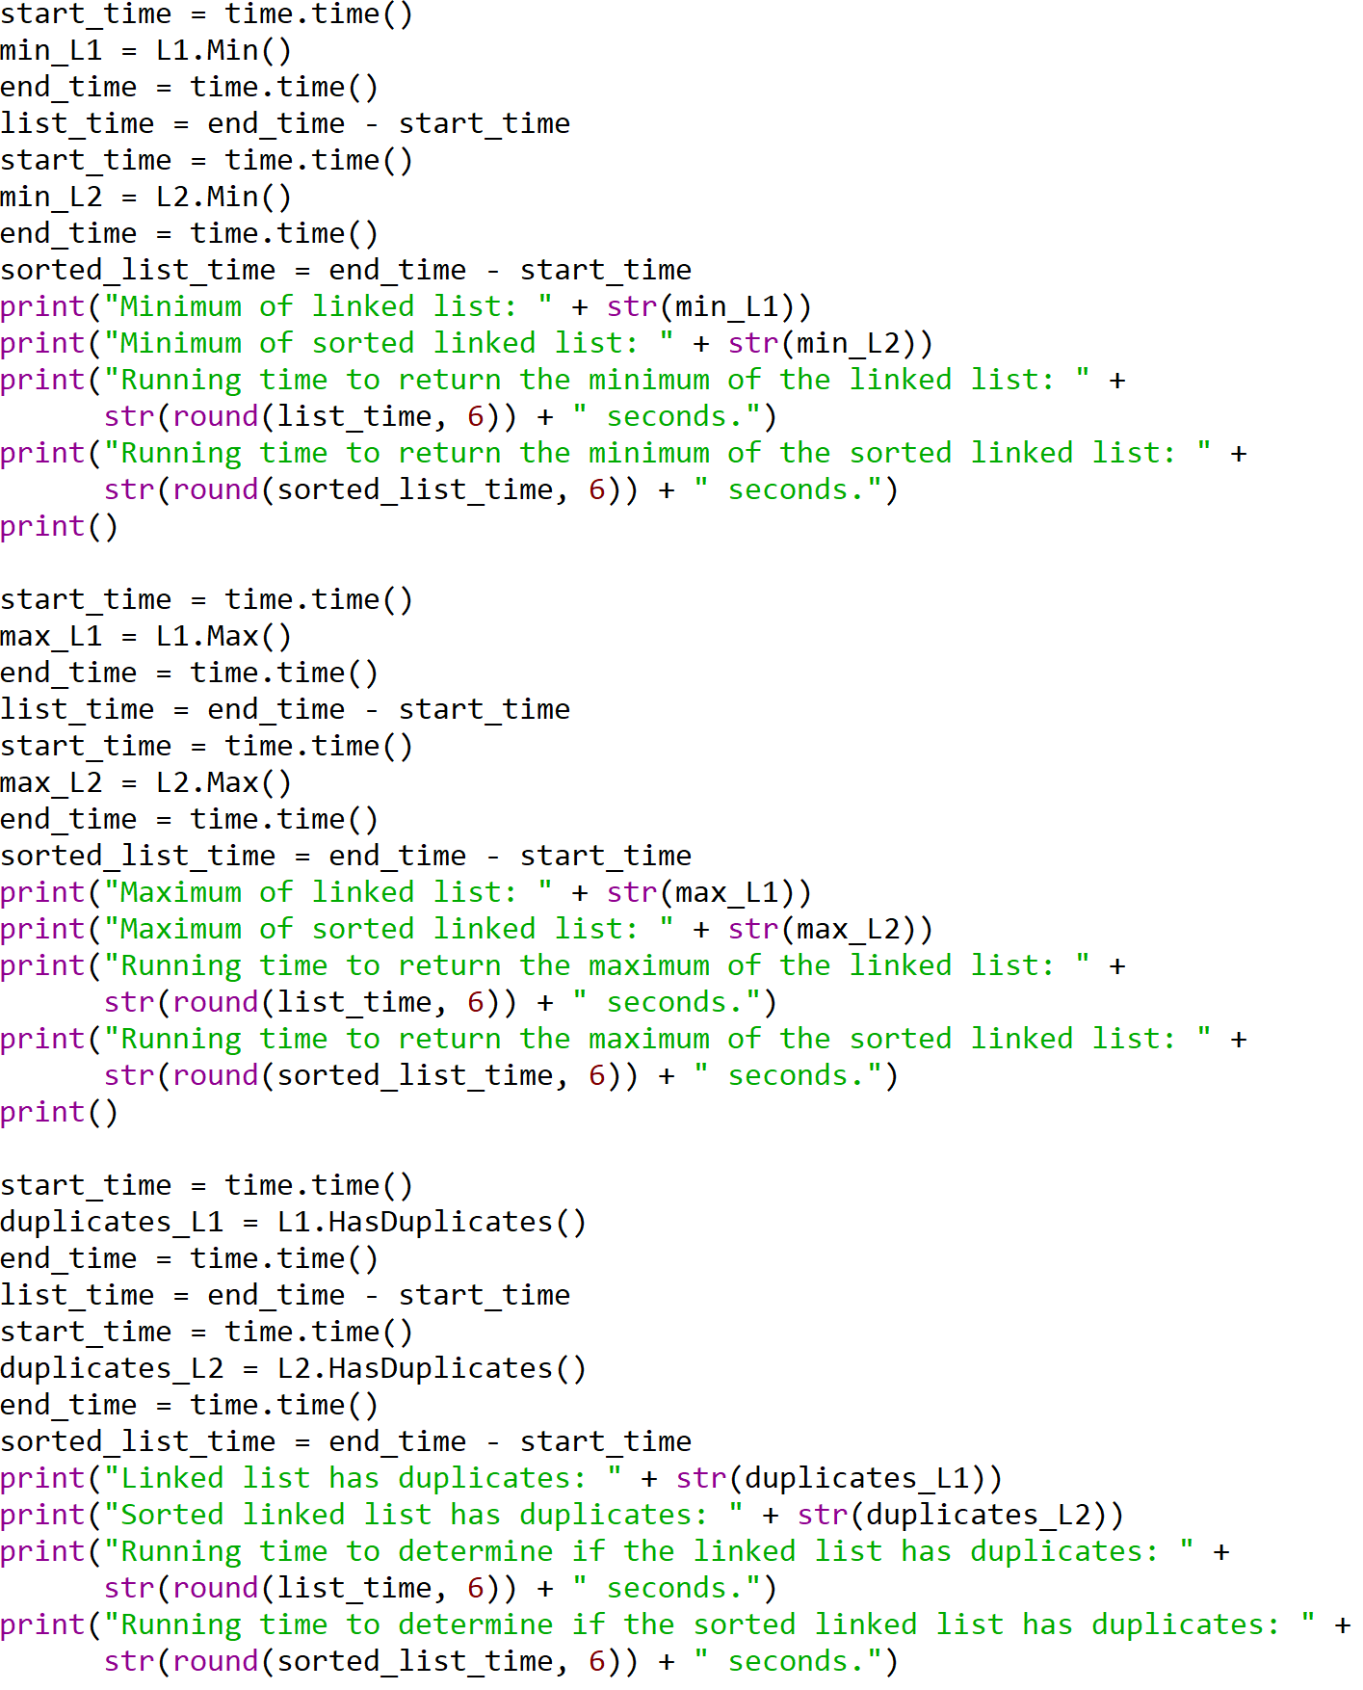

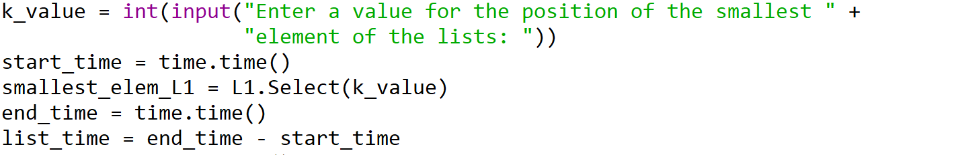

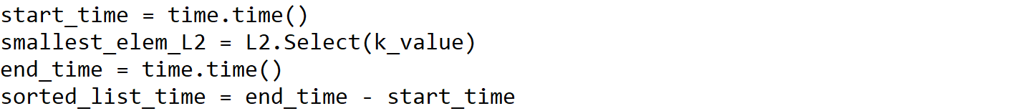

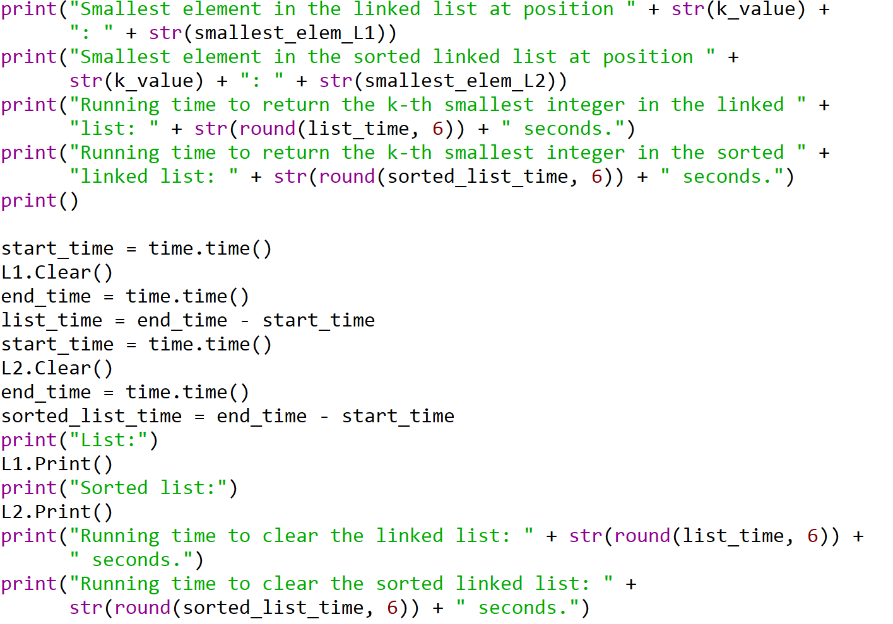

I certify that this project is entirely my own work. I wrote, debugged, and tested the code being presented, performed the experiments, and wrote the report. I also certify that I did not share my code or report or provided inappropriate assistance to any student in the class.